

**République Algérienne Démocratique et Populaire**

**Ministère de l’enseignement supérieur et de la recherche scientifique**

**Université des sciences et de la technologie**

**HOUARI BOUMEDIENE**



Memory

Presented with a view to obtaining the master's degree

In chemistry

Specialty: analytical chemistry

Theme

Presented by:

Miss. Zeghbib Ania

Miss. Abderrahmani Sara

Publicly supported on 07/07/2025, before the examination jury composed of:

|  |  |  |  |
| --- | --- | --- | --- |
| Name | First name | Grade |  |
| Foudil Cherif | Yazid | Professor at the USTHB | President |
| Issaadi | Halima Meriem | MCA at the USTHB | Examiner |
| Benkaci-Ali | Farid | Professor at the USTHB | Supervisory |
| Rahmoune | Nawel | MCB at the USTHB | Representative of the incubator |
| #error# | Flida | PCH officials -Saidal | Socio-economic representative |

Promotion: 2024/2025

Thanks

Above all, we thank Allah, the all-powerful and the merciful, for granting us the health, the will and the patience necessary to carry out our master's training and to cross, with faith and determination, each stage of this route.

We send our sincere gratitude to our promoter, Pr. Benkaci-Ali Farid, for his attentive supervision, his scientific rigor and her enlightened advice, which have greatly enriched this work.

We warmly thank the members of the jury, Mr. Foudil Cherif Yazid and Mme. Issaadi Meriem, for the time devoted to the evaluation of this thesis as well as for their precious comments.

We also express our deep gratitude to the teams of structures where we have had the opportunity to carry out our internships, including the research and development center (CRD) of Saidal and the École Normale Supérieure (ENS), as well as at Pr. Sadallah Mohcene, for their welcome, their technical support and their benevolent collaboration.Your contribution has been essential to the accomplishment of this research, and we are infinitely grateful to you.

We would also like to warmly thank the Doctoral student Rezzig Khaled and doctoral student Chabane Chaouch Aziza who helped us in this work.

We are also grateful to the technicians and staff of these institutions, the support of which has greatly facilitated the realization of our practical work.

To our family, a real pillar of our journey, we send all our gratitude for their unconditional love, their unwavering support and their constant encouragement, which carried us throughout this adventure.

Finally, we thank everyone, close or distant, who, directly or indirectly, have contributed to the success of this work.May everyone find the sincere expression of our deep gratitude here.

Dedication

By the grace of Allah, the Almighty, which lights up our paths, strengthens our hearts and guides our steps ...

I dedicate this memory to those who walked by my side with love, patience and confidence.

To my mother Hadji Sadia, my pillar, my light in the dark days, my refuge in the storms.No line will never be enough to express the immensity of my gratitude for your unconditional love, your sacrifices and your prayers that have brought me so far.

To my father Zeghbib Said, for his quiet strength, his right advice and his constant support, often discreet but always present.Your look full of pride was an invaluable source of courage for me.

To my sister Katia and my brother Hakim, who, each in their own way, offered me affection, inspiration and strength.You are an essential part of my balance.

In Malek, for his kindness, his attentive presence and his discreet but sincere support.Thank you for your kindness in our family daily life.

To my little angel Ourabah, whose smile illuminates our hearts.Your presence is a source of sweetness and inspiration in my life.

To my precious friend Rahma Hammoudi, for your sincere friendship, your faithful presence, your listening without judgment and your contagious energy.Thank you for being there at every stage, never fail.

To my friends, those who offered me moments of joy, comfort, sharing and sometimes simple silences that do good.Thank you for making this path a softer adventure.A very particular thought in Massi, for his sincere friendship, his comforting words and his constant presence, even at a distance.

To all my family, close or distant, young and old, for their love, their encouragement, their prayers and their warm, even silent presence.

At my pair of Sara, more than a teammate: an accomplice at all times for four years.Together, we built much more than a project - we shared a real life course.Thank you for your patience, your confidence and your constant commitment.

And finally, to Pr. Benkaci-Ali Farid, for the confidence granted, the quality supervision, and the advice that enriched this thesis and guided our work with requirement and benevolence.

This memory is a tribute to all these expensive souls.To you, I owe what I have become today.Ania

Dedication

Above all, I thank Allah, the very high for giving me strength, the flying and the patience to follow my studies, carry out and bake this modest work.

From the deep of my heart that I dedicate this work:

To my father Mouhend Larbi, you are my landmark, my courage, my example.You have always brought me with your gestures, your look, your love and your confidence.Even when I was on the verge of letting go, you found the words to get up.I'm so proud to be your daughter.

To my mother Nora, my life, my joy, you have always been there for me, in my tops as in my stockings.You brought me, supported, loved more than I could never thank you.I grew up with your love, your patience, your attention.And today, if I got there, it’s thanks to you.Thank you for always being proud of me.I love you with all my heart.

To my sister, Salwa, you have always been there, sweet, present, ready to listen to me without judging.Thank you for being this little corner of peace when everything was too heavy.

To my brothers, Yahia and Smail, you are my discreet strength, my bearings.Thank you for being my pillars.

To my grandfather Yahia, may God offer you his peace and welcome you in his vast paradise.  
Your memory is a tender light that never goes out in me.

To my uncle Djafer, you were more than an uncle.Thank you for each gesture, each word, each presence.Thank you for your precious help, for your outstretched hand, your real support, your presence that I will never forget.

To my whole family, my grandparents, my uncles, my aunts, my cousins, cousins ​​... Thank you for being my base, my identity, my roots.Thank you to each of you for love, encouragement.Even by far, I felt you near me.

To my dear friends: Kenza, Amina, Sarra, Yasmine, Fedwa, Achewak, Rahma, Sabrina and Houda, who have put light in the dark days, laughs in long nights,  
Thank you for your sincerity, your warm words, your loyalty without conditions.  
Without you, this course would not have had the same flavor.

To my binomial Ania, thank you for being there in all the tops as in all the stockings.Your seriousness, your patience, your good humor made this path more beautiful.Thank you for this beautiful complicity, you are one of the most beautiful memories of this work.

To my supervisor, Mr. Benkaci Ali Farid, thank you for your availability, your patience and your precious advice.

To all of you, this thesis is not just a work of end -of -studies.It is a reflection of my path, and an offering of gratitude.

Sara

Summary in French

ملخص بالعربية

ABSTRACT ENGLISH

List of abbreviations

(G): Gazous State.

(L): Liquid state.

(S): Solid state.

° C: degree Celsius.

µg: microgram.

µl: microlitre.

ρ (water): water density at the temperature taken on the day of the experience.

A: absorbance.

AFNOR: French normalization association.

BC: Cryogenic grinding.

BS: Simple grinding.

C: Commiphora.

C: the dose in (mg/ml).

CM: centimeter (unit of length equal to 10-2 m).

D: Diameter.

DMSO: dimethylsulfoxide (polar organic solvent, used in chemistry and biology).

DPPH: 2.2-Diphenyl-1-Picrylhydrazyl (molecule used to assess antioxidant activity).

ENS: École normale supérieure.

EV: Electron-Volt (energy unit in physics equivalent to the energy acquired by an electron crossing a potential difference in a volt).

Eve: Extraction by water vapor.

FDA: Food and Drug Administration.

G: Gramme (mass unit of the international system equal to 10-3 kilogram).

GC-MS: gas chromatography coupled with mass spectrometry.

GHz: Gigahertz (frequency unit equivalent to 109 Hz).

H: The humidity level in (%).

H: time (unit of time equal to 60 minutes).

HD-MO or MWSD or MAHD or HDDD: Hydrodistillation assisted by microwave.

HE: Helium (chemical element, HE symbol).

HE: essential oil.

HPLC or CLHP: high performance liquid phase chromatography (High Performance Liquid Chromatography).

HV: vegetable oil.

J.-C: Jesus Christ.

Kiref: Van den Dool of reference.

MHz: Megahertz (frequency unit equivalent to 106 Hz).

Min: minute (unit of time equal to 60 seconds).

ML: Millilitre.

Mol: mole (unit of quantity of matter, equal to 6.022 × 1023 elementary entities).

NIST: National Institute of Standards and Technology (National Institute of Standards and Technology, United States).

N2: nitrogen ..

A: yield in (%).

RI: Van den Dool index.

SNC: central nervous system.

TR: retention time.

UV: Ultraviolet (electromagnetic radiation whose wavelength is lower than that of visible light).

Calf: the volume of water in (ml).

W: watt.

Wiley: Wiley company spectral database (often used in mass chromatography/spectrometry for the identification of compounds).

List of figures

Figure 1: Diversity of medicinal and aromatic plants used in phytotherapy.

Figure 2: Structure of Isoprene.

Figure 3: Structures of some hydrocarbon sesquiterpenes.

Figure 4: Structures of some oxygenated sesquiterpenes.

Figure 5: Structures of some aromatic compounds.

Figure 6: Diagram of hydrodistillation extraction.

Figure 7: Diagram of the hydrodistillation technique assisted by HD-MO microwave.

Figure 8: Diagram of the steam training device assisted by microwaves.

Figure 9: Diagram of the Soxhlet apparatus.

Figure 10: ultrasonic bath.

Figure 11: Analysis by gas chromatography coupled with mass spectrometry (GC-MS).

Figure 12: Diagram Analysis by high performance liquid chromatography (CLHP or HPLC).

Figure 13: Commiphora Myrrhe.

Figure 14: Commiphora Myrrhe, erased in nature.

Figure 15: Chemical structures of dominant compounds identified in myrrh essential oil.

Figure 16: Plant matter.

Figure 17: Classic hydrodistillation assembly (HD) for extraction of the essential oil of myrrh.

Figure 18: Mounting hydristillation assisted by microwave (HD-MO) for extraction of the essential oil of myrrh.

Figure 19: Sixhlet experimental assembly used for the extraction of bioactive compounds.

Figure 20: Experimental device of the rotary evaporator (rotary evaporator) used for the vacuum concentration of the extracts.

Figure 21: GC/MS equipment, AG Technologies: GC 790A, Auto Sampler 7693, SM

5975C Inert XL EI/CI MSD.

Figure 22: Antimicrobial activity by the discharge method on disk on nutritional agar.

Figure 23: Photographic steps of albumin extraction from egg whites.

Figure 24: The DPPH solution.

Figure 25: Diluted solutions of essential oil and extract used for tests.

Figure 26: Different dilutions Prepare.

Figure 27: UV spectrophotometry apparatus used for analyzes.

Figure 28: Preparation of the extract solution with Tween 20.

Figure 29: weighing with a mouse on an electronic balance.

Figure 30: Oral cavage of a mouse with flexible probe, in a vertical position.

Figure 31: Rest of the mice in their cage after the cavage.

Figure 32: Installation of the mouse in the compression tube.

Figure 33: Immersion of the tail in the double boiler.

Figure 34: placement of the mouse on the plate in the transparent cylinder.

Figure 35: Intraperitoneal injection of the acetic acid solution in mice.

Figure 36: Mouse placed in an individual observation cage after injection of acetic acid.

Figure 37: Abdominal twists after acetic acid injection.

Figure 38: Variation in the extraction efficiency of the essential oil of myrrh as a function of the techniques used with simple grinding.

Figure 39-A: Energy consumed according to the techniques used.

Figure 39-B: CO2 clearance compared to techniques.

Figure 40: Differential yield of the essential oil of myrrh extracted by different extraction methods.

Figure 41: Cumulative yield of the essential oil of myrrh extracted by different extraction methods.

Figure 42-A: Energy consumed according to the techniques used with optimal time 80%.

Figure 42-B: Energy consumed according to the techniques used with optimal time 90%.

Figure 43-A: CO2 clearance compared to the techniques used with optimal time 80%.

Figure 43-B: CO2 clearance compared to the techniques used with optimal time 90%.

Figure 44: Differential and cumulative yield of the essential oil of myrrh extracted by HD-MO 800 W with different types of grinding.

Figure 45: GC-MS chromatogram with hydrodistillation assisted by microwave power 800W BS.

Figure 46: Variation of the differential percentage of the majority compounds of the essential oil of the myrrh as a function of HD-MO 800W-BS time.

Figure 47: Cumulative percentage of majority compounds from the essential oil of myrrh extracted by the HD-MO 800W-BS technique.

Figure 48: Fragment spectra of the majority compounds identified in the case of HD-MO 800W BS.A: Furanoeudesma-1,3-Diene.B: Elemène <β->.C: Curzerène.

Figure 49: Variation of the percentage of chemical classes of essential oil as a function of time by the HD-MO 800-BS technique.

Figure 50-A: Cumulative percentage of chemical classes of essential oil from myrrh extracted by the HD-MO 800-BS technique.

Figure 50-B: Cumulative percentage of chemical classes of essential oil from myrrh extracted by the HD-MO 800-BS technique.

Figure 51: GC-MS chromatogram with hydrodistillation assisted by microwave power 800W BC.

Figure 52: Variation of the percentage of majority compounds of the essential oil of myrrh as a function of HD-MO 800W-BC time.

Figure 53: Cumulative percentage of majority compounds from the essential oil of myrrh extracted by the MO 800W-BC technique.

Figure 54: Variation of the differential percentage of the chemical classes of essential oil as a function of time by the HD-MO 800W-BC technique.

Figure 55: Cumulative percentage of chemical classes of myrrh essential oil.

Figure 56: HPLC chromatogram of myrrh extract according to the region and the microwave power studied, region 1: Saudi Arabia HD-MOP = 800 W, Region 2: Pakistan HD-MO P = 800 W, Region 3: Yemen HD-MO P = 800 W, Region 4: Saudi Arabia HD-MO P = 60.

Figure 57: Inhibition zones of essential oil and myrrh extract against tested microorganisms.

Figure 58: Graphs representing the % of inhibition of the denaturation of albumin as a function of the concentration of extracts and essential oils.

Figure 59: Histogram of IC50 (µg/ml) values ​​of essential oils and extracts from the myrrh obtained by the simple grinding method and diclofenac sodium.

Figure 60: Antioxidant activity as a function of the concentration of essential oils and extracts from myrrh.

Figure 61: Histogram of IC50 (µg/ml) values ​​of essential oils and extracts from the myrrh obtained by the simple grinding method.

Figure 62: Effect of latency treatment in the Tail Flick test in animals.

Figure 63: Effect of treatment on the reaction latency to the heating plate test in animals.

Figure 64: percentages of inhibition of the extract 300mg/kg on the number of torsions induced by acetic acid.

Figure 65: Final formulation of the therapeutic Roll-On based on myrrh.

Figure 66: Final formulation of therapeutic balm based on myrrh resin.

Figure 67: Final Vaseline Formulation based on Myrrhe extract.

Tables list

## Table 1: Chemical families of HES and their biological properties.

Table 2: Main constituents identified in myrrh and their approximate percentages (Ljaljević Grbić, M. 2018).

Table 3: The microbial strains tested as well as their references.

Table 4: Operating conditions for the different methods of extraction of the essential oils of Commiphora Myrrha.

Table 5: Steps intervals of different extraction techniques (BS).

Table 6: Optimistic times for different extraction techniques.

Table 7: Extraction kinetics of the essential oil of the myrrh extracted by HD-MO P = 800W BS followed by GC-MS.

Table 8: Extraction kinetics of the essential oil of the la Myrrh extracted by HD-MO P = 800W BC followed by GC-MS.

Table 9: Results of HPLC analysis of phenolic compounds of myrrh resin.

Table 10: Results of antimicrobial activities.

Table 11: Result of antioxidant activity by DPPH.

Material table

Introduction ……………………………………………………………………………………… 1

Chapter I: bibliographic synthesis

I.1 Medicinal plants ……………………………………………………………………… 3

I.1.1 Socio-economic and cultural importance ………………………………………………… 3

I.2 Essential oils …………………………………………………………………… 4

I.2.1 Definition of essential oils ………………………………………………………… 4

I.2.2 Composition of essential oils ……………………………………………………… 4

has.Terpenic compounds: terpenes and terpenoids ……………………………………… 4

b.Aromatic compounds ………………………………………………………………… 5

c.Composed of various origins …………………………………………………………… 6 I.2.3 Location of essential oils ……………………………………………………… 6

I.2.4 Physical properties of essential oils …………………………………………… 6

I.2.5 Biological activities of essential oils …………………………………………… 7

I.2.6 Extraction procedures for essential oils ………………………………………… 8

I.2.6.1 Hydrodistillation ……………………………………………………………………… 8

I.2.6.2 Extraction assisted by microwave …………………………………………………… 9

I.2.6.3 Extraction by SOXHLET ……………………………………………………………… 11

I.2.6.4 Ultrasound extraction ……………………………………………………………… 12

I.2.7 Analysis methods ………………………………………………………………. ……… 12

I.2.7.1 Analysis by UV-visible spectroscopy ……………………………………………. …… 12

I.2.7.2 Analysis by chromatography coupled with GC-MS mass spectrometry ... ... ......

I.2.7.3 Analysis by chromatography in high performance liquid phase …………. ……… 13

I.3 Hydrols ……………………………………………………………………… .. ……… 15

I.4 Plant extracts ………………………………………………… ...……………… 15

Chapter II: the representation of the plant

II.1 The myrrhe resin ………………………………………………………… .. …………… 16

II.1.1 Definition ……………………………………………………………………… ... ………… 16

II.1.2 Botanical description ……………………………………………………………… 16

II.1.3 Harvesting and resin trade …………………… .. …………………………. ……… 17

II.1.4 Physico-chemical properties of myrrh resin essential oil ………………… 17

II.1.5 Chemical composition ……… ....... …………………………………………………… 17

II.1.6 Therapeutic effect of myrrh biomolecules ………………………………………… .19

* Antioxidant ………………………………………………………………………… ... 20
* Anti-cancer ……………………………………………………………………… ... 20
* Antibacterial and antifungal …………………………………………………. …… ... ..20
* Antiparasitic… …………………………………………………………………… ..… .20
* Anti-infectious ………………………………………………………………………… .20
* Analgesic and anti-inflammatory ……………………………………………………… 21

II.1.7 Other uses …………………………………………………………………… .21

II.1.8 Toxicological data of the essential oil of myrrh ………… ... …………. …… 22 22

Chapter III: Materials and operating conditions

III.1 Material and method of extraction ……………………………………………………… 23

III.1.1 Classic hydristillation ……………………… .. ………………………………… 24

III.1.2 Hydrodistillation assisted by microwave …………………………………………… ..24

III.1.3 Extraction by volatile solvent ……………………………. ………………………… 25

III.2 Operating analysis conditions …………………………………………………… ..27

III.2.1 Operating conditions for the analysis of essential oils by gas chromatography coupled with mass spectrometry (GC-MS) …………………………… 27

III.2.2 Operational conditions of analysis by high performance liquid chromatography (HPLC) ……………………………………………………………………… .. ……………… 29

III.3 Activities in vitro ………………………………………………………………………… 30

III.3.1.Antimicrobial …………………………… ... …………………………………………… 30

III.3.2 Anti-inflammatory …………………………………………………………………… 32

III.3.3 Antioxidant ………………………………………………………………………… ... 34

III.4 Activities in vivo ………………………………………………………………………… 37

III.4.1 Evaluation of the analgesic activity of the extract of myrrhe ………………………… ..37

Chapter IV: Results and discussion

IV.1 Study of the extraction of the volatile fraction ……………………………………………… ..45

IV.1.1 Study of the extraction yield of the essential oil of myrrh ………………… 45

IV.1.2 Energy and environmental appearance ……………………………………………… 46

IV.1.3 Study of the extraction kinetics of the essential oil of myrrhe ……………… ... 47

IV.1.4 Studies of extraction kinetics as a function of time by GC-MS ……………… ..51

IV.1.4.1 Case of HD-MO technique P = 800W BS ……………………………………………… 52

IV.1.4.2 Cases of HD-MO technique p = 800W BC ……………………………………………… 62

IV.2 Study of the chemical composition of the polyphenolic fraction by HPLC-Dad HPLC ………………………… ………………………………………………………… ..… ..69

IV.3 Study of antimicrobial activity of myrrh resin on bacterial and fungal pathogenic strains ………… ………………………………………………………… .76

IV.4 Study of the anti-inflammatory activity of essential oils and extracts of myrrhe ………………………………… ………………………………………………… .77

IV.5 Study of the antioxidant activity of essential oils and myrrh extracts by the trapping method to the DPPH …………………… ……………………………………… 79

IV.6 Evaluation of the analgesic activity of the ethanolic extract of Myrrhe …………. …… 81

Chapter V: Formulation

V.1 Roll-on innovative myrrh for targeted application …………………… .. ……… 83

V.2 MYRRHE BALAGE for optimal skin protection and regeneration ………… 84

V.3 Vaseline based on myrrh extract… ………………………………………………… 85

Conclusion ………………………………. ……………………………… .. …………………… .87

Reference bibliographies.

Annex.

General introduction

For centuries, medicinal plants have been an essential source of natural treatments.They are used to treat and prevent many diseases, thanks to their richness in bioactive compounds which give them various therapeutic properties (Bakkali, F. et al. 2008).

Today, these plants are the subject of many scientific research, in order to identify and enhance new active molecules for pharmaceutical, cosmetic or food applications.This richness in natural compounds, such as terpenes, polyphenols or alkaloids, explains their growing interest (Burt, S. 2004).

Myrrh (Commiphora spp.) Is one of these medicinal plants widely recognized for its therapeutic effects.Originally from the arid regions of East Africa and the Arabian Peninsula, its resin has been used for centuries in traditional medicine in various cultures for its antiseptic, anti-inflammatory, analgesic and healing properties (Shen, T. et al. 2012).

Its chemical composition is complex and is in the form of essential oil, gum and resin, which gives it many applications in the pharmaceutical and cosmetic fields (Hanus, L.O. et al. 2005).Despite its ancient use, several aspects linked to the chemical composition and the biological effects of myrrh still remain to be deepened.This is why our work aims to enhance this resin through its extraction, analysis and evaluation of its biological properties, in an innovative framework.

In this study, we have extracted two types of myrrh fractions: the volatile fraction and the phenolic fraction.For the volatile fraction, we used two extraction techniques: classic hydrodistillation (HD) and hydrodistillation assisted by microwave (HDMO).The essential oils obtained were then analyzed by gaseous chromatography coupled with mass spectrometry (GC-MS) in order to identify their main constituents (Adams, R.P. 2007).

At the same time, the phenolic fraction was obtained by extraction to the Soxhlet using ethanol as a solvent, then analyzed by high performance liquid chromatography (HPLC) to determine its composition in phenolic compounds (Singleton, V.L. et al. 1999).

We have evaluated the biological activities of essential oil and the ethanolic extract of myrrh.The tests focused on their antimicrobial, antioxidant and anti-inflammatory effects.In addition, analgesic activity was evaluated in vivo only on the ethanolic extract (Brand-Williams, W. et al. 1995; Koster, R. et al. 1959)

Following the results obtained and taking into account the demonstrated biological properties of myrrh resin, including its anti-inflammatory, antioxidant and antimicrobial effects, we have designed and proposed simple therapeutic formulations.

These formulations have been developed from an applied valuation perspective, aimed at effectively exploiting the pharmacological potential of myrrh in products for medical or cosmetic use.This approach makes it possible to envisage a transfer of knowledge acquired towards concrete applications, with a particular interest in the development of innovative solutions and accessible in the field of natural health.

Chapter I

Bibliographic synthesis

I.1 Medicinal plants

According to the 10th edition of the French Pharmacopoeia (Afssaps. 2010), medicinal plants are plant drugs within the meaning of the European pharmacopoeia, at least a part of which has drug properties (Figure 1).

They relate to two origins at the same time.First the spontaneous plants called "wild" or "picking", then second the cultivated plants (Bézanger-Beauquesne, L et al. 1986).

* Spontaneous plants: (or wild, naturally grows without human intervention), they were the only ones used in the past and still represent today a significant percentage of the Algerian market.Their distribution depends on the soil and especially on the climate.
* Cultivated plants: (introduced and intentionally maintained by man), these ensure sufficient raw material to meet the needs and drugs collected are homogeneous from an appearance and chemical composition point of view.Another advantage, and not the least, all possible confusion by picking is excluded here, which also allows a more timely harvest.

**Figure 1 :** Diversité de plantes médicinales et aromatiques utilisées en phytothérapie

I.1.1 Socio-economic and cultural importance

Most plant species contain substances that can act, at one level or another, on the human and animal organism.They indeed have advantages whose drugs are often devoid (Iserin, P. 2001).The fundamental reason is that the active ingredients of plants come from biotic processes spread throughout the living world, while synthetic drugs are xenobiotics with very poorly controlled side effects (Bruneton, J. 2009).Medicinal plants are therefore important for pharmaceutical research and the development of drugs, directly acting as therapeutic agents, but also as a raw material for the synthesis of drugs or as a model for pharmaceutically active compounds (Decaux, I. 2002).

I.2 Essential oils

I.2.1 Definition of essential oils

According to (Durville, J-P. 1930), the essential essences or oils, also known as volatile oils, are odorous oily, volatile substances, not very soluble in water, more or less soluble in alcohol and in ether, colorless or yellowish, flammable which are easily altered by resin.When they are pure and natural, they do not contain any fatty substances: they only consist of volatile aromatic molecules, hence their name of essential oil.The term "oil" underlines the viscous and hydrophobic character of these substances, the term "essential" indicates the main characteristic of the plant through its exhale.

* Essence: natural secretion developed by the plant organism, contained in various types of producer organs, variable according to the part of the plant considered.
* Essential oil: natural extract of raw materials of vegetable origin, obtained by distillation by water vapor, that is to say that essential oil is distilled essence.(Besombes, c.2008).

According to the French AFNOR Normalization Association, the HES are: "Products obtained either from raw materials of plant origin, or by steam training, or by mechanical processes from the Citrus epicarpe, or by" dry "distillation.The essential oil is then separated from the aqueous phase by physical processes "(AFNOR, Paris. 2000).

I.2.2 Composition of essential oils

Essential oils (HES) are complex mixtures of very varied molecules belonging mainly to two chemical groups compared to their biogenetic origins: terpene (terpenes and their oxygenated derivatives) and aromatic compounds derived from phenylpropane (Boukhobza, F. and Goetz, P. 2014).Certain compounds of various origins (alcohols, aldehydes, ketones, esters, etc.) are generally in the state of trace.All compounds are characterized by a low molecular weight (Bakkali, F. et al. 2008).

1. Terpenic compounds: terpenes and terpenoids

Terpenes are natural hydrocarbons, of structure either cyclic or open chain.Their raw formula is (C5H8) n of which n of the number of basic pattern called isoprene (or 2-methylbuta-1,3-diene) of C5H8 formula (Figure 2).Thus, depending on the value of n, we meet the monoterpenes (n = 2), the sesquiterpenes (n = 3), the diterpenes (n = 4), etc.(Chagra, K .2019).Terpénoids, also known as isoprenoids, are compounds with the structure of terpenes and belonging to different chemical families such as alcohol, aldehydes, ketones, esters and ethers (Benaissa, O. 2011; Samate, A.D. 2002).

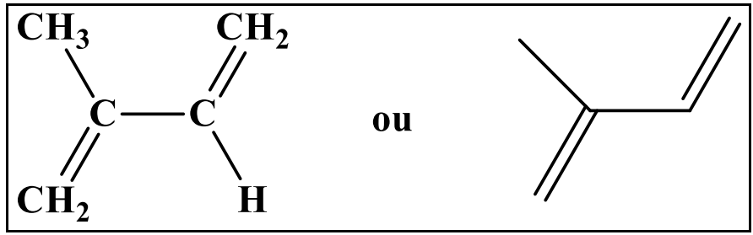

**Figure 2** : Structure de l’isoprène

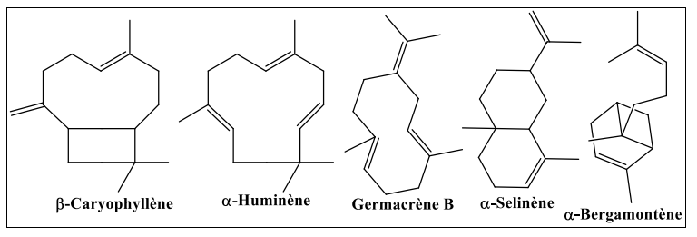

**Figure 3 :** Structures de quelques sesquiterpènes hydrocarbonés

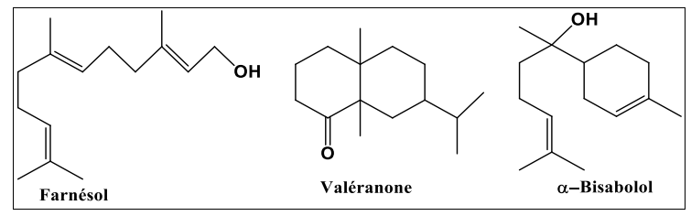

**Figure 4 :** Structures de quelques sesquiterpènes oxygénés

1. Aromatic compounds

Unlike terpene derivatives, aromatic compounds (Figure 5) are less frequent in HES.Very often, it is allyle and propénylphenol.These aromatic compounds constitute an important whole because they are generally responsible for the characters of essential oils.(Hessas, T., Simoud, S. 2018).

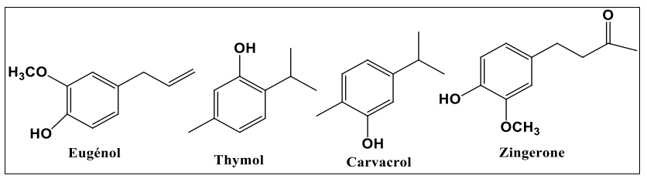

**Figure 5 :** Structures de quelques composés aromatiques

1. Composed of various origins

In addition to the mainly terpenic and aromatic compounds, essential oils can contain a great diversity of secondary chemicals, such as nitrogen and sulfur compounds, alcohols, fatty acids, coumarins, lactones, as well as aldehydes, ketones, esters and oxids, contributing to their varied biological properties (Bruneton, J. 2009).

I.2.3 Location of essential oils

The HES can be extracted from all the organs of the plant:

* Flower tops (lavender, mint, ylang, chamomile, etc.).
* Roots or rhizomes (vetiver, angelica, ginger ...).
* Bark (lemon, orange ...).
* Wood (resin, cedar, sandalwood, camphor, ...).
* Fruits (pepper ...) and leaves (eucalyptus ...).
* Seeds (cardamons, coriander, fennel, nutmeg ...).(1)

I.2.4 Physical properties of essential oils

Essential oils are generally colorless or slightly yellowish liquids, characterized by a strong and specific odor for each plant.They are volatile at room temperature and have a density generally lower than that of water, although there are exceptions.Their boiling point varies according to the nature of the compounds present, but is generally relatively low, which justifies their distillation with water vapor.Insoluble in water, they are however perfectly soluble in organic solvents such as ethanol, ether or vegetable oils.These physical properties not only influence their extraction methods, but also their formulation and their stability in therapeutic or cosmetic use (Bruneton, J. 2009; Yahiaoui, N. 2005).

I.2.5 Biological activities of essential oils

The biological activity of the HES depends on their chemical composition and the interactions between their components (Table 1) (Pibiri, M. C. 2006; Lahlou, M. 2004).They have several major therapeutic properties.They have antibacterial action thanks to phenols, monoterpenes, aldehydes and ketones that stimulate natural defenses.They also have antifungal properties, protecting from food and food microorganisms (Zambonelli, A. et al. 2011; Mangena, T. et al. 1999).The HES are antiparasitic by pushing insects and antivirals by slowing down the spread of viruses while strengthening immunity.They have anti-inflammatory, healing and antioxidant effects, thus promoting cellular regeneration.Some HES improve blood circulation, relieve digestive disorders and act as antispasmodic.They also have calming effects, facilitating sleep, and deodorizing, purifying air by eliminating certain odors.

## Table 1: Chemical families of HES and their biological properties.

|  |  |
| --- | --- |
| Chemical families | Biological properties (Benayad, N. 2008; Belkou, H. et al. 2005) |
| Hydrocarbon monoterpenes | Fungistatic, bacteriostatic, insecticide, nematicide, herbicide, stimulating |
| Hydrocarbon its | Calmant, anti-inflammatory, antiallergic, antibacterial, antifungal |
| Terpenic phenols | Antioxidant, stimulating, tonic, antiseptic, bactericidal, fungicide, antiviral, antiparasitic |
| Monoterpenic alcohols | Anti-inflammatory, antiseptic, bactericidal, fungicide, antiviral, antiallergic, immunostimulant, neurotoxic |
| Sesquiterpenic alcohols | Tonic, stimulating |
| Monoterpenic aldehydes | Antifungal, sporicide, insecticide, antihypertensive, anti-inflammatory |
| Monoterpenic ketones | Calmant, antiviral, antifungal, neurotoxic, antiepileptic |

I.2.6 Extraction procedures of essential oils

I.2.6.1 Hydrodistillation

* Classic hydrodistillation

Hydrodistillation is the reference technique in the study of volatile compounds of a plant in the field of research (Figure 6).This is the normalized method for the extraction of HES from dry spices.



**Figure 6** : Schéma de l'extraction par hydrodistillation

Teisseire, P. J. (1991) indicates that this technique consists in immersing plant matter in a water bath, then the whole is brought to a boil under atmospheric pressure.The heat allows the bursting and release of the fragrant molecules contained in vegetable cells.These aromatic molecules form an azéotropic mixture "water +e" with the water vapor.The latter is condensed, cooled and recovered in an Essek or Florentine vase.The HE being lighter than water (except a few rare exceptions) it flies over the hydrosol this technique has been applied in numerous works (Lagunez Rivera, L. 2006).

This method is generally used in the event of essential oils whose chemical constituents are thermorestelling.

The drawbacks of this method are:

* The calcination of plant material, which leads to a modification of the composition and the chemical characteristics of the HE.
* The non -control of the temperature of the container containing the mixture (water + plant organs).
* The modification of the smell, color and composition of HE during distillation (Chalchat et al, 1997).

I.2.6.2 Extra assisted by microwave

Microwaves or hyperfrequency are electromagnetic waves which occupy a frequency band of three decades of 300 GHz at 300 MHz.The most used frequency is 2450 MHz, which corresponds to a wavelength in the air of 12.2 cm.

The microwave heating mechanism is based on the fact that polar molecules, such as water, have negative and positive ends: these are dipoles.In the absence of an electric field, the dipoles are randomly oriented.Under the effect of a continuous electric field, the molecules tend to orient themselves in the direction of the electric field.Under the effect of an alternative electric field of frequency F, the dipoles are oriented in the direction of the field on a half-alternation, disorient themselves when the field cancels and reorient in the other direction during the second half alternation: it is the dipolar rotation.Electric energy is converted into kinetic energy by this dipolar rotation.Kinetic energy is then partially transformed into heat.The alignment of dipoles with respect to the electric field is upset by the forces of interaction between molecules (liaison forces by hydrogen bridge and van der waals bond forces can be assimilated to internal friction forces that exist in solid-solid contacts.(Roussy, G., & Pearce, J. A. 1995).

These forces will oppose the free rotation of the molecules and the friction produced, the release of heat is born.

The main drawbacks of microwave assisted extraction are:

* The possible degradation of certain thermosensitive or unsaturated compounds by thermal effect or hydrolysis, which can alter the quality of the extract.
* The loss of certain volatile or fragile constituents during the process.
* The possible presence of residues of organic solvents in the final product, especially when the extraction is carried out with solvents, which complicates their elimination and poses problems of purity and valuation.
* The high investment cost for specialized equipment compared to traditional methods.
* The need for a separation or filtration step to isolate the vegetable matrix of the extraction fluid.
* An industrial development still limited, the technique being mainly used on a laboratory or pilot scale.
* Hydrodistillation assisted by microwave

Hydrodistillation assisted by microwave (HD-MO), developed by Stashenko et al.(2004a and 2004b), is an innovative technique which differs from classic hydrodistillation by its heating mode (Figure 7).It uses microwave heating based on a reverse thermal gradient, unlike conventional heating.Under the effect of selective heating and reduced pressure, the water contained in the vegetable matter comes in boiling, thus facilitating the extraction of volatile compounds.These are then condensed, cooled and decanted.

This method is rapid, economical in energy and water, and makes it possible to obtain an extract without residual solvent (Mompon, B. 1994).

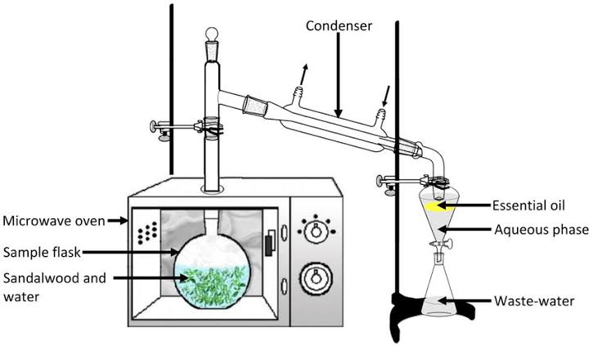

**Figure 7 :** Schéma de la technique d’hydrodistillation assistée par micro-ondes HD-MO

* Microwave water steam training

Steam training assisted by microwave (MWSD), developed by Sahraoui et al.(2008), is based on the principle of steam training, with the only difference that the column containing the plant material is placed in a microwave oven, while the rest of the device remains outside (Figure 8).Tested on the extraction of lavender essential oils, this process has reduced the extraction time by 30 to 6 minutes compared to the classic method.

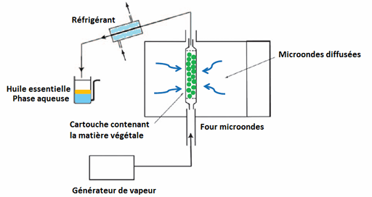

**Figure 8 :** Schéma du dispositif d'entraînement à la vapeur assisté par microondes

The analysis revealed an identical composition of the oils obtained by the two techniques, with a faster opening of the glands containing the essential oil under the effect of microwaves, explaining time saving (Sahraoui et al. 2008).It has the advantage of being more effective than hydrodistillation in the limitation of hydrolysis phenomena of essential oil and lies in the lowering of the distillation temperature, which avoids the decomposition of oil obtained.

I.2.6.3 Extraction by Soxhlet

This technique is made for a device called the Soxhlet (Figure 9).It consists in passing a flow descending of fresh solvent.The solvent affecting plant material, remains fresh because it is distilled in the heated tank where it is collected rich in plant matters after extraction.Going up and passing through the refrigerant, the solvent condenses and falls on the bed of plant material (Lucchesie, M. E. 2005).

**Figure 9 :** Schéma de l'appareil de Soxhlet

The separation of the extract solvent is made using the device called the rotary evaporator.In this device we make a vacuum evaporation using a vacuum pump with a control valve.During evaporation the ball is rotated and plunged into a heated liquid bath.The device has a refrigerant with a condensate balloon.The balloon rotation creates a larger and renewed exchange surface, therefore making it possible to carry out a rapid evaporation.(Penchev, P. I. 2010).

I.2.6.4 Ultrasonic extraction

The plant material is immersed in a solvent and subject to the action of ultrasound.The sound waves cause mechanical vibrations in the environment through a succession of expansion and compression phases (Figure 10).Bubbles are thus formed (cavitation phenomenon).In the vicinity of the cell walls, these bubbles are deflated.This produces ultra-rapid micro-games of liquid which cause the destruction of these walls and lead to the release of the molecules sought in the environment.

**Figure 10 :** Bain à ultrasons

A solvent elimination step is necessary to recover essential oil.Several research has been carried out on the extraction of essential oils by ultrasound by using laboratory equipment (Chemat, S. et al. 2003).

I.2.7 Analysis methods

I.2.7.1 UV-visible spectroscopy analysis

The molecular absorption spectroscopy is based on the measurement of the absorbance transmutant has solutions contained in transparent cells with a length of the absorption path equal to the.In general, between the concentration of an absorbent analyst and absorbance, there is a linear relationship which is expressed by the Béer-Lambert equation:

***A = log I0/I = ε. l. C = - log T***

Where: A: designates absorbance.

I0: Intensity of the incident department.

I: intensity of the transmitted radius.

ε: the absorption coefficient which is a constant for an absorbent species and a given transition (L/Mol.cm) (Zerfa, A., Kouchache, K. E. 2015).

I.2.7.2 Analysis by chromatography coupled with GC-MS mass spectrometry

Gaser chromatography coupled with mass spectrometry is today one of the most used techniques in analytical chemistry (Figure 11).The principle of this technique consists in transferring the compounds separated by chromatography to the gas phase by the mobile phase (vector gas) in the mass spectrometer at the level of which, they will be fragmented into variable mass ions whose separation will be according to their mass.The main difficulty encountered during this coupling is due to the big difference in pressure.Indeed, the SM requires a very low pressure level, while the gas chromatography takes place at a higher pressure level.The identification is then carried out by comparison of the retention indices and mass spectra of individualized constituents with those of the reference products contained in computerized libraries containing several thousand spectra (Bendif, H. 2017).

**Figure 11 :** Analyse par chromatographie en phase gazeuse couplée à la spectrométrie de masse (GC-MS)

I.2.7.3 Analysis by high performance liquid chromatography

It is a technique of analytical separation of molecules present in a mixture.Its great precision allows the search for traces.Chromatography in the liquid phase made it possible to carry out analyzes which were not previously possible with the techniques on a thin layer or in the gas phase.This form of chromatography is frequently used in biochemistry and toxicology.

* Principle

The compounds to be separated (solutes) are put into solution in a solvent.This mixture is introduced in the liquid mobile phase (eluent).Depending on the nature of the molecules, they interact more or less with the stationary phase in a tube called chromatographic column.

The mobile phase pushed by a high pressure pump, travels the chromatographic system.This is what has been called liquid chromatography under high pressure

(HPLC).

The mixture to be analyzed is injected and then transported through the chromatographic system.

The solution compounds are then distributed according to their affinity between the mobile phase and the stationary phase.

At the outlet of column thanks to an appropriate detector The different solutes are characterized by a peak.All of the recorded peaks are called chromatogram.The detector signal is amplified and recorded, the oven temperature is maintained constant (Figure 12).

* Field of application

HPLC is used in the detection of multiple residues of quinolone antibiotics, sulfonamide, β-lactamine, macrolide, tetracycline ..., in very varied samples such as milk or muscle tissue.

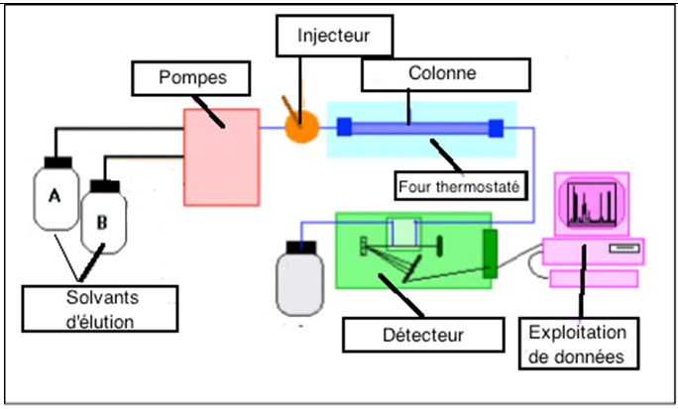

**Figure 12 :** schémaAnalyse par chromatographie liquide à haute performance (CLHP ou HPLC)

I.3 Hydrols

Treated at the start as a waste from the distillation of HES, hydrosols are today increasingly present on the natural products market.Indeed, a hydrosol is an aqueous distillate recovered after the extraction of the HE by Eve.It can be kept for a year in bottles protected from light, at an ambient temperature not exceeding 15 ° C.

The hydrosols contain the same chemical compounds (hydrophilic active ingredients, a very small amount of HE, trace elements and mucilage) as HES with different contents (Piochon, M. 2008).All the compounds contained in the hydrosol are necessarily in its HE.Despite their small proportion in active ingredients, they have certain interesting pharmacological and biological activities: antibacterial (Sagdiç, ô. 2003) and antifungal (Boyraz, N. and ôzcan, M. 2005) activities.They are frequently used in the composition of certain cosmetic products, such as food aromas or as ingredients in kitchen recipes and in the composition of drinks.

I.4 Plant extracts

Plant extracts are preparations obtained from plant parts (leaves, roots, stems, seeds, etc.) using solvents to extract the bioactive compounds.They represent a precious source of natural substances used in various fields such as pharmacology, cosmetics, food and phytotherapy.Among the most commonly used solvents are ethanol and methanol, due to their polarity and their ability to solve a wide range of polar and semi-polished compounds, including flavonoids, alkaloids, phenols and terpenes (Sasidharan, S. et al. 2011).

Ethanolic extract is often a privilege for therapeutic or food applications because of its low toxicity and compliance with health standards.Conversely, methanol, although it allows a more complete extraction of certain phenolic compounds thanks to its higher polarite, is toxic to humans and its use is therefore limited to laboratory studies (Azwanida, N. N. 2015).

The choice of solvent therefore directly influences the yield and the chemical composition of the extract obtained.Many works have shown that extraction efficiency also depends on temperature, extraction time, solvent/plant ratio, and agitation mode (Bimakr et al., 2011; Do et al., 2014).The selection of the optimal solvent is thus based on a compromise between efficiency, selectivity, security and destination of the extract.

Chapter II

Representation of the plant

II.1 Myrrhe resin

II.1.1 Definition

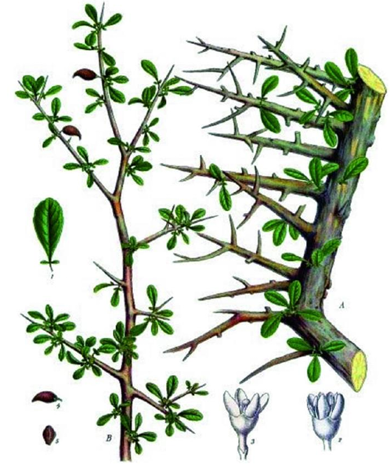

**Figure 13 :** Commiphora myrrhe

II.1.2 Botanical description

Myrrh trees reach approximately 3 to 10 m in height (they are smaller in southern Arabia, Ethiopia, India, Somalia, and are characterized by their branches with the many thorns (nomicos, E.Y.H. 2007). The majority of species have persistent oval leaves imparipen, very small and not very abundant, as for example in C.(Tucker, A.O. 1986), (Demisew, S. 1993).Myrrh secrete a resin-residence when they undergo mechanical, or biotic injuries (Figure 14).

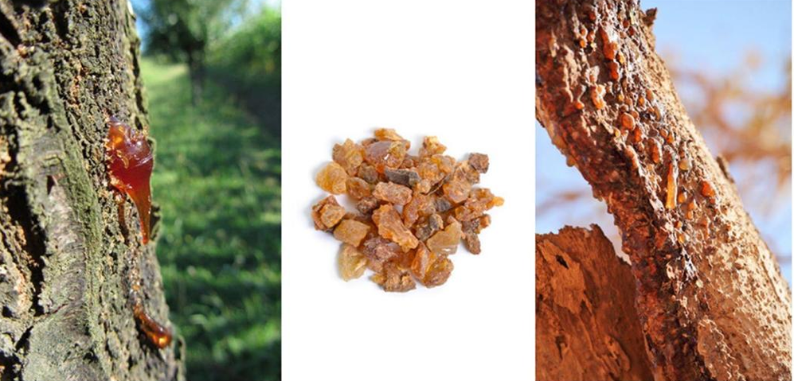

Figure 14: Commiphora Myrrhe, erase in nature

II.1.3 Harvesting and resin trade

In Somalia, there are two periods of "tapping" for myrrh with around 8 incisions per tree at each period.The rest time is approximately 6 months to 2 years, and if this period is not respected, the tree is exposed to higher risk of death (Lemenih, M. 2004).In the past, the main source of myrrhe marketed was that coming from the species C. Erythrea, known as Opecanax.Today, the most common myrrh comes from C. Myrrhe Var.Molmol, and its main producers are located in Somalia and Ethiopia and exported nearly 6000 tonnes/year at the end of the 80s (Al-Harrasi, A. et al., 2019).

II.1.4 Physico-chemical properties of essential oil of myrrh

* Density at 20 ° C: 0.950-1.040.
* Refraction index at 20 ° C: 1,510-1.535.
* Rotatory power at 20 ° C: -150 ° to -50 °.
* Flash point: 111 ° C.
* Aspect: amber liquid to red or brown amber yellow, slightly viscous.
* Volatility: volatile essential oil, but more viscous than most essential oils.
* Solubility: very soluble in oily oils, alcohol as a high basis, organic solvents, but not very soluble in water.

II.1.5 Chemical composition

Myrrh is an oleo gum resin produced by different species of the genus Commiphora.It consists of 3 to 4 % impurities, 7 to 17 % of volatile oils, 25 to 40 % soluble alcohol resins, 57 to 61 % soluble gum in water (Massoud et al. 2001).

Alcohol soluble resins contain:

* Commiphorical and commiphoric acids,
* Commiférine, Heerabomyrrhols, Heeraboreène (Rao et al. 2001),
* Cinnamaldehyde, cadinène, cumalcool, cuminaldehyde, m-crresol, dipensène, lemonène, pinene, sesquiterpenes, furanosequiterpene, herabolène, terpenes,
* Alcohols, α-camorane, myrcene, z-guggulsterol, aldehydes I, II, III, guggulsterol.

Water soluble gums mainly contain:

* Galactose, arabinosis, 4-o-methylglucuronic acid, xylose,
* Acid polysaccharides (Bisset and Wichtl. 1994),
* Proteins (18-20 %) (Leung, L. 1980).

The volatile fraction of myrrh is rich in:

* Furano-Sesquiterpénoids (Elemental structures, Eudesmane, Guaiane, Runcates),
* Aromatic compounds responsible for its characteristic odor (Bruneton, J. 2009),
* Bioactive constituents such as furanodiene, curzérene and furanoeudesma-1,3-Diene, which contribute to its analgesic properties (Dolara, P. et al. 1996).

After the results found in Table 2 (Ljaljević Grbić, M. et al. 2018): "Myrrh essential oil contains several dominant compounds.Furanoeudesma-1,3-dène is the main constituent, representing 17.65 %of its composition, followed by curzerne at 12.97 %, and β-elemene at 12.70 %.We also find germacrene B at 12.15 %, germacrene D at 9.13 %, German has 5.87 %, and finally linden at 5.34 %.These elements contribute to the aromatic and therapeutic properties of essential oil.(Figure 15).

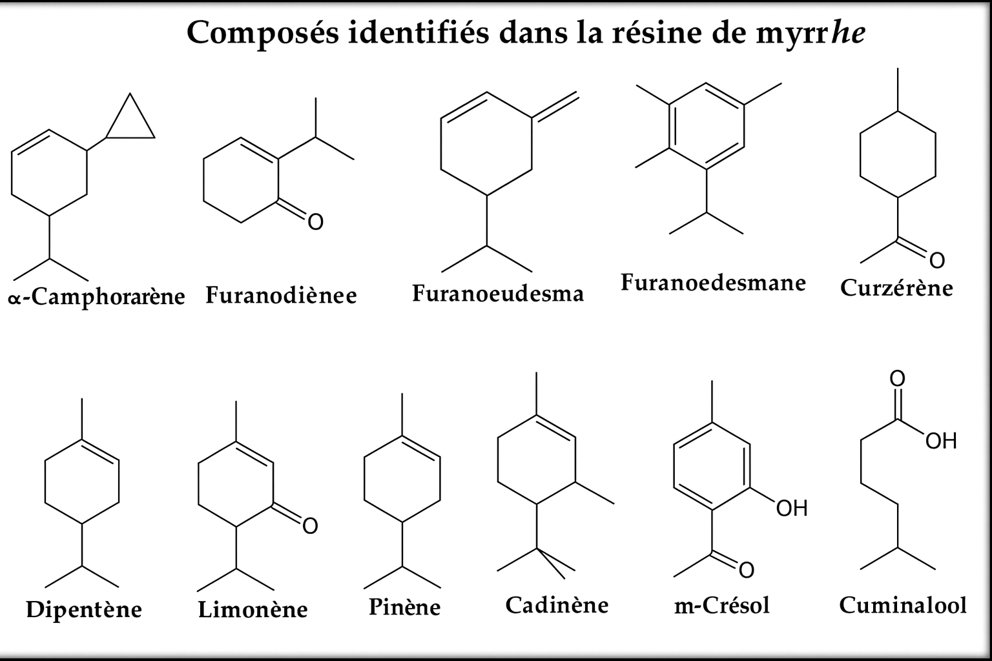

Figure 15: Chemical structures of dominant compounds identified in myrrh essential oil

Table 2: Main constituents identified in myrrh and their approximate percentages (Ljaljević Grbić, M. et al. 2018)

|  |  |
| --- | --- |
| Compound | Percentage (%) |
| Furanoeudesma-1,3-Diene | 17.65 |
| Curzérene | 12.97 |
| β-elemn | 12.70 |
| Germacrene B | 12.15 |
| German germacrene | 9.13 |
| German has | 5.87 |
| Linden | 5.34 |

II.1.6 Therapeutic effect of myrrh biomolecules

One of the most widely recognized and widely used plant products in Saudi Arabia is C. Myrrhe.It was widely used in traditional old medicine as a disinfectant and antibacterial agent, as well as to relieve pain (top, S. et al. 2012).

The plant is commonly seen in Jizan, a city in the Kingdom of Saudi Arabia on the Red Sea coast.C. Myrrhe is an aromatic oleogum resin which is exuded of the rod of C. Myrrhe (Alsharif, K. 2020).It is a powerful antibacterial drug used to treat brucellosis, glandular fever, sinusitis, gingivitis, aphtes and parasitic infections (Abdel-Hay, M. and al. 2002; Abdul-Ghani, R. A. et al. 2009).In addition, volatile oils of myrrh and their raw extracts have shown a variety of biological actions, including cytotoxic, anesthetic, anti-inflammatory, antiviral and antibacterial properties (Tipton, D. et al. 2003; food, V. N. et al. 2021).

Anterior phytochemical studies have indicated that flavonoids, steroids and lignans are frequently present in plant stems.French Triterpesnoids are the main isolated component of the resins of the Commiphora species (Shen, T. et al. 2012; Dekebo, A. et al. 2002).It has been documented that many essential oils of Commiphora species contain monoterpenes, oxygenated sesquiterpenes and sesquiterpenic hydrocarbons (Başer, K. et al. 2003; Rehman, M. E. et al. 2022).The development of safe and environmentally friendly pesticides and microbial struggle are essential for public health.

In order to detect the bioactive ingredients and the allelo chemical compounds of medicinal plant resins, raw plant extracts like C. Myrrhe are studied.In this study, the emphasis was placed on the evaluation of the chemical composition of the methanol extract of resin from the eco-espress of the Arabian desert of C. Myrrhe.This evaluation was carried out by gaseous phase chromatography- mass spectrometry, aimed at identifying the biochemical components responsible for its biological activity.Through in vitro tests, the study evaluated the larvicide efficiency of vegetable resin against Aedes Egypt larvae, while examining its antioxidant and cytotoxic properties.

* Antioxidant

A 2010 study published in the journal Food and Chemical Toxicology revealed that myrrh could protect against liver lesions thanks to its strong antioxidant power.Although this study was carried out on rabbits, its use in humans is also possible.

* Anti-cancer

Myrrh also has anticancer virtues.A 2011 study has shown that myrrhe could reduce the proliferation or replication of human cancer cells.Researchers have found that myrrh inhibit the growth of eight types of cancer cells, especially gynecological cancers.Although additional research is necessary to determine precisely how to use myrrh in cancer treatment, these first research is promising (Siddiqui, M. Z. 2016; Su, S. et al. 2011a).

* Antibacterial and antifungal

Historically, myrrh was used to treat wounds and prevent infections.It can still be used to treat minor skin irritations such as athlete's foot, ringworm and acne.Its antibacterial and antifungal efficiency has been demonstrated against several pathogens (Saha and Ahmed. 2012).A few drops are applied to a clean towel before applying directly to the skin.

* Antiparasitic

A myrrh medication has been developed to treat fasciole, a parasite infecting humans worldwide.This parasite is generally transmitted by ingestion of aquatic algae and other plants.The use of myrrh has reduced the symptoms of infection and reduce the number of eggs in the parasite in the stool (El-Ashram and Suo. 2017).

* Anti-infectious

The HE of Myrrhe is a remarkable anti-infectious, which gives excellent results in the event of gastric infections and Oto-Rhino-Laryngo Logical (Rahman, MM. Et al. 2008).In these indications, it can be used by skin, massage on the spine and the soles of the feet three times a day for four days, or orally after being carefully diluted, for example three drops in fifteen drops of vegetable oil (HV) of nigelle.Immunostimulant, it can both fight infectious agents and stimulate the body to defend itself against pathogenic microorganisms.

* Analgesic and anti-inflammatory

Sesquiterpenes give the HE of bitter Myrrh very interesting analgesic properties (SU, S. et al. 2011b).Some traditional African medicines have long integrated it as an oral antalgic.It can be applied in local massage in the treatment of rheumatism and muscle disorders, but also in mouthwash to relieve oral problems.

II.1.7 Other uses

Myrrh is recognized for its medicinal and therapeutic properties.It was used in China to treat skin problems from the Kaibao era in 973 AD, India in Ayurvedic medicine, and by Romans to treat worms, abdominal pain and dental problems.In Chinese medicine, myrrh (C. Opobalsamum and C. Myrrha) was used to treat oral ulcers, pain, inflammatory diseases, blood disorders and arthritis.The Guggul (C. Mukul) has also been used in Ayurvedic medicine for 3000 years before J.-C. to deal with obesity problems (Shen, T. et al. 2012).

It was approved by the FDA (Food and Drug Administration) as an flavoring and self -seasoning agent and as a conservation agent in food and drinks (Shalaby and Hamouda. 2014).Recently, products derived from myrrh have aroused increasing interest as therapeutic products and food supplements because of their various beneficial properties, in particular antiviral, anti-obesity, anticancer, hepato protectors and hypoglycemic (Orabi, S. H. and al. 2020) Commiphora Myrrha L. and its derivative products were used to treat theInfections, inflammatory diseases, obesity.Fractures and arthritis.Myrrh in traditional oriental medicine has been used to improve wound care, joint pain, gastric dysfunction and burns (Shen, T. et al. 2012).

The HE of Myrrhe is part of the group of HES so -called spiritual, alongside the Hes of incense and Nard from the Himalayas reputed to raise the mind.It is therefore often used to create an atmosphere conducive to meditation, makes it possible to forget its hassles and anxieties, and to harmonize the nervous system.It reduces all kinds of mental disorders, such as anxiety, fatigue, phobias, depression or overwork.The HE of bitter Myrrhe is also used in palliative care units to allow patients to go calmly.It also has the reputation of being the HE of acceptance of suffering.

II.1.8 Toxicological data of the essential oil of myrrh

Despite the beneficial activities of essential oils, they can be more or less toxic, either in situ (irritation, allergic and photo-toxic reaction), or at the level of an organ (neurotoxicity, hepatotoxicity, nephrotoxicity ... etc.).It is necessary to assess the potential danger, which they are likely to represent at a certain level of exposure in order to avoid any risks.

Myrrh oil being one of the most common uses in topical application, people with sensitive skin should be careful.Myrrh can cause dermatitis, or skin inflammation, in some people.Always test the oil on a small area before applying it all over the skin to ensure the lack of allergic reaction.This discovery was reported in a study published in Contact dermatitis.

* In case of ingestion, myrrh can cause stomach aches and diarrhea.Although generally without gravity, chronic diarrhea can cause dehydration.It is therefore advisable to stop its use in the event of gastrointestinal disorders.
* Pregnant women should avoid taking myrrh because it can increase uterine contractions.
* Another potential side effect of myrrh is cardiac irregularity and the drop in blood pressure, although this is mainly observed in high doses, greater than 2 to 4 grams per day.Anyone with a heart problem should consult a doctor before using myrrh oil.According to a study published in the review Phytotherapy Research (Izzo and Ernst, 2009).
* Myrrh can reduce blood sugar;It is therefore not recommended for diabetic people or suffering from other glycemic disorders.Due to her interaction with blood sugar, she is also not recommended for people who have to undergo surgery.It is advisable to stop its use at least two weeks before the intervention (Bone and Mills, 2013).
* Myrrh essential oil is not recommended for people taking anticoagulants like warfarin, as it could interact with this medication.It is also not recommended for people under antidiabetic treatment, due to the risk of drug interaction (Izzo and Ernst, 2009).

Chapter III

Materials and operating conditions

This work aims to extract and enhance the bioactive compounds present in the myrrhe resin (C. Myrrhe) by comparing two methods: HD and HD-MO, after a simple grinding (BS) and cryogenic grinding (BC) of the raw material.

The study aims to assess the yield and the extraction kinetics of each method, in order to identify the most effective operating conditions.The extracts obtained were then analyzed by GC-MS for volatile compounds and by HPLC for heavy fractions.

Finally, in vitro and in vivo tests were carried out to assess the biological activities of HEs and extracts.

This work contributes to a better understanding of the influence of extraction techniques on the quality and organic activity of myrrh extracts.

* Vegetable matter

The plant material used in this study was acquired from a herbalist located in Semmar (Algiers).According to the information provided by the seller, its origin is assigned to Yemen (Figure 16).

**Figure** **16 :** La matière végétale

III.1 Material and extraction method

The extraction was carried out at the Master's Laboratory of the Faculty of Chemistry, USTHB.

As part of this experimental work, three extraction methods have been implemented with two types of grinding: simple (BS) and cryogenic (BC) in order to isolate compounds of interest from the Myrrhe resin (Commiphora Myrrha).This is classic hydrodistillation, hydrodistillation assisted by microwave (MAHD), and extraction by Soxhlet.Each method has been chosen according to the chemical nature of targeted compounds, as well as their volatility, polarity and thermal sensitivity

III.1.1 Classic hydristillation

* Principle

This method consists in heating a heterogeneous mixture of water and resin to the boil to form a heteroazéotrope whose vapors cause volatile compounds.These vapors then condenses in a refrigerant and separate by decantation in an aqueous phase (aromatic water) and an organic phase (essential oil).

* Procedure

In a one liter ball, 150 g of crushed myrrhe resin are introduced, followed by 750 ml of distilled water, making sure not to fully fill the ball in order to avoid any overflow during boiling.The mixture is then brought to a boil using a bally heater (Figure 17).The generated water vapor leads to the fragrant molecules released by the resin.These vapors go through a column, then are condensed in a refrigerant.The condensate is collected drip in a decan bulb, where the separation of the phases takes place by difference in density.At the end of distillation, two phases are formed:

* Organic phase: oily and very fragrant, called essential oil, containing the majority of volatile compounds.
* Aqueous phase: slightly fragrant, called aromatic water, containing a small amount of fragrant compounds.

The essential oil, being less dense than water, is recovered by decantation.

**Figure** **17 :** Montage d’hydrodistillation classique (HD) pour l’extraction de l’huile essentielle de résine de myrrhe

III.1.2 Hydrodistillation assisted by microwave

* Principle

Microwaves are selectively absorbed by the water contained in the resin, causing rapid volumetric heating and the rupture of cell walls.Volatile compounds are then released more quickly, which significantly reduces the extraction time and energy consumption compared to the conventional technique.

* Procedure

A mixture composed of 150 g of crushed myrrhe resin and 750 ml of distilled water was introduced into a round ball, then placed in a modified microwave oven used as a heating source.The distillation system includes a reflux refrigerant connected to a decanting bulb (Figure 18).Microwave heating (600/800 W) has enabled water vaporization and volatile compounds.The condensed vapors were collected drop by drop, allowing the separation of two phases:

* An organic phase (essential oil),
* An aqueous phase (aromatic water).

The essential oil was then recovered by decantation.

**Figure 18** : Montage d’hydrodistillation assistée par micro-ondes (HD-MO) pour l’extraction de l’huile essentielle de résine de myrrhe

III.1.3 Volatile solvent extraction

* Soxhlet extraction
* Principle

Soxhlet extraction is based on a repeated solid liquid extraction process.The solvent (hexane) is brought to a boil in a heated balloon, then its vapors condense in a refrigerant located above the cartridge containing the solid sample (crushed plant material).

The condensed solvent falls drop on the sample, allowing the extraction of lipophilic compounds.When the level of the solvent reaches the siphon, it automatically empties in the distillation ball, causing the extracted compounds.This cycle is repeated continuously, which allows complete extraction without adding fresh solvent to each cycle.

* Procedure

Place 150g of myrrhe resin crushed in a cartridge in filter paper (cellulose), closed.Insert this cartridge into the body of the Soxhlet extractor mounted on a 1l round ball containing 250ml of ethanol at 96%.Connect a water refrigerant at the top of the device.

Heat the ball to bring the ethanol to a boil (78.37 ° C) (Figure19).Ethanol vapors go up, condense in the refrigerant and fall on the cartridge containing the resin.

The hot solvent percola through the resin, dissolving the lipophilic compounds.Once the extractor's room is filled, the automatic siphon is triggered, returning the enriched solvent (Miscella) to the ball.This cycle is repeated automatically for about 1:30 min, ensuring complete extraction of interest compounds.

After the end of the extraction, let the system cool.Remove the ball containing the Miscella.Eliminate ethanol by vacuum evaporation using a rotary evaporator, thus obtaining the oily extract from the myrrh resin.

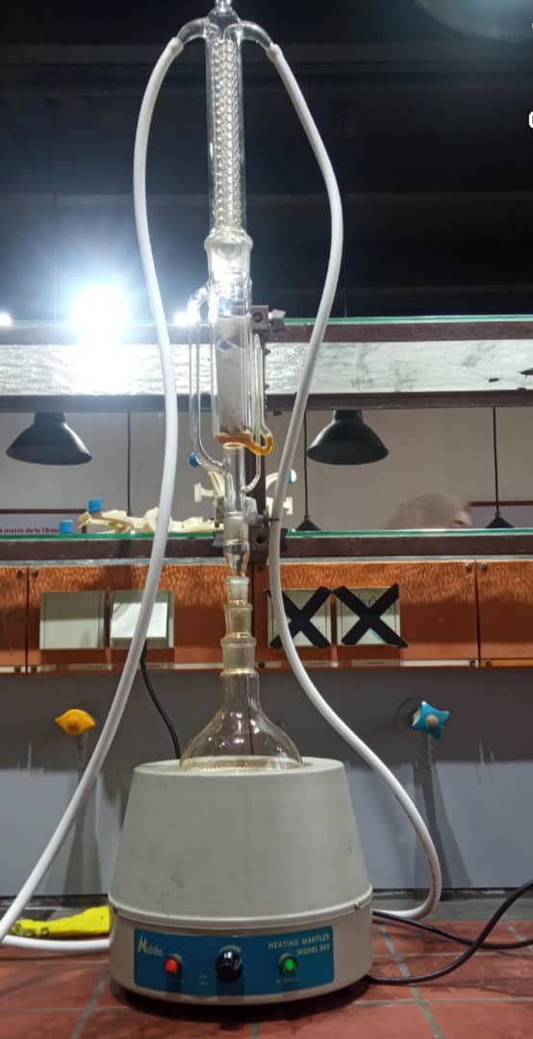

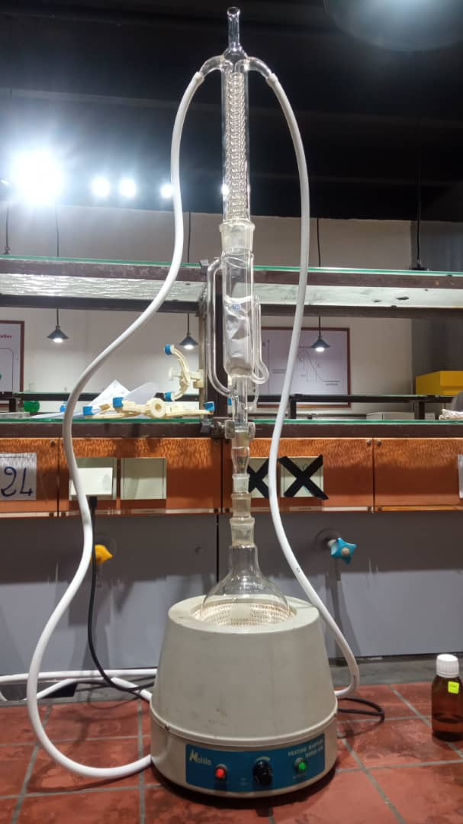

**Figure 19 :** Montage expérimental de Soxhlet utilisé pour l’extraction des composés bioactifs

* Solvent evaporation

After extraction, the oil and the solvent mixed (liquid-liquid mixture) in a single phase.To separate them, you must first evaporate the ethanol solvent.For this operation, rotary evaporation or the rotary evaporator is used (Figure 20).After this operation, the extract obtained is weighed.

**Figure 20** : Dispositif expérimental de l’évaporateur rotatif (évaporateur rotatif) utilisé pour la concentration sous vide des extraits

After extraction and recovery, the essential oil and the extract obtained by the different extraction methods were stored in sterile glass bottles.These were then placed in the refrigerator at a temperature of 4 ° C, in order to preserve the stability of volatile compounds until they are used for phytochemical analyzes and biological activity tests.

III.2 Operating analysis conditions

III.2.1 Operating conditions for the analysis of essential oils by gas chromatography coupled with mass spectrometry (GC-MS)

Essential oils are complex mixtures made up of organic compounds with a wide variety of carbon structures and chemical functions.Their analysis generally requires in -depth work of separation and identification.Gaser chromatography coupled with mass spectrometry (GC-MS) is the most appropriate technique for this type of analysis, due to its sensitivity, high resolution and its ability to identify the compounds present even in the state of traces (Figure 21).

* The analysis was carried out using a gas phase chromatography (GC) coupled with a mass spectrometer (MS), depending on the following parameters:

For gaseous chromatography, an HP -5 MS type hair column (Apolar Stationary phase 5% - phenyl and 95% - METHYLPOLYSILOXANE) was used, containing an apolar stationary phase.This column has the following dimensions: 30 meters in length, an internal diameter of 250 µm and a film thickness of 0.25 µm.Helium (HE) was used as a vector gas, with a flow rate fixed at 1.5 ml/min.

The sample injection was carried out in Splitless mode, with an injection temperature maintained at 250 ° C.A volume of 25 µl has been injected, corresponding to a solution of essential oil diluted in 1 ml of 99.99 %pure methanol.

The oven temperature program was defined as follows: a first support phase at 250 ° C for 10 minutes, followed by a rise in temperature at a rate of 4 ° C/min until reaching 60 ° C, temperature maintained for 8 minutes.

Regarding mass spectrometry, the analysis was carried out in scanning mode (scan), with ionization by electronic impact at 70 EV.The temperature of the ion source has been set at 230 ° C, that of the quadriple at 150 ° C, and the temperature of the auxiliary element at 300 ° C.

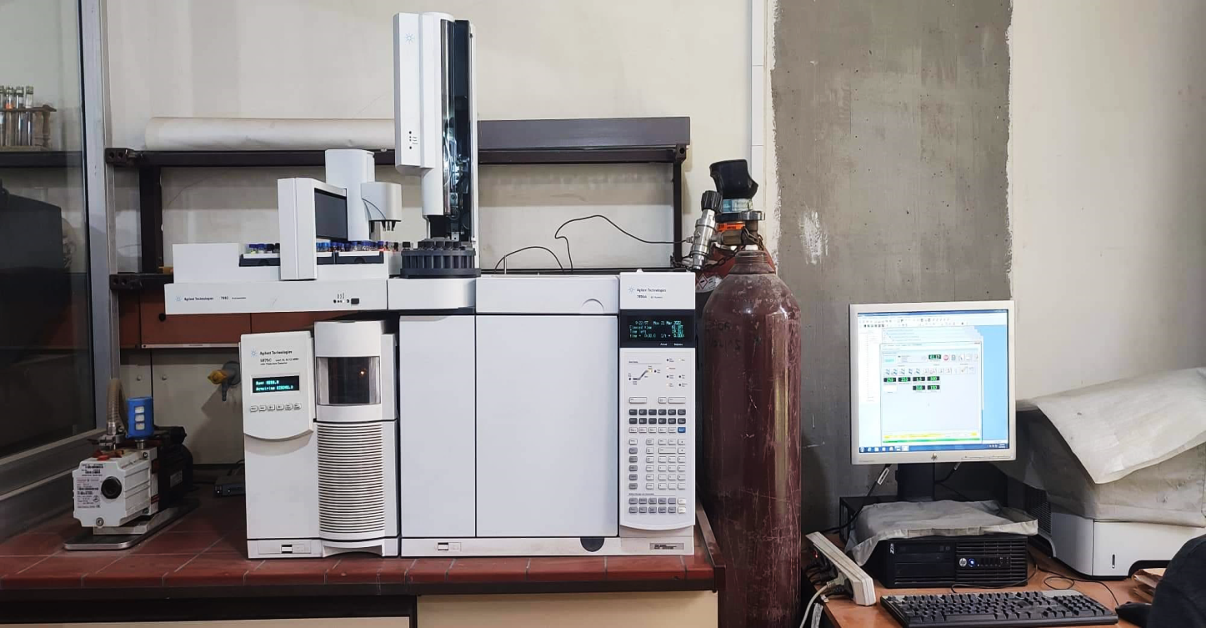

**Figure 21 :** Appareillage GC/MS, type AG Technologies : GC 790A, Auto sampler 7693, SM

5975C Inert XL EI/CI MSD

* Determination and identification of compounds by GC-MS

The identification of the compounds present in the essential oil was carried out from the chromatograms obtained by GC-MS, based mainly on the retention indices (RI).These clues were calculated according to the Van Den Dool and Kratz equation, allowing normalization of the retention time for volatile compounds compared to a series of N-Paraffinic alcanes analyzed under the same conditions.

The equation used is as follows:

$$RI=100n+100×\left( \frac{ tri-trn}{tr(n+1)-trn} \right)$$

With :

* RI: retention index of the unknown compound,
* N: Number of carbon atoms from the elected N-Alcane just before the unknown compound,
* Sorting: retention time of the unknown compound,
* TRN: preceding n-alcane retention time,
* TR (N+1): retention time of the following n-alcana.

This method allows a more reliable and reproducible comparison of volatile compounds, regardless of minimal variations in chromatographic conditions.The identification of the constituents was then confirmed by two additional approaches:

1. Comparison of experimental retention indices with those postponed in the literature.
2. Analysis of mass spectra, compared to reference libraries (such as NIST or Wiley), making it possible to identify the compounds on the basis of their characteristic fragmentation.

All of these data (retention time, retention index, and mass spectrum) allowed a reliable characterization of the main volatile compounds present in the sample analyzed.

III.2.2 Operating conditions of analysis by high performance liquid chromatography (HPLC)

HPLC is particularly suitable for the analysis of polar and non -volatile compounds present in myrrh resin extracts.Thanks to its high performance in separation and its compatibility with the heat -sensitive compounds, this technique allows fine identification of secondary metabolites, such as flavonoids, phenolic acids and other bioactive compounds.

* The experimental conditions applied during HPLC analysis:

The ethanolic extract was dissolved in 15ml of acidified distilled water (pH = 2), then subject to three successive extractions using a mixture of 15ml of diethyl ether and ethyl acetate (1: 1 V/V).After extraction, the organic phase was recovered and the organic solvents eliminated using a rotary evaporator.The residue was dissolved in a hydro-methanolic extract (30:70 V/V) before being injected into the HPLC.

Sixteen phenolic stacks were analyzed by HPLC.The diluted samples from the Myrrh resin were injected into the HPLC.The separation of the phenolic compounds was carried out using an HPLC system agilent series 1260 equipped with a quaternary pump with degaseur associated with an automatic thermostatic sampler.

Control of the instrument and data analysis were carried out using the AGULET HPLC CHEMSTATION software.The separation of the phenolic compounds was carried out on a C18 column with opposite phase (5 µm, 150 mm × 3 mm in internal diameter) thermostatized at 35 ° C per HPLC equipped with a Diode bar detector.The solvent system used was an A gradient (water + 0.1 % formic acid) and B (acetonitrile + 0.1 % formic acid).The solvent flow was 1.5 ml/min.The sample injection volume was 20 µl.The election gradient was as follows: 0-5 % B (0-10 min);5-17 % B (10-18 min);17-25 % B (18-33 min);25-100 % B (33-48 min);100-5 % B (48-51 min).The detection and identification of phenolic compounds were carried out at 254.4 nm and 280.4 Nm using a Diode bar detector (DAD);Identification of peaks was obtained by comparing the retention time and the UV spectra of the chromatogram with those of pure stallions.

* Determination and identification of HPLC compounds

High performance liquid chromatography (HPLC) is an analytical technique of choice for the separation, detection and identification of non -volatile and thermosensible compounds present in the myrrh resin.It makes it possible to split the complex mixtures of plant extracts depending on the differences in polarity, molecular size or chemical affinity with the stationary phase of the chromatographic column.The identification of the main bioactive compounds is carried out by comparison of the retention times obtained with those of authentic standards, as well as by spectral analysis via a UV-visible detector, generally adjusted to a wavelength adapted to the functional groups present (280.4NM and 254.4NM).In addition, the data obtained is faced with that of the literature to confirm the nature of the identified compounds.

This method ensures a precise and reliable characterization of the key secondary metabolites of myrrh, thus contributing to a better understanding of its pharmacological properties.

III.3 activities in vitro

This study was carried out in microbiology and physico-chemical laboratories: Saidal Dar El-Beida production site.It was divided into three parts (antimicrobial, anti-inflammatory and antioxidant).

III.3.1.Antimicrobial

Antibacterial and antifungal activity means the capacity of a compound to inhibit or eliminate both bacteria and pathogenic fungi.The myrrh resin (C. Myrrhe), widely recognized for its therapeutic virtues, is particularly studied for its antimicrobial properties against bacterial and fungal pathogens.In this context, the HES and myrrh extracts were assessed on different bacterial and fungal strains using standard microbiological methods.

In this study, myrrhe extracts were prepared in the form of solutions to defined concentrations using DMSO, while the essential oil was used pure, also dissolved in the DMSO for antibacterial and antifungal activity tests.

* The principle

The process consists in disseminating discs permeated by the extract to be analyzed on a solid medium, where a test germ has been previously sown (Figure 22).Once the diffusion has been reached, an inhibition zone appears around the discs, indicating the effect of the extract on bacterial growth.The measurement of the diameter of this area makes it possible to assess the sensitivity of the microorganism tested and the intensity of the antimicrobial activity of the sample, using a scale of diameters of the inhibition zones.

Figure 22: Antimicrobial activity by the discharge method on disk on nutrients

The referenced microbial strains consist of three bacteria and three fungal strains.They come from the unity of Saidal - Dar El Beïda of Algiers (Table 3).

Table 3: The microbial strains tested as well as their references

|  |  |  |  |  |  |
| --- | --- | --- | --- | --- | --- |
| Microbial Strain | | | ATCC | Gram | Official clsi standards |
| Escherichia coli | | | #error# | #error# |  |
|  | | |  |  |  |
| Staphylococcus aureus | | | #error# | #error# | Resistant: D <6mm |
|  | | |  |  |
| Pseudomonas aeruginosa | | | #error# | #error# | Sensitive: 7mm <14mm  Very sensitive: 15mm <20mm |
|  | | |  |  |
| Bacillus spizizenii | | | #error# |  | Extremely Sensitive: D> 21mm |
|  | | |  |  |
| Candida albicans | | | #error# |  |  |
|  | | |  |  |  |
|  |  |

* Procedure

The evaluation of the extract antimicrobial activity was carried out according to the solid environmental method.This approach first consists of seeding the microbial germ targets on a sterile agar, ensuring a homogeneous distribution of microorganisms.Sterile paper discs, previously impregnated with the extract to be tested, are then placed on the surface of the inoculated medium.

After incubation, the diffuse extract radially around the discs, inhibiting microbial growth if it has an antimicrobial effect.This inhibition is reflected in the appearance of a clear area, free from growth, delimited around each disc.The diameter of this inhibition area, measured in millimeters, quantifies the inhibitory effect of the extract.The more extensive this area, the more significant antimicrobial activity is considered.

* Comparison with witnesses

Negative witnesses: a solvent like DMSO is used to ensure that the effect observed comes from the extract and not from the solvent.

III.3.2 Anti-inflammatory

The assessment of anti-inflammatory activity makes it possible to verify the capacity of an extract to reduce an induced inflammatory reaction.Myrrh resin (C. Myrrhe), traditionally used to relieve pain and inflammation, has been tested in this context using an appropriate biological model.This approach aims to explore its effectiveness in comparison with a standard anti-inflammatory.

* The principle

Inflammation is often associated with the denaturation of proteins.This test assesses the ability of an extract to prevent the denaturation of serum albumin, simulating an anti-inflammatory response.An inhibition of this denaturation reflects a protective effect comparable to that of an anti-inflammatory.

* Experimental protocol

1. Preparation of oil and myrrh extract: in vials, dilue:

* Oil: m he = 0.15g v ethanol = 10ml
* The extract: m extract = 0.15g v ethanol = 10ml

1. Extraction of albumin from egg whites (Figure 23):

* Preparation of the solution: separate the 6 egg whites and place them in a clean container, then add a purified volume of water equivalent to the volume of egg whites.
* Agitation: Shake the solution obtained (egg whites + purified water) for 15 minutes at room temperature to properly mix the two components.
* Adding vinegar: Add 2 to 3 drops of white vinegar for each 100 ml of solution (egg whites + purified water).Vinegar promotes albumin coagulation.
* Centrifugation: centrifugal the solution to 3700 rpm for 15 minutes to separate the different phases (sediment and liquid phase).
* Washing the sediment: Recover the sediment (which contains albumin) and washing it with distilled water to eliminate the remaining impurities.
* Recovery of albumin: After washing, recover the sediment which contains albumin.The latter can be used for other applications.

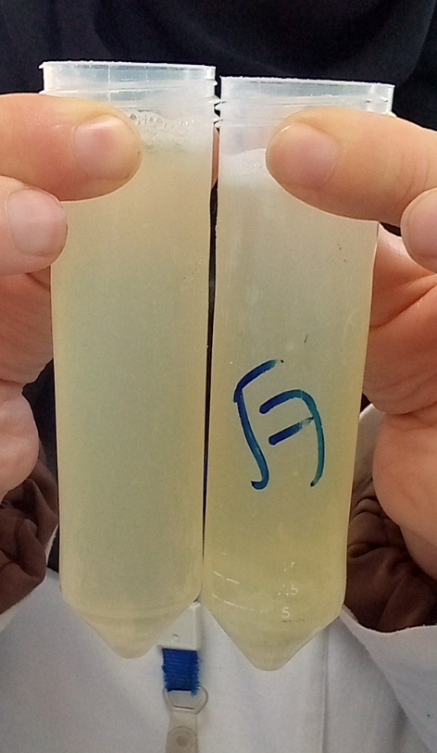

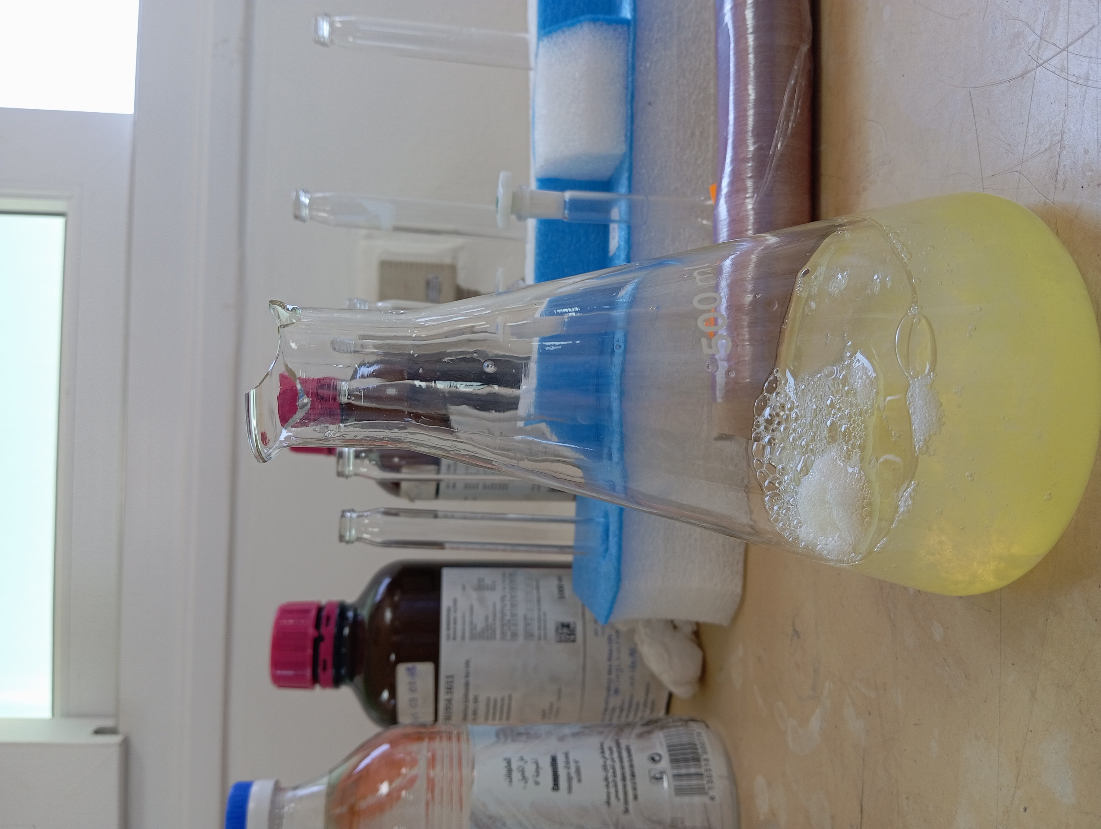

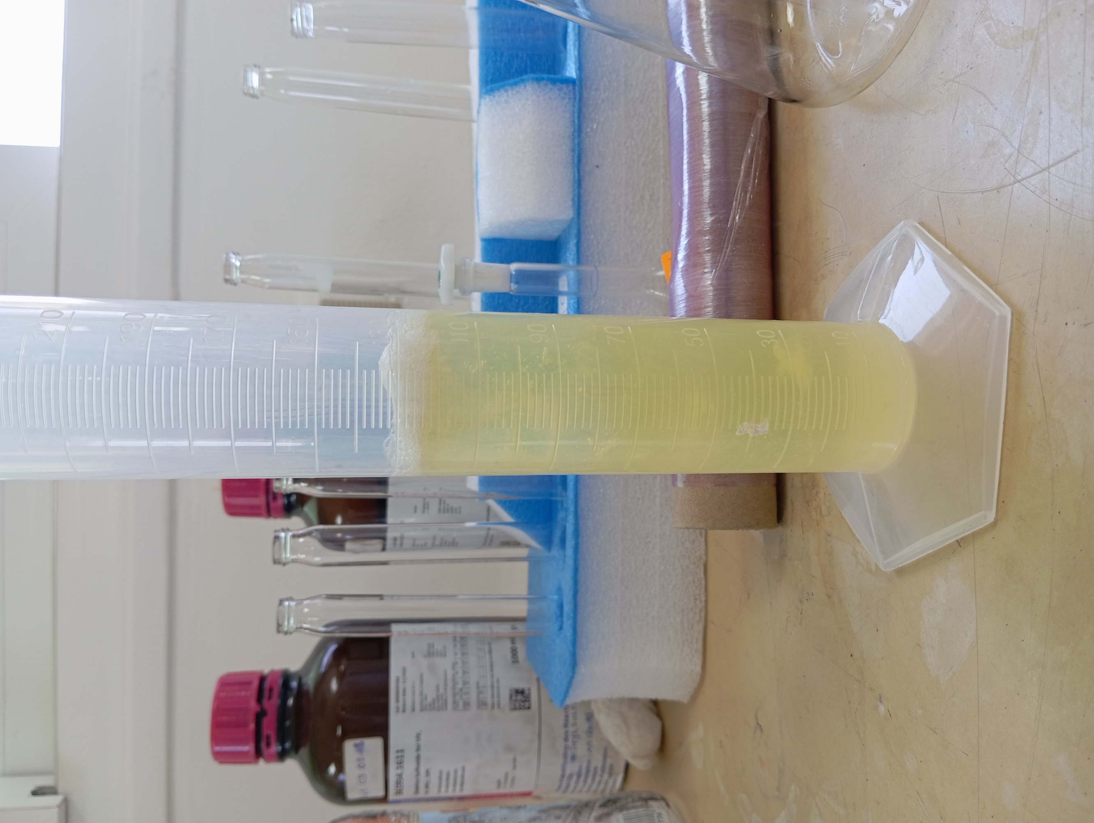



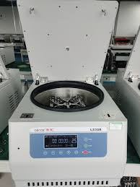

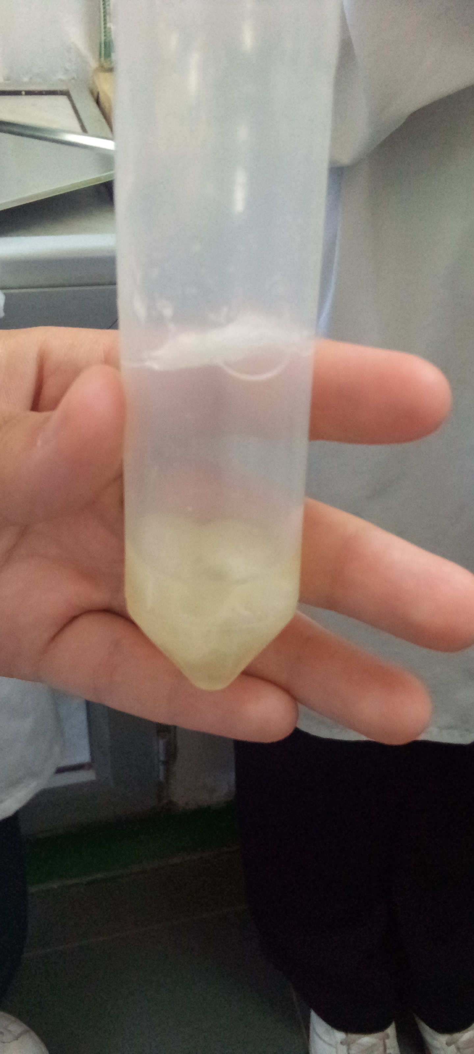

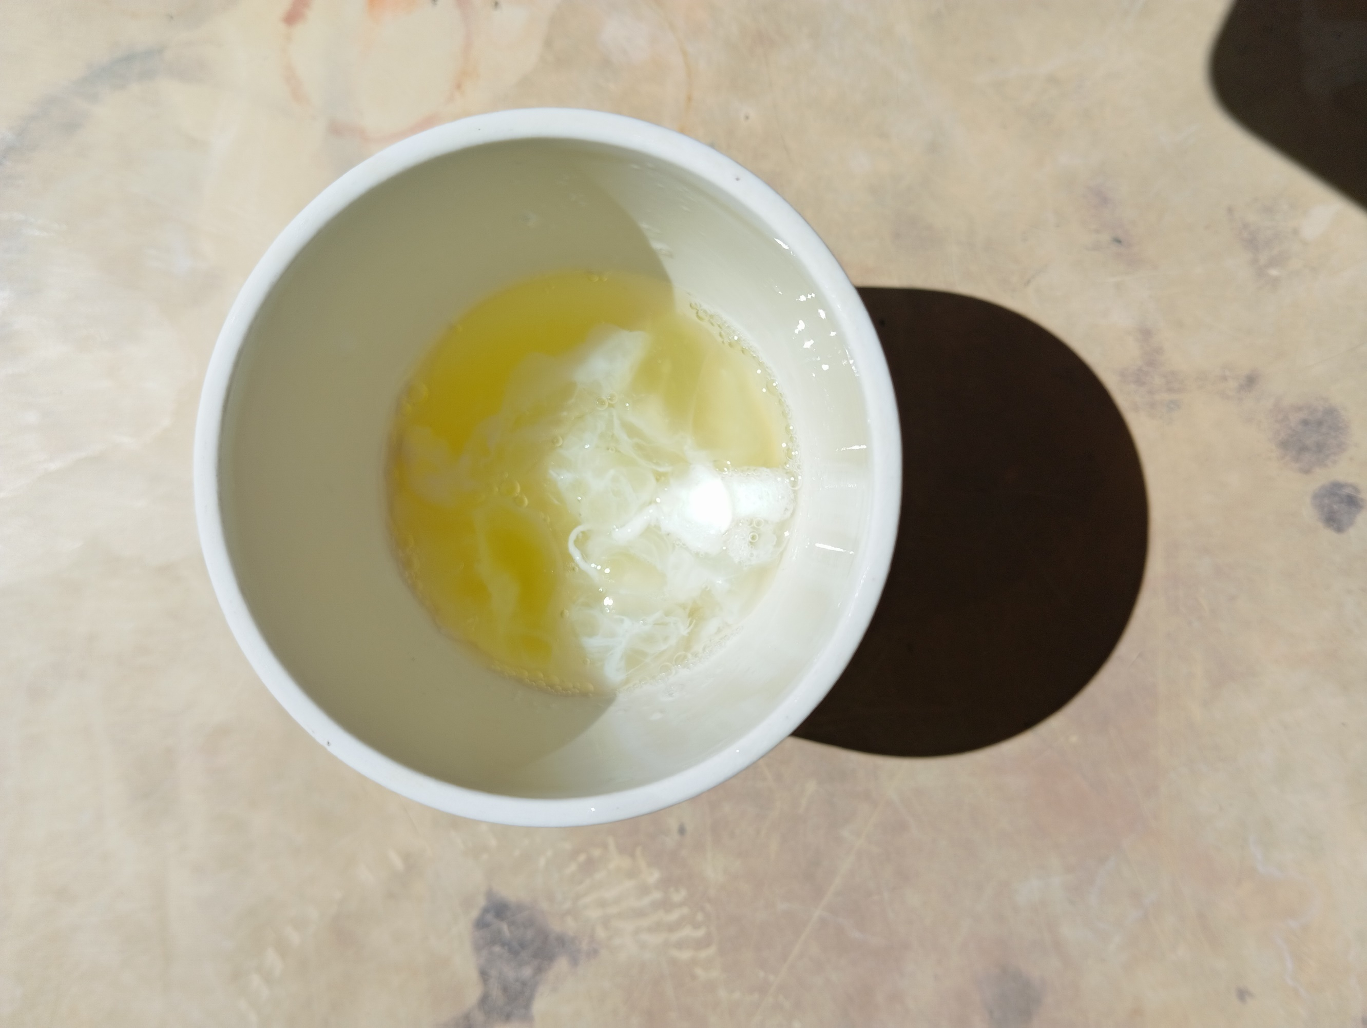

**Figure 23 :** Étapes photographiques de l’extraction de l’albumine à partir des blancs d’œuf

1. Preparation of the albumin 2%solution:

We weigh 2 g of albumin, which we then mix with 100 ml of distilled water.The mixture is agitated for 2 minutes using an agitator.

1. Preparation of reaction mixtures:

* Preparation of tubes: for each essential oil or extract, prepare the following tubes:
* 5 reaction tubes (named A to E for HE and 1 to 5 for extracts),
* 1 witness tube containing only albumin,
* 1 Tube witness without HE or extract.
* Preparation steps:

Tube A: Add 2 ml of ethanol + 2 ml of the HE.→ Shake carefully.

Tube B: Take 2 ml of the A + 2 ml tube solution of ethanol.→ Shake.

Tube C: Take 2 ml of the tube solution B + 2 ml of ethanol.→ Shake.

Tube D: Take 2 ml of the C + 2 ml tube solution.→ Shake.

Tube E: Take 2 ml of the tube solution D + 2 ml of ethanol.→ Shake.

Then take 2 ml from this final solution and throw it away.(We're going to do the same steps for the extract).

* Adding the buffer solution and albumin: in each tube A to E (1 to 5), then add: 2.8 ml of buffer solution + 0.2 ml of albumin solution

1. Induction of denaturation: Heat the tubes in a double boiler at 72 ° C for 5 minutes.
2. Cooling: Let the samples cool at room temperature.
3. Measure: Measure the absorbance at 660 Nm using a UV spectrophotometer.

#### Calculation of inhibition (%):

#### **Inhibition (%) = $\frac{|AContrôle- Aéchantillon| }{AContrôle​}$* 100**

#### 

* Acontrol: absorbance of the negative witness (without extract),
* Sample: absorbance of the tested extract.

Remarks :

* The higher the percentage of inhibition, the more marked the anti-inflammatory effect.
* It is recommended to do triplicate tests to ensure the reliability of the results.

III.3.3 Antioxidant

Antioxidant activity reflects the ability of a compound to neutralize free radicals, responsible for oxidative stress and various cellular disorders.The myrrh resin (C. Myrrhe), rich in phenolic and terpenic compounds, is traditionally used for its protective properties.In this study, its extracts were assessed for their antioxidant potential using an adapted in vitro test.

* Principle of antioxidant activity (DPPH method)

The DPPH test is based on the ability of antioxidants to give an electron or a hydrogen atom to the free radical DPPH • (2.2-diphenyl-1-picrylhydrazyl), thus resulting in its reduction.This reaction causes a change in color of dark purple to pale yellow, measurable by a decrease in absorbance at 517 nm.The greater the drop in absorbance, the higher the antioxidant power of the sample.

* Procedure

1. Preparation of a DPPH solution

The DPPH solution has been prepared in a vial deemed by the solubilization of 4.1 mg of DPPH in 100 ml of ethanol.The vial is covered with aluminum for 30 min (Figure 24).

**Figure 24 :** La solution de DPPH

1. Preparation of a mother solution from HE and extract

To prepare the mother solution, 0.1 g of essential oil (HE) and 0.1 g of extract were weighed with precision, then dissolved in ethanol.The final volume was adjusted to 10 ml using a gauged vial.The final concentration obtained for each mother solution is 10 mg/ml (Figure 25).

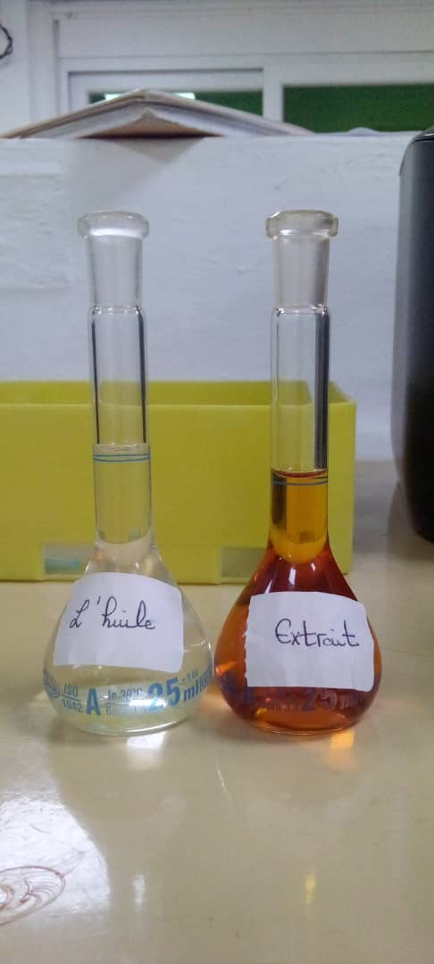

**Figure 25 :** Solutions diluées d’huile essentielle et d’extrait utilisées pour les tests

1. Preparation of dilutions

Dilutions of decreasing concentrations have been prepared from a mother solution of 10mg/ml, in order to obtain the following concentrations intended for antioxidant activity tests: 5mg/ml, 1mg/ml, 0.5mg/ml, 0.1mg/ml, 0.05mg/ml, 0.01mg/ml, 0.005mg/ml,0.001mg/ml and 0.0001 mg/ml (Figure 26).

**Figure 26** : Différentes dilutionspréparer

* The percentage of inhibition is calculated according to the formula below:

1. Reading antioxidant activity results

At 517 nanometers in fact reading by using the visible UV spectrophotometer (Figure 27).

**Figure 27** : Appareil de spectrophotométrie UV utilisé pour les analyses

III.4 Activities in vivo

This in vivo study was carried out within the laboratories of the École normale supérieure (ENS) and focused on the evaluation of the analgesic activity of the experimental formulation.Three complementary tests have been implemented: the tail withdrawal test (Tail-Flick), the heating plate test (Hot Plate) and the torsion test (Writhing Test).

III.4.1 Assessment of the analgesic activity of myrrhe extract

The evaluation of the analgesic activity of myrrh extract was carried out using murine behavioral models recognized for their sensitivity to substances with analgesic potential.Three additional tests were used: the tail withdrawal test (Tail-Flick Test) and the heating plate test (Hot Plate Test) and the torsion test (Writhing Test).These methods make it possible to measure the nociceptive response induced by a thermal stimulus, respectively at the spinal level (medullary reflex) and supraspinal (central pain integration).These models are commonly used in experimental pharmacology to characterize the analgesic effects of natural or synthetic compounds.

has.Preparation of myrrh extract

A quantity of 0.3 g of ethanolic extract of myrrh resin was removed, then incorporated into 0.7 ml of Tween 20 to facilitate dispersion.The mixture was then completed with distilled water until reaching a final volume of 5 ml.The solution was homogenized using a vortex for 10 minutes, until a stable and uniform suspension is obtained, suitable for intraperitoneal administration in mice.The prepared solution is then temporarily stored in an amber bottle, out of light, until its use (Figure 28).

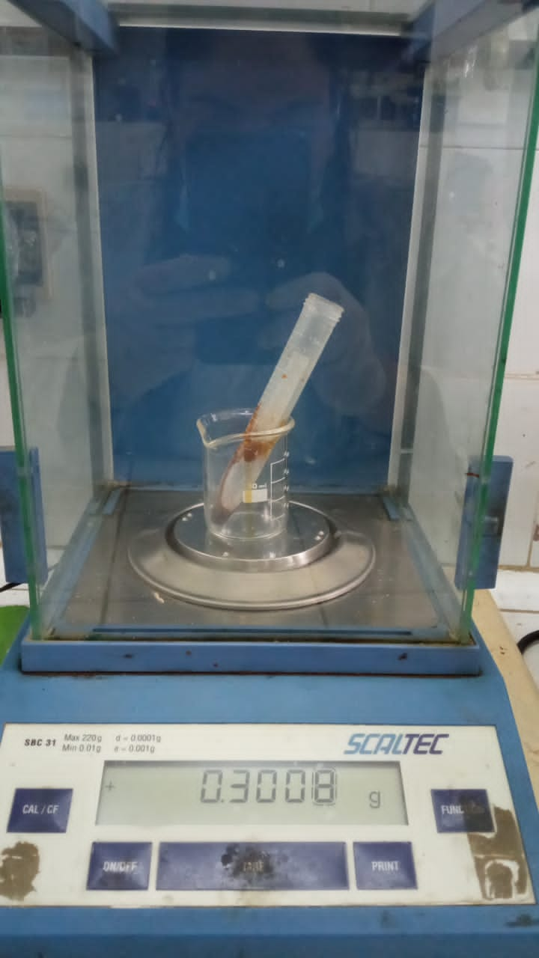

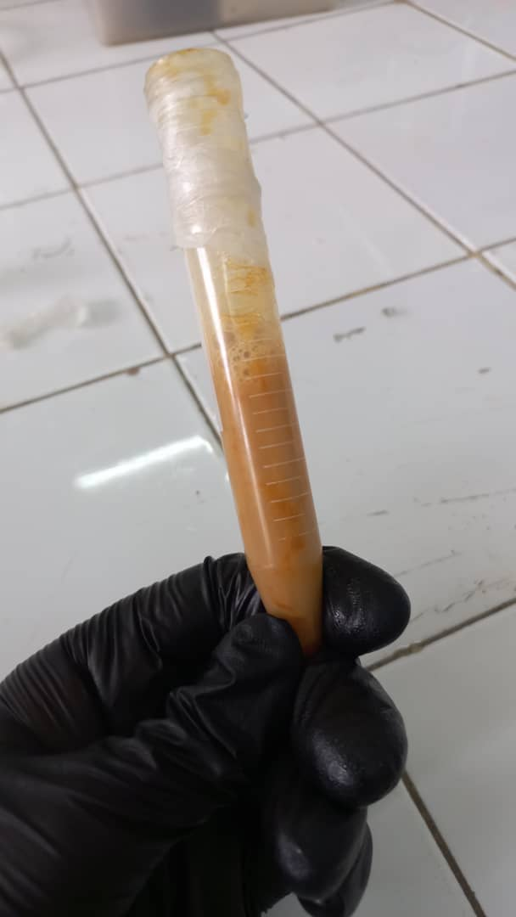

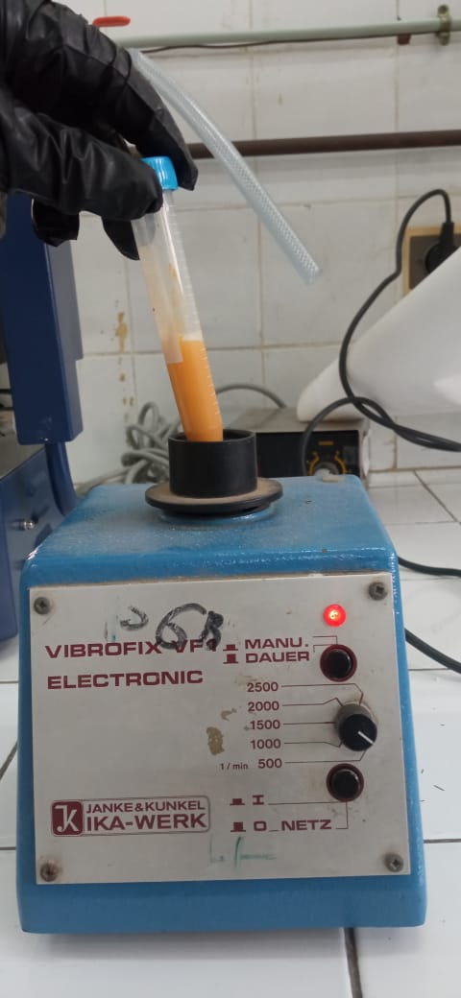

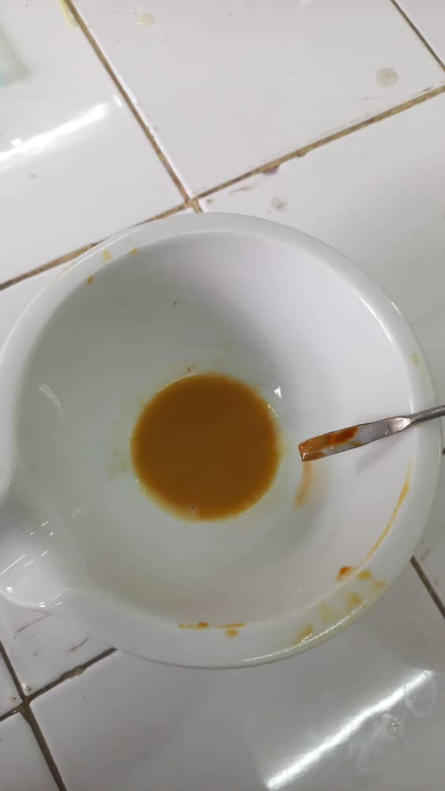

**Figure 28** : Préparation de la solution d’extrait avec Tween 20

b.Adjustment of the dose per weighing of animals

Before the cavage, each mouse was weighed individually using an electronic precision balance (Figure 29).The administered dose (mg/kg) was calculated according to the following formula:

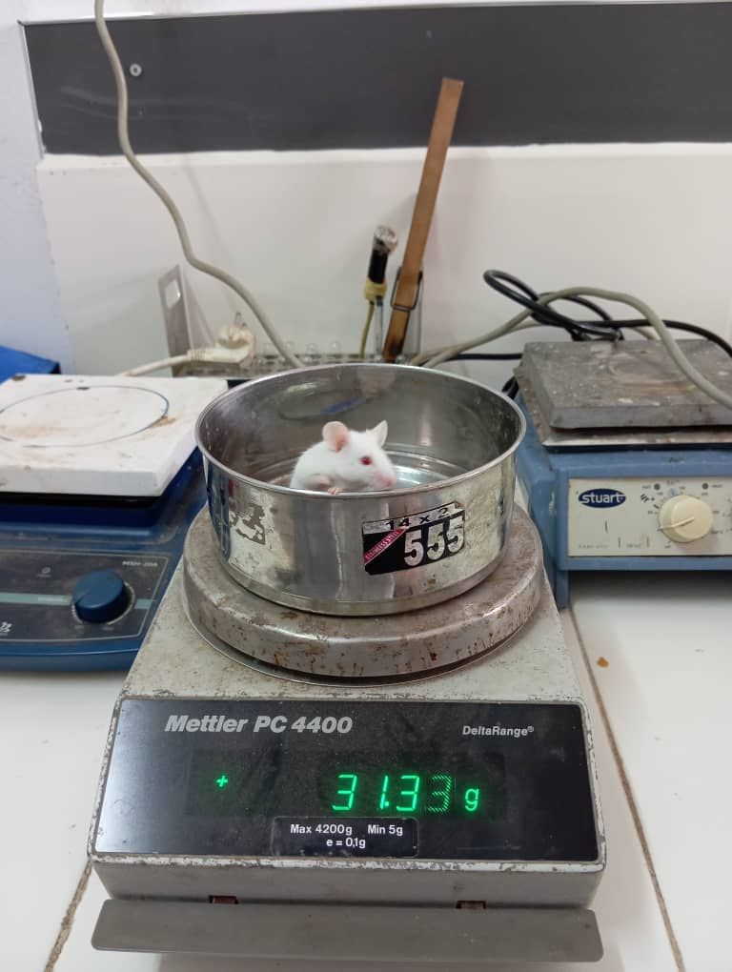

**Figure 29 :** Pesée d’une souris sur une balance électronique

c.Administration by CAVAGE (oral route)

The administration of myrrh extract was carried out by oral route, using the gastric caving technique, commonly used in preclinical pharmacology to reproduce the digestive absorption of natural substances.

* A flexible gastric probe, adapted to the size of the mice, was used to gently introduce the extract solution directly into the stomach (Figure 30).
* The administered volume was calculated according to the individual body weight of each mouse, determined during the weighing phase (see section B).
* Each animal has received a single administration by cavage, made with caution to avoid stress, reflux or false road.
* All of the manipulations were carried out in compliance with the conditions of hygiene, sterility and animal welfare.

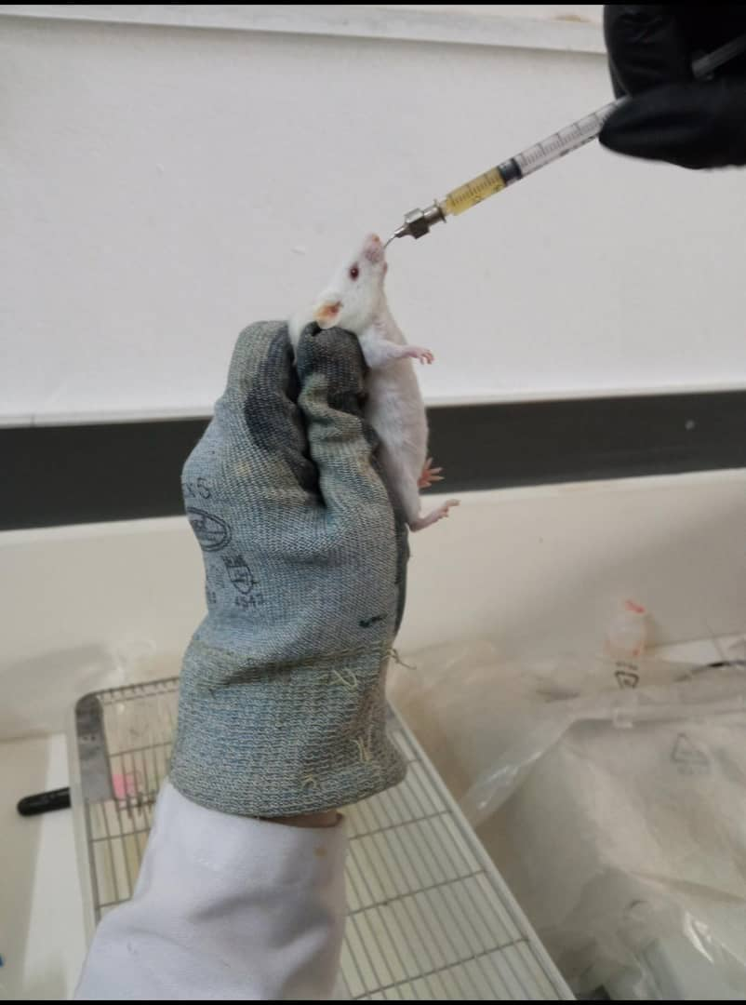

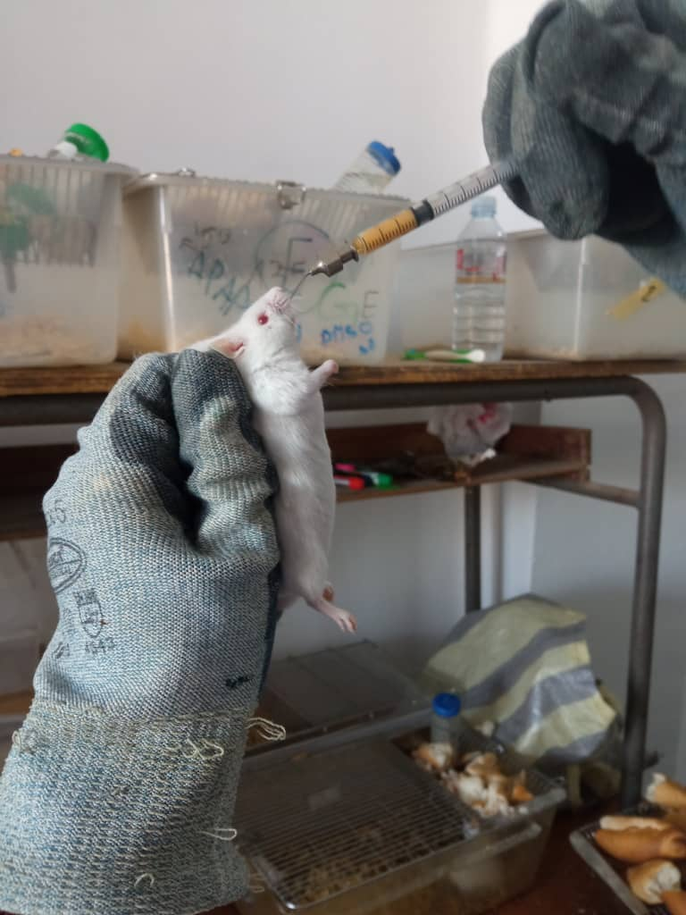

**Figure 30 :** cavage oral d’une souris avec sonde souple, en position verticale

ouce.

1. Post-administration latency period

After the cavage, the animals are returned to their respective cages and observed for a period of 60 minutes, in order to allow the systemic absorption of the myrrh extract before the behavioral tests (Figure 31).

**Figure 31 :** Repos des souris dans leur cage après le cavage

1. Tail withdrawal test (Tail-Flick Test)

The purpose of this test is to assess the acute analgesic effect of myrrh resin by measuring the reflex time to withdraw tail in mice exposed to a harmful thermal stimulus.

* Principle

The tail withdrawal test, or Tail-Flick Test, is a standardized experimental model used to assess the acute nociceptive response of spinal origin in rodent, generally mouse or rat.It is based on the principle according to which exposure of the caudal end to a harmful heat source induces a rapid withdrawal reflex, independent of the upper centers of the nervous system.This withdrawal period constitutes a quantifiable indicator of pain sensitivity and makes it possible to assess the antinocceptive effect of pharmacological substances, in particular these targeting the medullary mechanisms of the transmission of pain.

* Procedure
* Preparation of equipment: A bain-marie is preheated to a controlled temperature between 47 and 49 ° C, ensuring a harmful thermal stimulus without causing irreversible short-term tissue lesions.
* Habitization of the animal: Each mouse is placed individually in a transparent plexiglass tube, designed to restrict the animal's movements while minimizing stress.The device only allows the distal end of the tail to overtake outside the tube (Figure 32).
* Application of the thermal stimulus: Once the animal is properly positioned, the terminal portion of the tail (about 4-4.5 cm) is delicately submerged in the bain-marie.From the moment the tail comes into contact with hot water, a stopwatch is triggered to measure the time (second) put by the animal to remove its tail in response to the thermal stimulus (Figure 33).
* Interpretation and judgment criteria: The observed withdrawal period is noted with precision.A maximum threshold of 35 seconds is generally imposed to avoid any burns or thermal damage to the tail.If no withdrawal movement is observed beyond this period, the test is interrupted immediately, and the tail is removed manually.
* Repetitions and controls: Each measure is carried out at adequate intervals in order to avoid thermal awareness or a conditioned response.Groups control (without treatment) and experimental (treated with the substance to be tested) allow a rigorous comparison of the antinocceptive effect.



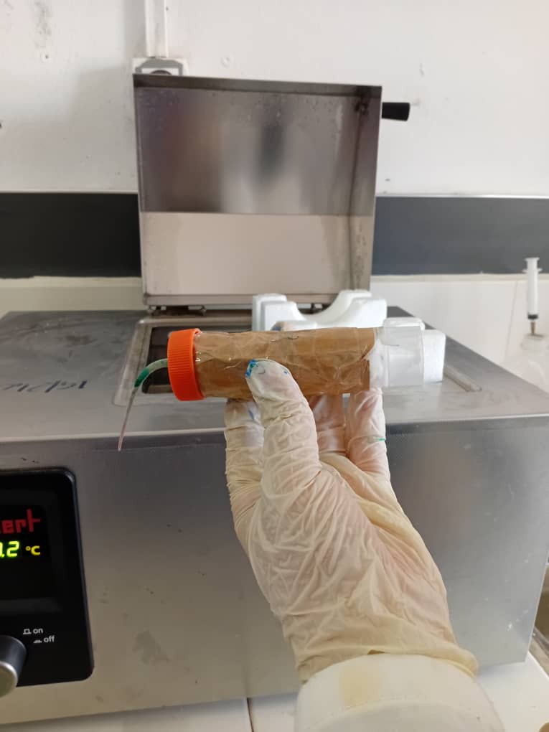

**Figure 33 :** Immersion de la queue dans le bain-marie

**Figure 32 :** Mise en place de la souris dans le tube de contention

1. Heating plate test (Hot Plate Test)

The aim of this test is to assess the central analgesic effect of the myrrh resin by measuring the time before the appearance of reflex behaviors in pain in mice exposed to a nociceptive thermal stimulus on a heating plate.

* Principle

The heating plate test is an experimental model used to assess the supraspinal behavioral response to a nociceptive thermal stimulus in mice.Unlike purely spinal reflexes, this test measures integrated reactions involving higher nerve centers, such as licking posterior legs, jumps or tremors, thus reflecting the central integration of pain.It is particularly relevant for the evaluation of analgesic compounds acting in the central nervous system.

The heating plate test is one of the most widespread nociception tests based on a high intensity stimulus.The pain induced by the thermal stimulus must go through the central nervous system (SNC) (Chahar et al., 2012).

* Material and operating mode
* Preparation of the device: The heating plate is set to a constant temperature between 54 and 56 ° C, verified and stabilized before each experimental session using a precision thermostat.
* Positioning of the animal: Each mouse is placed individually in the center of the heating plate, inside a transparent plexiglass beaker which limits its movements and prevents any leak throughout the duration of the test (Figure 34).
* Behavioral observation: Pain indicative reactions are observed carefully: mainly licking the hind legs, jumps and tremors.These behaviors reflect the activation of supraspinal nociceptive paths and are indicators of painful perception.
* Latence time measurement: A digital stopwatch is triggered as soon as the mouse is placed on the plate.The time elapsed before the appearance of a first pain behavior is precision.
* Safety and experimental limits: in order to prevent any risk of prolonged burns or suffering, maximum latency time of 30 seconds is imposed.If no nociceptive behavior is observed at the end of this period, the animal is immediately removed from the plate.
* Repetition and control: The test is repeated several times at regular intervals according to the protocol, with control groups (without treatment) and treated groups to allow a comparative evaluation of the analgesic effect.

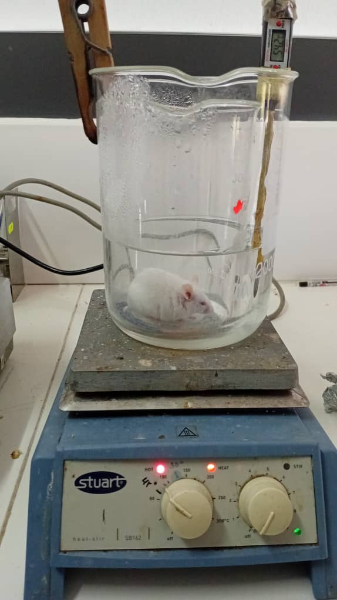

**Figure 34 :** Placement de la souris sur la plaque dans le cylindre transparent

1. The abdominal torsion test (Writhing Test)

The aim of this test is to assess the peripheral analgesic effect of myrrh resin, quantifying the painful responses induced by visceral chemical irritation in mice, in the form of characteristic abdominal contortions.

* Principle

The abdominal torsion test, known as Writhing Test, is a sensitive model of nociception used for the assessment of analgesic potential for peripheral action.It is based on the intraperitoneal injection of a diluted acetic acid solution, which induces pain of visceral origin by local release of inflammatory mediators such as prostaglandins and bradykinins.These mediators stimulate peripheral nerve endings, causing a series of involuntary contractions of the abdomen, generally accompanied by a stretch of the hind legs.

This test is widely used to detect the analgesic activity of natural extracts or synthetic compounds acting on the peripheral path of pain (Vogel, H. G. 2008; Collar, H. O. J. et al. 1968).

* Material and operating mode
* Preparation of the solution: An acetic acid solution is 0.6 % prepared (V/V) in sterile physiological serum, just before use in order to guarantee its stability and effectiveness.
* Administration: Each mouse receives an intraperitoneal injection of the acetic acid solution at a dose of 10 ml/kg of body weight, using a sterile with fine needle syringe (Figure 35).

**Figure 35 :** Injection intrapéritonéale de la solution d’acide acétique chez la souris

* Observation: Immediately after injection, each mouse is placed in an individual transparent observation cage.After a 5 -minute induction period, abdominal contortions are counted for a period of 20 minutes (Figure 36).
* Pain criteria: The characteristic movements to be recorded include the withdrawal of the abdomen, the stretching of the posterior legs, the elevation of the basin or the repeated abdominal contractions (Figure 37).

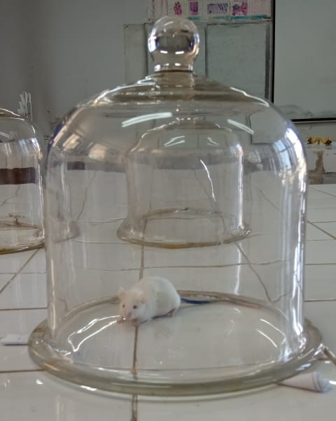

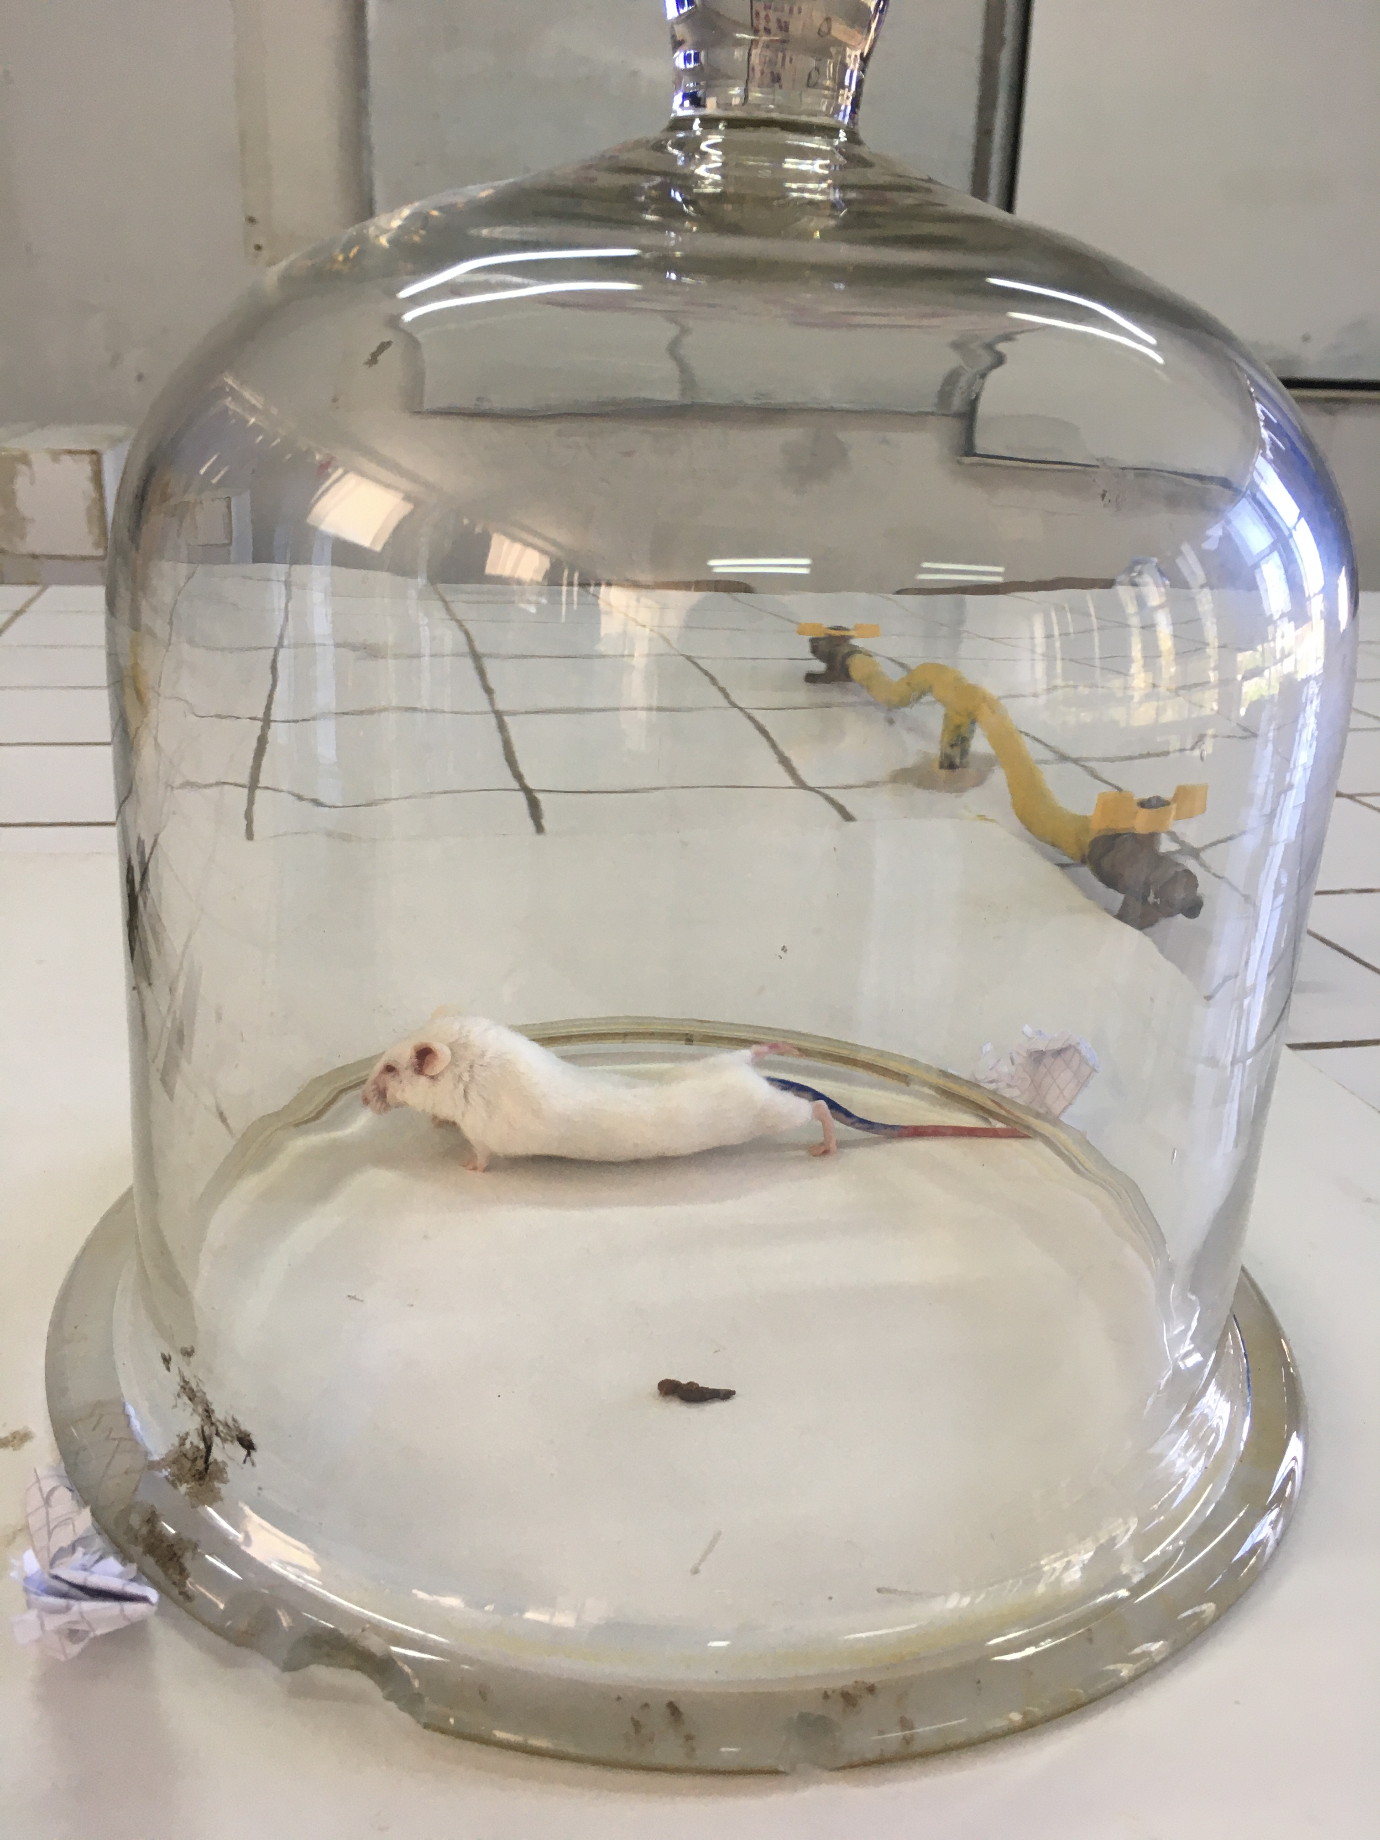

**Figure 36 :** Souris placée en cage d’observation individuelle après injection d’acide acétique

**Figure 37 :** Torsions abdominales après l’injection acide acétique

Figure 16: L’injection

Chapitre IV Matériels et méthodes

activité analgésique

L’effet analgésique des extraits a été évalué suivant le nombre de torsions abdominales

induites par l’injection intrapéritonéale (Figure 16) d’une solution de (10ml/Kg)

de l’acide acétique (0,6 %)suivant la méthode décrite par Kosteret al., (1959).

Torsions abdominales après l’injection acide acétique.

1. Experimental remarks and ethical conditions

* Animals have been manipulated in accordance with animal welfare standards.
* A rigorous cleaning of equipment (double boiler, plate) was carried out.
* No abnormal injury or behavior was observed during the post-test period.

Chapter IV

Results and discussion

In this chapter, we present the results obtained through all the experimental steps carried out.These include extraction yields, the chemical composition of the extracts analyzed by GC/MS and HPLC, as well as the various biological activities evaluated.These results make it possible to appreciate the quality of extracts and to better understand their pharmacological potential.

IV.1 Study of the extraction of the volatile fraction

## IV.1 Study of the extraction yield of the essential oil of myrrh

According to AFNOR standard, the yield of essential oil is defined as the ratio between the mass of essential oil obtained after extraction and the mass of the dry plant material used.It is expressed as a percentage and calculated (Table 4) by the following formula:

$$R\%=(\frac{Masse de l'HE }{Masse de matiére végétale sèche})× 100$$

Table 4: Operating conditions for different methods of extraction of essential oils of Commiphora Myrrha

|  |  |  |
| --- | --- | --- |
|  | HD (BS) | HD-MO (BS) |
| Power (W) | 800 | 800 |
| Sample weight (g) | 150 | 150 |
| Volume of distilled water (ML) | 800 | 750 |
| Extraction time (min) | 102 | 48 |
| Yield (%) | 2.36 | 1.90 |

### IV.1.1 Influence of extraction techniques used on yields

The influence of the performance extraction technique has been evaluated by comparing two methods: classic hydrodistillation (HD) and hydristillation assisted by microwave (HD-MO), under the same conditions (Figure 38).

The yield obtained by the HD method (2.36 %) turned out to be slightly higher than that obtained by the HD-MO method (1.90 %), despite a shorter extraction time for the latter (48 min against 102 min for HD).This difference can be explained according to different reasons, such as the phenomenon of solute transfer (HE) through the different stages of extraction and in places in both cases HD and HD-MO.Indeed, in the case of HD the time dedicated to extraction from endogenous sites (pores, mesopore and micropor) is slower than that of the HD-MO technique.

**Figure 38 :** Variation du rendement d’extraction de l'huile essentielle de la myrrhe en fonction des techniques utilisées avec broyage simple

## IV.1.2 Energy and environmental appearance

In order to assess the energetic aspect of extraction techniques, the energy consumed (expressed in kWh/g) was calculated according to the formula:

=

With: E: electric energy in kilowatt hour (kWh) per gram of HE.

P: The power of the device in Watt (W).

T: Total time of the second heating.

Mi: The mass of essential oil (G).

With regard to environmental impact, carbon dioxide rejected in the atmosphere has been calculated according to the fact that 1 kWh generated by the combustion of coal or another fossil fuel, rejects 800 g of CO2 in the atmosphere, using the below:

$$m {CO}_{2 }=E ×800$$

With: M CO2: the quantity of carbon dioxide released in gram (G).

E: The electrical energy consumed in kilowatt hour (kWh).

According to Figure 39-A, we note that the HD technique is more consumer of energy than HD-MO, indeed microwaves allows an intense heating which is carried out from interior to the outside unlike conventional hydrodistillation, where heating is carried out from outside to interior.This peculiarity of microwaves considerably promotes the diffusion of HES of internal medium to the external part (Chemat, F. et al., 2017; Benkaci-Ali, F. 2015).

This difference is also reflected in terms of environmental impact, measured through associated CO2 emissions.The release of CO2 reaches 179.64g for the HD-MO technique (BS 800W), against 307.34g for HD (BS 800W) (Figure 39-B), which confirms a direct correlation between the energy consumed and the greenhouse gas emissions.This link is consistent with the principles established by the energy conversion equation in carbon equivalent (CO2) demonstrating that any increase in electricity consumption in a process is translated as a proportional increase in CO2 released in the atmosphere (Chemat et al., 2017; Benkaci-Ali, F. 2007).

**Figure 39-b :** Dégagement du CO2 par rapport aux techniques utilisées

**Figure 39-a :** Energie consommé en fonction des techniques utilisées

## IV.1.3 Study of the extraction kinetics of the essential oil of myrrh

### IV.1.3.1 Differential yield

The differential yield corresponds to the amount of essential oil extracted at a given moment.In this section, the study focused on the variation in differential efficiency as a function of the extraction time (Figure 40), for two techniques (HD and HD-MO).The curves obtained have different kinetic profiles (Table 5).The first phase, corresponding to the rapid liberation of HES from exogenous sites, is between 0 and 10 minutes for both methods.The HD-MO 800W technique shows an extraction to accelerate with higher yields from the first minutes, unlike HD which reaches its maximum efficiency more slowly.The second phase, marked by a gradual slowdown in extraction dominates by the extraction of the HE from endogenous internal sites (pores, mesopore, micropores).The third step of depletion is observed after 45 minutes of extraction, indicating the end of the extraction process.

Figure 40: Differential yield of the essential oil of myrrh extracted by different extraction methods

Table 5: Steps intervals of different extraction techniques (BS).

|  |  |  |  |
| --- | --- | --- | --- |
|  | Step 1 | Step 2 | Step 3 |
| T (Min) HD-MO 800W | 0 - 10 | 10 - 45 | After 45 |
| T (min) HD 800W | 0 - 10 | 10 - 45 | After 45 |

### IV.1.3.2 Cumulative yield

To better exploit the results of the extraction kinetics we have drawn the cumulative yield according to the heating time (Figure 41).The curves obtained highlight distinct profiles between the two methods, reflecting a different extraction kinetics influenced mainly by the thermal transfer mode and the intensity of applied energy.

The HD-MO 800W technique is distinguished by a rapid start of the extraction process, with significant progression from the first minutes.Indeed, a cumulative yield of 0.87 % is already reached after 15 minutes, to peak at 1.81 % at the end of the extraction (50 min).This performance is explained by the intense and targeted thermal effect of microwaves, which promotes a faster rupture of plant structures, facilitating the release of volatile compounds from exogenous and endogenous sites.

Unlike the HD 800W technique presents a slower extraction dominated by the second stage of extraction.The 50-minute cumulative yield reaches only 0.85 %, less than half of that obtained with HD-MO.This result is explained by the nature of conventional heating, less effective in terms of thermal transfer, with slower penetration of heat in the plant matrix.Thus, the extraction is done slower due to the diffusion of the Het of internal pore sites, a mesopore towards the exterior.

The analysis of optimal extraction times makes it possible to quantify the energy and temporal efficiency of the two techniques.Thus, the time required to reach 80 % of the maximum yield (T80) is 22 minutes for HD-MO, against 48 minutes for HD.Similarly, the optimal time to reach 90 % of the yield (T90) is 35 minutes respectively for HD-MO and 56 minutes for HD (Table 6).Generally, it is recommended to sacrifice 10 to 20% yield for a significant reduction in heating time Table 6 for a saving of time, energy, CO2 free and above all a high quality of extracted oil (reduction in chemical degradation reaction).

**Figure 41** : Rendement cumulées de l’huile essentielle de de la myrrhe extraite par différentes méthodes d’extraction

Table 6: Optimistic times for different extraction techniques

|  |  |  |  |
| --- | --- | --- | --- |
|  | Optimal time 80% | Optimal time 90% | T total |
| T (Min) HD-MO 800W | 22 | 35 | 43 |
| T (min) HD 800W | 48 | 56 | 65 |

### IV.1.3.3 Energy and environmental aspect

According to the results obtained (Figure 42 and 43), HD-MO turns out to be the most economical method in energy, with a consumption of 0.163Wh/g, compared to 0.210 kWh/g for HD at the same power.This trend is also reflected at the environmental level, where CO2 emissions are lower for classical technique (150 g against 187 g for the microwave method).Thus, despite the kinetic advantages of microwave assisted extraction, simple hydristillation remains more favorable in terms of energy and environmental sustainability.

**Figure 42-b :** Energie consommé en fonction des techniques utilisées avec le temps optimale 90%

**Figure 42-a :** Energie consommé en fonction des techniques utilisées avec le temps optimale 80%

**Figure 43-b :** Dégagement du CO2 par rapport aux techniques utilisées avec le temps optimale 90%

**Figure 43-a :** Dégagement du CO2 par rapport aux techniques utilisées avec le temps optimale 80%

## 

## IV.1.4 Studies of extraction kinetics according to time by GC-MS

The study of the extraction kinetics of the essential oil of myrrh (Commiphora Myrrha) by HD-MO at 800W makes it possible to better understand the dynamics of appearance, accumulation and disappearance of aromatic compounds during the process.Two types of resin prior treatment were compared: simple grinding (BS) and cryogenic grinding (BC), in order to assess the impact of the latter.

The analysis of the volatile compounds was carried out by gaseous chromatography coupled with mass spectrometry (GC-MS), allowing the identification of nearly 100 constituents: 90 volatile compounds in sample BC and 98 in the BS sample (Tables 7 and 8).

In the HD-MO 800W process, the type of grinding influences the extraction kinetic profile.Especially at the end of the extraction process.Overall, the quantity extracted with BC (N2 -196c °) is relatively less important with that obtained by BS has the exception of the interval of time 22 to 37min.

The study of 800 W HD-MO extraction kinetics shows that the type of grinding strongly influences yield.Simple grinding (BS) allows more effective extraction than cryogenic grinding (BC), with optimal release of the compounds followed by slower progression until reaching stability around 45 minutes, with a maximum yield of around 4.5 %.On the other hand, the BC with liquid nitrogen (-196c °) has a slower extraction, reaching earlier stability (around 30 minutes) with a lower yield (2.7 %).The decrease in efficiency with the BC probably due to the clogging phenomenon of the solid particles which prevents the good solid liquid contact, which reduce the surface (Figure 44).

Figure 44: Differential and cumulative yield of the essential oil of myrrh extracted by HD-MO 800 W with different types of grinding

IV.1.4.1 HD-MO technique case p = 800W BS

* From Figure 46, we note that the profile of each compound is different for each constituent.In some cases, the highest yields are obtained either during the first step or the second step, and even during the third step.This confirms the fact that the composition of isolated (differential) oil is very dependent on heating time, which considerably affects the quality of isolated oil, as well as its physico-chemical properties and biological activities.

During the second step, limited to 45 minutes, compounds such as Furanoeudesma-1,3-Diene (29.48 % to T1) and β-elemn (6.83 % at1) show rapid release comparing to the first step, reaching 42.03 % and 4.52 % at T3 respectively.This intensive initial extraction is characteristic of an exogenous transfer, facilitated by the disorganization of surface structures under the targeted thermal effect of microwaves.Curzerene has a remarkable ascending profile, from 13.47 % to T1 to a maximum of 20.98 % to T4, reflecting progressive endogenous diffusion.This phenomenon is explained by the late rupture of the deep structures resistant, such as the thickened walls of the oleiferous cells, which slow down access to hydrophobic compounds.The 2-Epi-α-Cèdrene-3-One, detected solely at T1 (14.73 %), shows a typical behavior of thermosensible compounds: its subsequent absence is probably resulting from a degradation by rearrangement or oxidation under the thermal effect, as reported by Bera, S. et al.(2020) In their analysis of sesquiterpenes extracted from myrrh.Curzérénone and elemol acetate, whose concentrations increased slowly to T5 (2.23 % and 2.22 % respectively), also testify to a deep release conditioned by thermal accumulation.This evolution combines with the results (HE, Z. et al. 2014), which have shown that the prolonged thermal action induced by microwaves generates a selective rupture of internal structures.

Other profiles such as those of elemol and γ-elemn remain more stable, but their slight increase over time indicates a compromise between structural accessibility and resistance to degradation.Compounds like germacrone and nootkatol have delayed extraction profiles, reaching their maximum concentrations at more advanced times, while muurolène (<γ->) decreases after a maximum.

The influence of the size of the crushed particles, the internal pressure induced by the selective absorption of microwaves, as well as the progressive destabilization of plant tissues make it possible to explain the differences observed between the compounds extracted in the initial phase and those released later.This behavior is in accordance with the mechanisms described by Chemat, F. et al.(2011), which underline the fundamental role of the thermal gradient and the structural properties of the matrix in the effectiveness of the microwave of natural substances.

* The yield study shows rapid extraction during the first 10 minutes, where more than 80% of total compounds, such as Furanoeudesma-1,3-Diene and Curzene, are released thanks to the grinding and microwave heating.Then, a slow phase continues beyond 20 minutes, with a weak gain (less than 10%), corresponding to the extraction of intracellular compounds like the elemol.A level is reached between 30 and 40 minutes, reflecting the saturation of the extractive process.

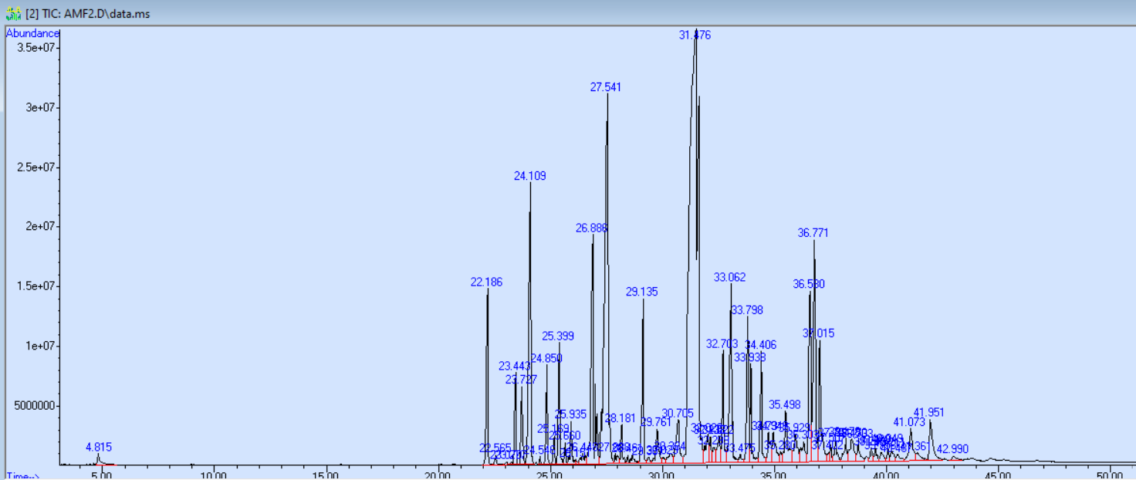

Figure 45: GC/MS chromatogram of hydrodistillation assisted by power microwave 800W BS (T2)

Table 7: Extraction kinetics of the essential oil of the myrrh extracted by HD-MO P = 800W BS followed by GC-MS

|  |  |  |  |  |  |  |  |
| --- | --- | --- | --- | --- | --- | --- | --- |
| Ki reference | Compound name | MF | T1 (%) | T2 (%) | T3 (%) | T4 (%) | T5 (%) |
| 939 | α-Pinène | C10h16 | 0.92 | 0.30 | 0.24 | / | 0.12 |
| 1338 | Δ-elemn | C15 H24 | 3.03 | 2.04 | 2.00 | 1.32 | 0.90 |
| 1351 | α-Cubeben | C15 H24 | / | 0.13 | 0.10 | / | / |
| 1360 | Silphirefol -4,7 (14) -Diene | C15 H24 | / | 0.05 | / | / | / |
| 1375 | α-ylangène | C15 H24 | / | 0.03 | / | / | / |
| 1376 | α-crop | C15 H24 | 1.42 | 1.04 | 0.78 | 0.56 | 0.35 |
| 1388 | β-bourbonnene | C15 H24 | 1.36 | 1.08 | 0.88 | 0.64 | 0.41 |
| 1390 | β-elemn | C15 H24 | 6.83 | 4.99 | 4.52 | 4.23 | 2.41 |
| 1409 | α-Gurjunène | C15 H24 | / | 0.07 | 0.06 | / |  |
| 1419 | (E) -Caryophyllène | C15 H24 | 1.47 | 1.04 | / | / |  |
| 1420 | β-ylangenous | C15 H24 | / | / | 0.96 | 0.78 | 0.45 |
| 1432 | β-copanes | C15 H24 | 0.36 | 0.31 | 0.31 | / | 0.17 |
| 1436 | γ-elemene | C15 H24 | 1.67 | 1.44 | 1.80 | 1.62 | 1.27 |
| 1439 | α-Guainene | C15 H24 | 0.24 | 0.22 | 0.20 | / | 0.10 |
| 1454 | α-Humulène | C15 H24 | 0.65 | 0.60 | 0.58 | / | 0.27 |
| 1460 | Allo-Aromadendrene | C15 H24 | / | 0.07 | / | / | / |
| 1466 | Ishwarane | C15 H24 | / | 0.32 | / | / | 0.10 |
| 1475 | 10-EPI-β-root | C15 H24 | / | / | / | / | 2.12 |
| 1476 | Cadina-1 (6), 4-Diene | C15 H24 | 5.14 | / | / | / | / |
| 1477 | γ-Gurjunène | C15 H24 | 0.71 | / | / | / | 0.34 |
| 1479 | γ-murolène | C15 H24 | / | 5.09 | 4.41 | 2.17 | / |
| 1481 | German germacrene | C15 H24 | 0.63 | / | 1.08 | 0.46 | 0.27 |
| 1499 | Curzérene | C15 H20 o | 13.47 | 11.13 | 14.81 | 20.98 | 14.27 |
| 1498 | α-selinène | C15 H24 | 1.01 | / | / | / | / |
| 1502 | γ-Patchoulene | C15 H24 | / | / | #error# | / | 0.27 |
| 1513 | γ-cadinène | C15 H24 | / | 0.26 | 0.11 | / | 0.10 |
| 1523 | Δ-Cadinène | C15 H24 | 0.60 | 0.49 | 0.80 | / | 0.45 |
| 1529 | Zonaren | C15 H24 | / | 0.34 | 0.13 | / | 0.09 |
| 1546 | Sélina-3.7 (11) -Diene | C15 H24 | / | / | 0.31 | / | 0.21 |
| 1548 | Italian epoxy | C15 H24 o | / | / | 0.19 | / | 0.15 |
| 1549 | Elemol | C15 H26 o | 1.74 | 2.13 | 2.13 | 1.14 | 1.25 |
| 1559 | Silphiperfol-5-Éné-3-Ol A | C15 H24 o | / | 0.14 | / | / | / |
| 1569 | #error# | C15 H26 o | / |  | 0.18 | / | / |
| 1572 | Furanoudesma-1,4-Diene | C15h18o | 0.48 | 0.79 | 1.00 | / | 0.67 |
| 1578 | Spathulanol | C15 H24 o | / | #error# | #error# | #error# | 0.15 |
| 1583 | Karyophyllene oxide | C15 H24 o | / | 0.13 |  | / | / |
| 1602 | Trans-élémenone | C15 H22 o | / | 0.38 | 0.41 | / | 0.33 |
| 1606 | Curzérénone | C15 H18 o | / | 1.32 | 1.62 | / | 2.23 |
| 1619 | Junnol | C15 H26 o | / | / | / | 36.66 | / |
| 1633 | Furanoudesma-1,3-Diene | C15h18o | 29.48 | 31.04 | 42.03 | 22.44 | 39.32 |
| 1627 | 2-Epi-α-Cèdrene-3-One | C15 H22 o | 14.73 | / | / | / | / |
| 1646 | Cubenol | C15 H26 o | / | / | #error# | / | 0.32 |
| 1651 | CEDR-8 (15) -ène-9-α-Ol | C15 H24 o | / | 0.79 | 1.07 | / | 1.30 |
| 1658 | Atractylone | C15 H20 o | / | 0.38 | 0.55 | / | / |
| 1660 | Gymnomitrol | C15 H24 o | / | 0.38 | 0.40 | / | 0.39 |
| 1669 | Methyl hinokiéate | C16h24o2 | / | 0.63 | 0.50 | / | 0.58 |
| 1680 | Elemol acetate | C17 H28 O2 | / | 1.56 | 1.88 | / | 2.22 |
| 1681 | Ishwarone | C15 H22 o | 4.19 | / | / | / | / |
| 1693 | Germacrone | C15 H22 o | / | 3.69 | 4.32 | 4.08 | 0.13 |
| 1697 | Acoronone B | C15 H24 o | / | / | / | / | 3.76 |
| 1709 | Cis-Thujopsenal | C15 H22 o | / | 0.18 | / | / | 0.26 |
| 1715 | NOOTKATOL | C15h24o | / | 1.87 | 3.17 | / | 5.86 |
| 1718 | (Z) -α-Atlantone | C15 H22 o |  |  |  | 2.92 | / |
| 1725 | (Z) -nuciferol | C15 H22 o | 1.54 | / | / | / | / |
| 1728 | (E) -nuciferral | C15 H20 o | / | 1.19 | / | / | 1.45 |
| 1736 | Eremophilone | C15 H22 o | / | 1.58 | 0.70 | / | / |
| 1752 | 1-acetyl-4,6,8-Triméthylazulnene | C15h16o | / | 0.64 | / | / | / |
| 1761 | (Z) -Lancéol | C15 H24 o | / | 0.86 | 0.60 | / | 1.25 |
| 1767 | Dimenol | C15 H26 o | / | / | 0.35 | / | / |
| 1774 | α-Costol | C15 H24 o | / | 0.18 | / | / | 0.20 |
| 1776 | Amorpha-4,7 (11) -Diene | C15 H24 | / | / | / | / | 0.17 |
| 1784 | Hinesol acetate | C17 H28 O2 | / | 1.27 | 0.56 | / | 0.75 |
| 1792 | Dimenone | C15 H24 o | / | / | / | / | 0.17 |
| 1797 | (2.5-Dimethoxyphenyl) -Phényl-Méthanol | C15h16o3 | / | 0.80 | / | / | 0.72 |
| 1803 | 14-Hydroxy -δ-Cadinène | C15 H24 o | / | / | 0.46 | / | / |
| 1811 | ISOCORON | C15 H24 O2 | / | / | / | / | 0.27 |
| 1811 | Vetivènic acid | C15h22o2 | / | 0.68 | 0.32 | / | 0.31 |
| 1820 | Acoron | C15 H24 O2 | / | / | 2.98 | / | 1.46 |
| 1823 | β-vetivone | C15h22o | / | 2.98 | 0.50 | / | / |
| 1831 | (Z) -Certate of nuciferol | C17h24o2 | / | 4.57 | / | / | 2.40 |
| #error# | O-Methyl-α-Pipsole | C16h22o3 | / | 2.04 | 0.23 | / | 0.85 |
| 1843 | α-Vetivone | C15 H22 o | / | / | / | / | 0.37 |
| 1856 | α-chhenopodiol | C15h26o2 | / | 0.13 | / | / | 0.26 |
| 1862 | Amorpha-4,7-Dièn-2-α-Acouxoxy-11-Methoxy | C18h28o3 | / | 0.24 | / | / | / |
| 1864 | thujopsenic acid | C15h22o2 | / | 0.47 | 0.37 | / | / |
| 1870 | Fuzziol | C15 H26O2 | / | / | / | / | 0.47 |
| 1875 | α-hexadécanol | C16 H34 o | / | / | / | / | 0.29 |
| 1887 | Optopanonyl acetate | C17 H28 O2 | / | 0.51 | 0.42 | / | 0.69 |
| 1897 | 8S, 13-Cédranédiol | C15h26o2 | / | 0.82 | / | / | / |
| 1905 | Isopimara-9 (11), 15-Diene | C20 H32 | / | / | / | / | 1.10 |
| 1912 | Kuddiol | C15 H26 o | / | 0.47 | 0.65 | / | / |
| 1922 | Total | C20 H32 | / | / | / | / | 0.20 |
| 1931 | Beyerene | C20 H32 | / | 0.24 | 0.13 | / | 0.19 |
| 1938 | Hint | C20 H32 | / | 0.27 | / | / | 0.33 |
| 1949 | Pimaradiene | C20 H32 | / | 0.26 | / | / | / |
| 1953 | Columellarine | C15 H20 O2 | / | / | / | / | 0.17 |
| 1961 | RIMUMENNE (tetrahydro) | C20 H32 | / | 0.19 | / | / | 0.29 |
| 1974 | Dolabradian | C20 H32 | / | 0.30 | / | / | 0.17 |
| 1978 | Biflorer | C20 H32 | / | 0.21 | / | / | 0.16 |
| 1997 | Kaur-15-ath | C20 H32 | / | / | / | / | 0.09 |
| 2000 | 13-Epimethyl-coat | C20 H32 | / | 0.98 | / | / | / |
| 2017 | Phyllocladene | C20 H32 | / | 0.34 | / | / | / |
| 2024 | Warburgenal | C15 H22 O3 | / | / | / | / | 0.87 |
| 2024 | Cataponol | C15 H18 O2 | / | / | 0.50 | / | / |
| 2043 | Kaurène | C20 H32 | / | 1.22 | 0.12 | / | / |
| 2057 | Manoeol | C20 h34 o | / | / | / | / | 0.80 |
| 2060 | 13-Epimanool | C20 h34 o | / | / | 0.37 | / | / |
| 2087 | Abiétadiene | C20 H32 | / | 0.15 | / | / | / |

Figure 46: Variation of the differential percentage of the majority compounds of the essential oil of myrrh as a function of HD-MO 800W-BS time



**Intensite%**

**Intensite%**

**m\z**



**A**

**B**

**Intensite%**

**m\z**

**m\z**



**Figure 48 :** Spectres de fragmentations des composés majoritaires identifiés dans le cas de HD-MO 800W BS. **A** : Furanoeudesma-1,3-diene. **B** : Elémène<β->. **C** : Curzérène

**C**

The analysis of variation profiles of differential chemical families depending on time (Figure 49) highlights very different profiles for each family depending on the chemical nature and the location of compounds in different internal sites.Hydrocarbon sesquiterpenes have a decrease in their percentage during their heating process probably linked to the physical dissemination phenomenon through location sites, as well as any stable degradation reactions.

In the case of oxygenated sesquiterpenes, a high increase in percentage is observed between 18 and 28 min in the second extraction followed by a rapid decrease up to 43 min.This fluctuation phenomenon is probably linked to a matrix transfer phenomenon that a phenomenon of thermal degradation. The increase in this compound is isolated during the second of extraction, this means that this compound family requires a relatively high heating time for this freed from the phase of plant particles.In the case of furanose composites, some are better extracted at the start of extraction, while the other is free only after a long heating.This is probably linked simultaneously to the molecular mass, the polarity and their coefficient of solid-liquid diffusion.For diterpenes and the rest of the compounds, similar gaits are observed in the observed phenomena are identical to the cases of furanic composites.

The cumulative profile of chemical classes shows two groups of chemical families, the 1st group in Figure 50-A where we observe horizontal curve profiles for hydrocarbon sesquiterpenes, a growing curve profile and another decreasing profile for oxygenated sesquiterpenes.In the case of Figure 50-B a strong fluctuation of percentage of the diterpenes and the rest of the compounds is observed due to several complex parameters involved such as molecular mass, polarity and their location in internal pore, mesopore and micropore sites.

**Figure 49 :** Variation du pourcentage des classes chimiques d’huile essentielle en fonction du temps par la technique HD-MO 800W-BS

**Figure 50-a :** Pourcentage cumulé des classes chimiques d’huile essentielle de la myrrhe extrait par la technique HD-MO 800W-BS

**Figure 50-b :** Pourcentage cumulé des classes chimiques d’huile essentielle de la myrrhe extrait par la technique HD-MO 800W -BS

## IV.1.4.2 HD-MO technique case p = 800W BC

* In the case of cryogenic grinding we note a considerable influence on the qualitative and quantitative aspect as well as on the profile of variation of the main composes identifies as a function of time in the differential case (Figure 52).The low particles obtained by BC have considerably impacted the quantitative and qualitative aspect of the Extraits (Koba, K. H. et al., 2016), so for the furanoeudesma-1,3-Diene the largest quantity was exhausted during the first 20 minutes, while a very small quantity obtained at the end of the exclusion process (Verzera, A. et al.May be explained by the dominance of exogenous sites (partial solubilization phenomenon) and in places during the early days of heating (Cvitković, D. et al., 2022).For curvene and β-elemn a moderate fluctuation in composition is observed.Furthermore, we note that the curve profile of β-elemn BC remains identical to that obtained in BS.

For the rest of the compounds (Nootkatol, Germacrone, Curzérénone and Élémol), we observe increasing gaits depending on time, this suggests that the transfer of materials from exogenous (dominant) sites is embarrassed by the phenomenon of the clogging of fine plant particles, which requires a significant heating time for their release (Diffusion) (Chemat, F. et al., 2017;Cravotto, G. et al., 2008). Let’s bake that BC has contributed to the appearance of new compounds such as bulnesol and β-vetivone (appeared in all times in BC and only in T2 and T3 in BS).

Differential kinetic study is the only technique capable of following qualitatively and quantitatively the presence of a compound as a function of time, unlike the cumulative kinetics which is used only to determine the chemical composition of real HE has a time T.

In Figure 53 relating to the cumulative percentage, we note that the percentage fluctuations are very stable to the exception of Furanoeudesma-1,3-Diene where a strong variation is observed during the first 20 minutes of extraction and which stabilizes at the end of the process, for the other compounds the same remark was noted.

Taking into account that the optimal time of 80% corresponding to 18 min of extraction, according to figures 47 and 53 relating to the BS and BC, certain compounds of importance such as Nootkatol, Germanone, Curzérénone, β-Vetivone, Elemol, Bulnesol, will be extracted in low percentage whileFuranoeudesma-1,3-Diene, Curzene and β-elemn will be obtained in high percentage.Hence an optimal extraction time must be chosen in a quantitative and qualitative way (chemical composition).Indeed, the aromatic profile of the He is very dependent on heating time, which significantly influencing their biological activities.

Figure 51: GC/MS chromatogram of hydrodistillation assisted by power microwave 800W BC (T2)

Table 8: Extraction kinetics of the essential oil of the myrrh extracted by HD-MO P = 800W BC followed by GC-MS

|  |  |  |  |  |  |  |  |
| --- | --- | --- | --- | --- | --- | --- | --- |
| Ki reference | Compose name | MF | T1 (%) | T2 (%) | T3 (%) | T4 (%) | T5 (%) |
| 939 | α-Pinène | C10h16 | 2.91 | / | 0.14 | 2.41 | 6.86 |
| 1338 | Δ-elemn | C15 H24 | 1.79 | 1.420 | 1.09 | 0.80 | 1.28 |
| 1351 | α-Cubeben | C15 H24 | 0.13 | 0.11 | 0.08 | / | / |
| 1375 | α-ylangène | C15 H24 | 0.04 | / | / | / | / |
| 1376 | α-crop | C15 H24 | 0.71 | 0.57 | 0.44 | 0.30 | 0.32 |
| 1388 | β-bourbonnene | C15 H24 | 1.11 | 0.94 | 0.70 | 0.44 | 0.41 |
| 1390 | β-elemn | C15 H24 | 6.44 | 6.23 | 4.59 | 3.05 | 2.98 |
| 1409 | α-Gurjunène | C15 H24 | 0.14 | 0.11 | 0.09 | 0.06 | / |
| 1411 | α-cedrene | C15 H24 | / | / | / | / | / |
| 1419 | Caryophyllène (e) | C15 H24 | 1.01 | 0.92 | 0.72 | 0.43 | 0.35 |
| 1432 | β-copanes | C15 H24 | 0.27 | 0.24 | 0.21 | 0.12 | / |
| 1436 | γ-elemene | C15 H24 | 1.27 | 1.41 | 1.48 | 0.81 | 0.59 |
| 1439 | α-Guainene | C15 H24 | 0.18 | 0.17 | 0.14 | 0.09 | / |
| 1454 | α-Humulène | C15 H24 | 0.62 | 0.54 | 0.42 | 0.34 | / |
| 1463 | Cadina-1 (6), 4-Diene (CIS) | C15 H24 | 0.20 | 0.14 | 0.14 | 0.22 | / |
| 1466 | Muurola-4 (14), 5-Diene (CIS) | C15 H24 | / | / | / | / | / |
| 1472 | DAUCA-5.8-Diene | C15 H24 | / | / | / | 0.29 | / |
| 1476 | Cadina-1 (6), 4-Diene (trans) | C15 H24 | 2.04 | 2.25 | 1.82 | 0.66 | / |
| 1481 | German germacrene | C15 H24 | 1.28 | 1.21 | 1.03 | 0.83 | 1.08 |
| 1498 | α-selinène | C15 H24 | / | 0.68 | / | / | / |
| 1499 | Curzérene | C15 H20 o | 9.88 | 12.95 | 12.96 | 9.70 | 9.42 |
| 1513 | γ-cadinène | C15 H24 | 0.38 | / | 0.23 | 0.20 | 0.43 |
| 1523 | Δ-Cadinène | C15 H24 | 0.37 | 0.41 | 0.41 | 0.41 | 0.32 |
| 1529 | Zonaren | C15 H24 | 0.14 | 0.09 | 0.16 | 0.14 | / |
| 1546 | Sélina-3.7 (11) -Diene | C15 H24 | 0.21 | 0.19 | 0.20 | 0.16 | / |
| 1549 | Elemol | C₁₅h₂₆o | 1.42 | 1.64 | 1.30 | 1.08 | 0.65 |
| 1557 | DAUCA-4 (11), 7-Diene (trans) | C₁₅H₂₄ | / | / | 0.13 | / | / |
| 1572 | Furanoeudesma-1,4-Diene | C₁₅h₁₈o | 0.46 | 0.72 | 0.83 | 0.63 | / |
| 1575 | Zierone | C₁₅h₂₂o | 0.18 | / | / | / | / |
| 1585 | Presilphirefolan-8-Ol | C₁₅h₂₆o | / | / | / | 0.12 | / |
| 1589 | cis-β-elememenone | C₁₅h₂₂o | 0.22 | / | / | / | / |
| 1602 | β-elememenone (trans) | C₁₅h₂₂o | / | / | 0.33 | 0.19 | / |
| 1606 | Curzérénone | C₁₅h₁₈o | 0.91 | 1.11 | 1.26 | 1.35 | 2.37 |
| 1612 | Insolve (CIS) | C₁₅h₂₄o | / | / | / | / | 0.54 |
| 1619 | Cedrol (epimère) | C₁₅h₂₆o | / | / | / | / | 15.48 |
| 1627 | Cedren-3-One (2-Epimer-α) | C₁₅h₂₂o | / | / | / | 23.54 | / |
| 1633 | Furanoeudesma-1,3-Diene | C₁₅h₁₈o | 22.68 | 35.10 | 33.18 | 8.62 | 11.39 |
| 1636 | Cadin-4-en-7-ol (CIS) | C₁₅h₂₆o | 6.77 | 11.69 | 7.93 | / | / |
| 1644 | Isobornyl isobutanoate (6-hydroxy) | C₁₄h₂₄o | 0.38 | 0.50 | / | 1.45 | / |
| 1651 | CEDR-8 (15) -En-9-α-ol | C₁₅h₂₄o | 0.36 | 0.51 | 0.79 | / | / |
| 1658 | Atractylone | C₁₅h₂₂o | 0.23 | / | 0.42 | 0.36 | / |
| 1669 | Methyl hinokiate | C₁₆h₂₄o₂ | 0.45 | 0.37 | 0.45 | 0.53 | / |
| 1671 | Bulnesol | C₁₅h₂₆o | 1.40 | 1.70 | 1.84 | 2.11 | 3.84 |
| 1693 | Germacrone | C₁₅h₂₂o | 2.12 | 3.15 | 2.83 | 2.93 | 3.26 |
| 1709 | Thujopsenal | C₁₅h₂₂o | 0.16 | / | 0.22 | 0.25 | / |
| 1715 | NOOTKATOL | C₁₅h₂₄o | 1.76 | 2.51 | 3.35 | 3.35 | 5.25 |
| 1728 | Nuciferal (Z) | C₁₅h₂₀o | 1.42 | 0.81 | 0.80 | 1.28 | 2.49 |
| 1736 | Eremophilone | C₁₅h₂₂o | 1.88 | 0.76 | 0.97 | 1.82 | 2.54 |
| 1752 | 1-acetyl-4,6,8-Triméthylazulnene | C₁₅h₁₆o | 0.47 | / | / | / | / |
| 1756 | #error# | C₁₅h₂₂o | / | / | 0.51 | 0.60 | 0.72 |
| 1760 | Cyclocolorenone | C₁₅h₂₂o | 0.21 | 0.48 | 0.77 | 0.95 | / |
| 1767 | Dimenol | C₁₅h₂₆o | / | 0.44 | / | / | 1.15 |
| 1774 | α-Costol | C₁₅h₂₄o | / | / | 0.25 | 0.36 | / |
| 1784 | Hinesol acetate | C₁₇h₂₈o₂ | 0.53 | 0.46 | 0.86 | 0.91 | 1.03 |
| 1797 | (2.5-Dimethoxyphenyl) -Phényl-Méthanol | C₁₅h₁₆o₃ | 1.06 | / | 0.40 | 0.68 | 1.49 |
| 1803 | Δ-Cadinène (14-hydroxy) | C₁₅h₂₄o | / | 0.58 | / | / | / |
| 1806 | NOOTKATONE | C₁₅h₂₂o | / | / | 0.27 | 0.30 | / |
| 1811 | Vetivènic acid | C₁₅h₂₂o₂ | 0.49 | / | / | 0.51 | / |
| 1820 | Acoron | C₁₅h₂₄o₂ | / | 1.24 | 1.51 | 3.38 | 3.78 |
| 1823 | β-vetivone | C₁₅h₂₂o | 3.68 | 2.21 | 2.47 | 5.73 | 7.54 |
| 1831 | Nuciferol acetate (Z) | C₁₇h₂₄o₂ | 6.10 | 0.69 | 1.43 | 2.65 | 4.00 |
| 1841 | Pipitzol (o-methyl, α) | C₁₆h₂₂o₃ | / | / | / | / | / |
| 1847 | Eremophilone (8-hydroxy) | C₁₅h₂₂o₂ | / | 0.40 | / | / | / |
| 1856 | α-chhenopodiol | C₁₅h₂₆o₂ | 0.35 | / | 0.30 | / | 0.60 |
| 1864 | Thujopsenic acid (CIS) | C₁₅h₂₂o₂ | / | / | / | / | / |
| 1870 | Fuzziol | C₁₅h₂₆o₂ | 0.19 | / | / | / | / |
| 1878 | Cubiten | C₂₀H₃₂ | / | / | / | 0.56 | 0.87 |
| 1889 | Cedranédiol (8s, 14) | C₁₅h₂₆o₂ | 0.48 | 0.19 | 0.57 | 0.75 | / |
| 1897 | CEDRANEDIOL (8s, 13) | C₁₅h₂₆o₂ | 0.89 | / | 1.04 | 1.38 | / |
| 1905 | Isopimara-9 (11), 15-Diene | C₂₀H₃₂ | / | / | / | / | 1.46 |
| 1912 | Kuddiol | C₂₀H₃₂ | 0.61 | 0.49 | 0.70 | 0.94 | 1.67 |
| 1931 | Beyerene | C₂₀H₃₂ | / | / | 0.23 | 0.28 | 1.19 |
| 1938 | Cembrene | C₂₀H₃₂ | 0.37 | / | 0.21 | / | / |
| 1949 | Pimaradiene | C₂₀H₃₂ | 0.31 | / | / | 0.45 | / |
| 1961 | RIMUMENNE (tetrahydro) | C₂₀H₃₂ | 0.30 | / | 0.20 | 0.54 | 1.14 |
| 1974 | Dolabradian | C₁₃h₁₂n₂o | 0.41 | / | 0.42 | 0.70 | / |
| 1978 | Biflorer | C₂₀H₃₂ | 0.38 | / | 0.29 | 0.43 | / |
| 1980 | Banisterine | C₂₀H₃₂ | / | / | / | / | / |
| 1997 | Kaur-15-ath | C₂₀h₃₄o | / | / | / | 0.69 | / |
| 2000 | DOLABRADIENE (13-epimer) | C₂₀H₃₂ | 1.22 | / | 1.62 | 1.03 | / |
| 2013 | Manoon oxide (13-epimer) | C₂₀H₃₂ | / | / | / | / | 0.41 |
| 2017 | Phyllocladene | C₁₅h₂₂o₃ | 0.28 | / | 1.11 | 0.88 | / |
| 2043 | Kaurène | C₂₀H₃₂ | 1.44 | / | / | 1.33 | / |
| 2088 | Nootkatinol | C₂₁H₄₄ | / | / | 0.16 | / | / |
| 2087 | Abiétadiene | C₁₅h₁₆o₃ | 0.27 | / | / | 0.40 | / |
| 2100 | Henaicosan | C₁₅h₂₆o | / | / | / | 0.66 | / |
| 2141 | Osthole | C₁₅H₂₄ | / | / | / | 0.33 | / |
| 2116 | Laurenan-2-One | C2032O | / | 0.66 | / | / | / |
| 2159 | Incensola | C20h34o2 | 0.37 | 0.70 | / | 0.29 | / |

**Figure 52 :** Variation du pourcentagedes composés majoritaires de l’huile essentielle de la myrrhe en fonction du temps HD-MO 800W-BC

**Figure 53:**Pourcentage cumulé des composés majoritaires de l’huile essentielle de la myrrhe extraite par la technique HD MO 800W-BC

**Figure:**Pourcentage cumulé des composés majoritaires de l’huile essentielle de la myrrhe extraite par la technique MO 800-BC.

**Figure:**Pourcentage cumulé des composés majoritaires de l’huile essentielle de la myrrhe extraite par la technique MO 800-BC.

In the case of differential chemical classes, the BC has led to different variation profiles from a chemical class has another with a significant fluctuation during this HE extraction, as it is already quoted, some composses are better extracted at the beginning (furanosequitrepene and sesquiterpenes), while other are better isolated at the end of the extraction, from the polarity andmolecular.

Figure 54: Variation of the differential percentage of the chemical classes of essential oil as a function of time by the HD-MO 800W-BC technique

The cumulative profiles of chemical classes have less significant fluctuations than the differential case, but with slightly different variation profiles.From Figure 55, the optimal time will not significantly make the percentage of different chemical classes, however the chemical composition of each class is strongly modified as shown in Figure 54 relating to the differential case.

**Figure 55 :** Pourcentage cumulé des classes chimiques d’huile essentielle de la myrrhe extrait par la technique HD-MO 800W BC

## IV.2 Study of the chemical composition of the polyphenolic fraction by HPLC-DAD HPLC

The ethanolic extracts of Myrrhe were analyzed by HPLC in order to identify the compounds more precisely.Table 9 presents the compounds identified from the isolated fraction.The structure of flavonoids was determined using the same standards as those used for HPLC analysis.Thirteen components have been identified (Figure 56) thanks to the retention times of the targeted reference substances (standards).The results of HPLC-Dad confirm the presence of phenolic compounds such as catechin, kaempferol, anthrone, 4-hydroxybenzoic acid, vanillin, quercetin, protocatechic acid and isovanilic acid.All these compounds, as well as salicylic acid and syringic acid, were identified in the present works.

It is interesting to note that the compounds of hydroxycinnic acid present in all the samples studied, such as coffee acid, vanillin, syringic acid, quercetin and catechin, have already been identified by other authors (Abbas, R. et al. 2020).Certain polyphenols such as coumaric acid, ningugenin, pyrocatechol and rutin have also been reported in previous studies (Abbas, R. et al 2020), but were not detected in our samples.

Although Propyl Galt and Ellagic Acid were not detected in our extracts, 4-hydroxybenzoic acid has been identified in all the samples studied.

In addition, some flavonols such as epigallocatechine gallate and hydrated catechin have not been reported in previous work on this plant.

Other significant compounds have also been exclusively discovered in the context of this work, such as salicylic acid, anthrone, protocatechic acid, 4-hydroxybenzoic acid, trans-2,4-deméthoxycinnomic acid,

Overall, the total phenolic yields (Table 9) of My1 (12.45 %), My2 (14.03 %) and My4 (18.02 %) were relatively higher than those of My3 (10.02 %).In addition, a significant difference in the composition has been observed according to the regions studied, in particular for the main phenolic compounds such as catechin (My1: 0.68 %, My2: 0 %, My3: 0.21 %, My4: 0 %), Kaempferol (My1: 0 %, My2: 0 %, My3: 043 %, My4: 0.06 %)(My1: 0.166 %, my3: 0.0282 %, my4: 0.0378 %), 4-hydroxybenzoic acid (my1: 0.113 %, my1: 3.0375 %, my3: 0.28 %, my4: 0.7209 %), vanillin (R1: 0.166 %, R2: 0.028%, R4: 0.037 %).It should be noted that myrrh from My2 is clearly distinguished from other regions, because catechin, vanillin and anthrone have not been detected, while a significant content of Kaempferol (0.06 %), salicylic acid (0.68 %) and 4-hydroxybenzoic (3.038 %) acid was isolated in isolatedhigh percentage.

Thus, compounds such as trans-2,4-methoxycinnic acid, quercitine hydrates, flavone, gallic acid and caffeic acid have not been detected in our samples, while certain phenolic compounds are common to all regions studied (with the exception of My2), such as vanillin, kaempferol,Anthrone.

In addition, some samples presented notable differences in their composition compared to other regions such as My1, My2 and My3, where compounds such as Kaempferol and Quercetine have not been detected.Due to its high content of biologically active polyphenols, myrrh resin could present many bioactive properties against painful rules, digestive problems, gingivitis and pharyngitis.It is well known to be useful in the treatment of various diseases, including obesity, lipid anomalies, cardiovascular problems, arthritis and fractures.

On the other hand, the flavanone detected as the main polyphenolic compound in all the samples studied also constitutes an additional advantage in the bioactivity of the resin as a powerful antioxidant and radical tramp (Lee, J.-H. 2015), reducing the risk of certain chronic diseases and presenting anticancer activities (Murti, Y. and Mishra, P., 2014)(PARDES, A. et al, 2003), and anti-inflammatory drugs (Frattarolo, L. et al, 2019).In addition, the My1 and MY3 samples presented an important content of catechin, with antioxidant, antimicrobial properties (Abd El-Raouf, O. M. et al, 2015), neuroprotective, anti-inflammatory and antidiabetics (Wang, R. et al, 2019).Kaempferol, salicylic acid and 4-hydroxybenzoic acid, mainly present in most of our extracts, can help strengthen antibacterial and anti-fungal activities as well as antiviral and anti-inflammatory effects, which makes a promising treatment against COVID-19 (Tutunchi, H. et al, 2020).

In addition, gallic acid was detected in the state of traces in the samples studied only with λ = 275.4.It is interesting to note that these significant differences in phenolic compounds are closely linked to geographic conditions (regions), in particular My2 of Pakistan, which is clearly distinguished from other samples.Regarding the effect of the power of microwaves, we have also found a significant difference in the composition between My2 and My4 from Yemen.In addition to the crushed surface difference, the heating intensity resulting from the high power of microwaves accentuates the difference in composition caused by the thermal degradation of polyphenols according to different chemical reactions.

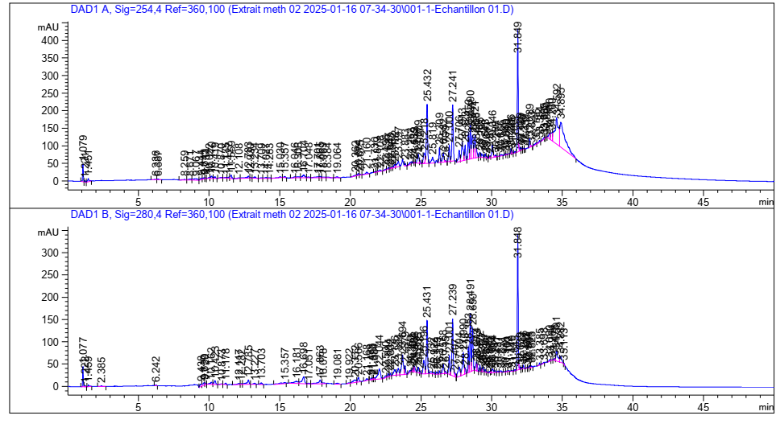

My1 Region 1

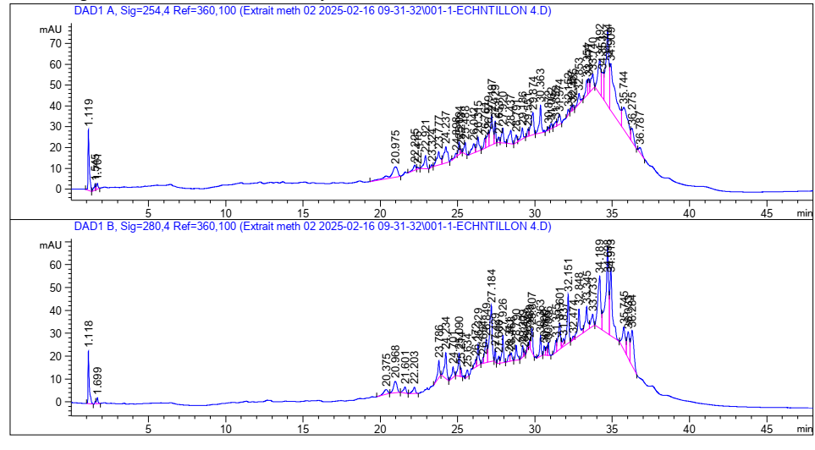

My2 Region 2

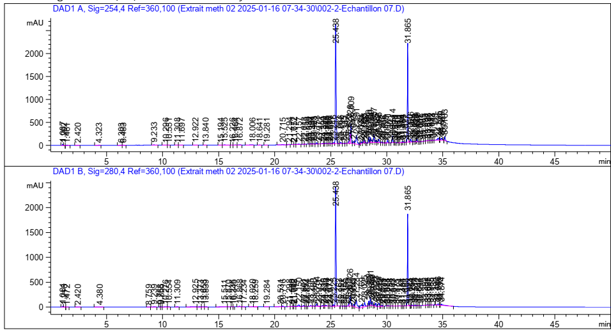

My3 Region 3

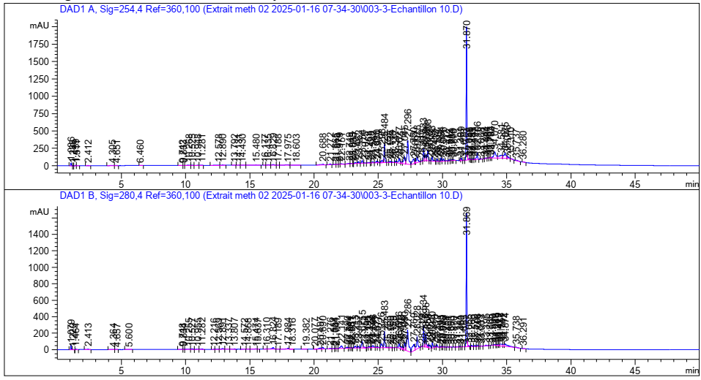

Figure 56: HPLC chromatogram of myrrh extract according to the region and the microwave power studied, region 1: Saudi Arabia HD-MOP = 800 W, Region 2: Pakistan HD-MO P = 800 W, Region 3: Yemen HD-MO P = 800 W, Region 4: Saudi Arabia HD-MO P = 600 W

|  |  |  |  |  |  |  |  |  |  |  |  |  |  |  |  |  |
| --- | --- | --- | --- | --- | --- | --- | --- | --- | --- | --- | --- | --- | --- | --- | --- | --- |
|  | My1 (Region 1) | | | | My2 (Region 2) | | | | My3 (Region 3) | | | | My4 (Region 4) | | | |
| Wavelength ʎ (nm) | 280.4 | | 254.4 | | 280.4 | | 254.4 | | 280.4 | | 254.4 | | 280.4 | | 254.4 | |
|  | TR (min) | % | TR (min) | % | TR (min) | % | TR (min) | % | TR (min) | % | TR (min) | % | TR (min) | % | TR (min) | % |
| 2.5-Dimethoxy cinnamic acid | 2.385 | 0.0893 | / | / | / | / | / | / | / | / | / | / | / | / | / | / |
| Parahydroxybenzoic acid | / | / | 20.675 | 0.1135 | 1,118 | 3.0375 | 1,119 | 4.01 | / | / | / | / | 20.690 | 0.7209 | 20.688 | 0.6308 |
| Caffeine | / | / | / | / | / | / | / | / | / | / | / | / | / | / | / | / |
| Gallic acid | Traces (For Wavelength ʎ = 275.4) | | | | | | | | | | | | | | | |
| Protocatechic acid | / | / | / | / | / | / | / | / | 4.380 | 0.0720 | 4.323 | 0.0432 | 4.364 | 0.0599 | 4.305 | 0.1244 |
| Anthrone | 1,222 | 0.1665 | 1,221 | 0.1145 | / | / | / | / | 1,213 | 0.0282 | 1.202 | 0.0237 | 1,229 | 0.0378 | 1.235 | 0.0287 |
| Catechin | 1.077 | 1,3920 | 1.079 | 1,1747 | / | / | / | / | 1.084 | 0.1475 | 1.087 | 0.2264 | 1.079 | 0.6813 | 1.086 | 0.56733 |
| Flavone | / | / | / | / | / | / | / | / | / | / | / | / | / | / | / | / |
| Isophanilic acid | / | / | / | / | / | / | / | / | 4.380 | 0.0720 | / | / | 4.364 | 0.0599 | / | / |
| Kaempferol | / | / | / | / | / | / | / | / | / | / | 4.471 | 0.043 | / | / | 4.471 | 0.06 |
| Quercetin | / | / | / | / | / | / | / | / | / | / | / | / | 4.657 | 0.0654 | / | / |
| Hydrate | / | / | / | / | / | / | / | / | / | / | / | / | / | / | / | / |
| Salicylic acid | / | / | 9.067 | 0.6824 | / | / | 1,119 | 4.11 | / | / | / | / | / | / | / | / |
| Syring acid | / | / | / | / | 1,118 | 3,0375 | / | / | / | / | / | / | / | / | / | / |
| Trans-4-Methoxycinnamic acid | / | / | / | / | / | / | / | / | / | / | / | / | / | / | / | / |
| Vanillin | / | / | 1,284 | 0.1665 | / | / | / | / | / | / | 1,284 | 0.028 | / | / | 1,284 | 0.037 |

**Tableau 9 :** Résultats de l’analyse HPLC des composés phénoliques de la résine de myrrhe

IV.3 Study of antimicrobial activity of myrrh resin on bacterial and fungal pathogenic strains

The evaluation of the anti -microbial activity of oil and myrrh extract was carried out by measuring the inhibition zones formed around the tested samples (Figure 57).

Table 10: results of antimicrobial activities

|  |  |  |  |
| --- | --- | --- | --- |
| Lots Bacteria | Extract + DMSO (mm) | Oil + DMSO (mm) | Oil (mm) |
| Pseudomonas aeruginosa | 8.88 | R | 7.7 |
| ESCherichia COOLIS | R | R | 7.66 |
| Candida albicans | 7.7 | 9.61 | 10 |
| Staphylococcus aureus | 15.31 | 11.1 | 12.01 |
| Bacillus subtilis | R | R | R |

Note: No activity was observed against the Bacillus Subtilis in the three preparations, which can be linked to intrinsic resistance or to an insufficient concentration in active ingredients.

Examination of the inhibition zones (Table 10) reveals that the ethanolic extract of dilute dilute to the DMSO is particularly active againststaphylococcusaurus (15.3mm) and shows a notable inhibition of pseudomonasaeruginosa (8.88mm), while pure essential oil, effectively inhibits the candidate (10mm) andEscherichiacoli (7.66mm) but loses its effectiveness when diluted in DMSO.On the contrary, the bacillussubtilis remains resistant to all the formulations tested.

The absence of an inhibition zone for some of them is mainly explained by their natural resistance, but can also result from the degradation of extracts and essential oils under the heating effect.

The results show that staphylococcus aureus is the most sensitive strain of myrrh extracts, whatever the form used (essential oil, ethanolic extract, etc.), while other microorganisms have variable levels of resistance depending on the strains and types of extracts.The DMSO, recognized for its properties of solubilization and facilitation of the penetration of molecules (Balouiri, M. et al., 2016), slightly improves the diffusion of the active ingredients of the extract or the oil to significantly increase the global activity.Consequently, the extract of myrrh in the presence of DMSO, appears as a partial natural alternative against certain gram-positive pathogens such as S. Aureus, while its effectiveness remains reduced towards gram-negative bacteria.

IV.4 Study of anti-inflammatory activity of essential oils and myrrh extracts

The results presented in Figures 58 and 59 revealed that the extract of the myrrh exerts a notable inhibitory activity, reaching a maximum percentage of inhibition of 95.98% at a concentration of 0.1875mg/ml.However, a gradual decrease in this activity has been observed at higher concentrations, which can be explained by an effect of saturation of the reaction environment or an interference linked to the turbidity of the mixture.The extract IC50 was estimated at 0.724mg/ml, reflecting moderate but significant efficiency.

The essential oil has also demonstrated a marked anti-inflammatory activity.The IC50 obtained (0.636mg/ml) is slightly lower than that of the extract, which suggests a lower inhibitory efficiency with lower concentration.This performance could be attributed to the richness of essential oil in volatile bioactive compounds, including sesquiterpenes and monoterpenes, widely recognized for their anti-inflammatory properties.

By way of comparison, the sodium diclofenac, used as a reference anti-inflammatory, presents an IC50 of 0.314mg/ml, according to a study carried out with the same method of protein denaturation (Thunbergia Grandiflora, 2022).Although the IC50s of natural extracts of myrrh are superior, indicating a lower inhibitory power, the results obtained remain significant.They support the interest of these extracts in the development of alternative natural formulations, potentially better tolerated and without major side effects linked to synthetic NSAIDs.

These observations are part of the continuity of previous work, like that of Ahmed et al.(2022), which has shown that the methanolic extract of Myrrhe effectively inhibits the thermal denaturation of albumin, with a dose-dependent response.Other studies have also highlighted the anti-inflammatory activity of certain specific compounds of myrrh, including myrthanol A, whose efficiency sometimes exceeds that of hydrocortisone (Dolara, P. et al., 2000).

Thus, the two forms extracted from myrrh resin-raw extract and essential oil-manifest a significant anti-inflammatory activity, confirming the traditional uses of this medicinal plant.The essential oil, in particular, could offer a promising natural therapeutic option in formulations with a gentle and well tolerated anti-inflammatory aim.

**Figure 58 :** graphes représentant le **% d’inhibition de la dénaturation de l’albumine** en fonction de la concentration des extraits et des huiles essentielles

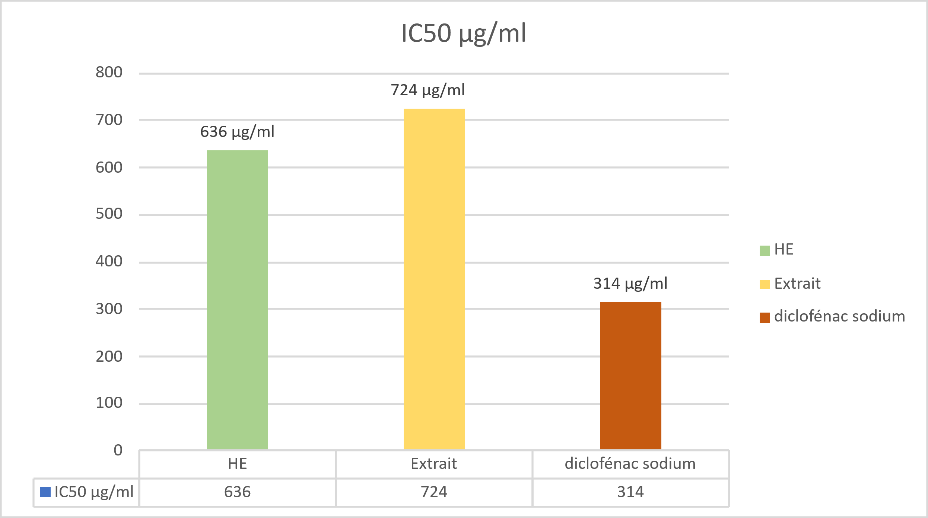

**Figure 59** : Histogramme des valeurs IC50 (µg/ml) des huiles essentielles et des extraits de Myrrhe obtenus par la méthode de broyage simple et diclofénac sodium

## IV.5 Study of antioxidant activity of essential oils and myrrh extracts by the trapping method at DPPH

The antioxidant activity of essential oils was evaluated by the method at the DPPH, by measuring the reduction of the free radical DPPH •, accompanied by a change in purple to yellow color, detected at 517 nm per spectrophotometry.The percentage of inhibition (% I) was calculated for each extract, with analyzes carried out in triplicate to guarantee the reliability of the results (Figure 60).

Figure 60: antioxidant activity as a function of the concentration of essential oils and extracts from myrrh

The analysis of IC₅₀ values ​​reveals that the extract studied presents a remarkable antioxidant activity, with an CI₅₀ of 0.7 µg/ml, surpassing that of essential oil (3.5 µg/ml) as well as reference antioxidants such as BHA (2.3 µg/ml) and BHT (4.63 µg/ml).

This notable efficiency could be attributed to the richness of the extract in phenolic and flavonoid compounds, known for their capacity to neutralize free radicals by transfer of electrons or protons (Ouahab, A. et al., 2023).In comparison, more moderate activity of essential oil could be explained by the predominance of terpene compounds, often less effective in the DPPH test because of their lipophilic character (Ghaliaoui, N. et al., 2020).These results (Figure 61) underline the potential of extract as a natural source of antioxidants, with interesting application prospects in the pharmaceutical and agrifood fields.

These observations are consistent with the data reported in the Ben Abdallah study, M. (2018) which showed that a notable antioxidant activity of an alcoholic extract of Myrrhe, with an IC50 close to that obtained here (0.0012 mg/ml), although the solvent used is different (methanol).Likewise, El-Kamali, H. H. et al.(2010) observed moderate antioxidant activity in myrrh essential oil.These variations between the results can be explained by several influential factors, including the nature of the solvent, the extraction method, the chemical composition of the sample, as well as the phenomena of synergy or antagonism between the different antioxidant molecules present.

Myrrh extract has proven more efficient than essential oil in the trapping of free radicals, making it a promising candidate for antioxidant applications in the pharmaceutical, cosmetics or nutraceutical fields.These results confirm that the choice of the type of extract plays a key role in the antioxidant efficiency of myrrh.

Table 11: Result of antioxidant activity by DPPH

IC50 µg/ml samples

He 3.5

Extract 0.7

BHT 4.63

Bha 2.3

Figure 61: Histogram of IC50 (µg/ml) values ​​of essential oils and extracts from the myrrh obtained by the simple grinding method

IV.6 Evaluation of the analgesic activity of the ethanolic extract of Myrrhe

The experimental study presented aims to assess the analgesic effect of a treatment on mice through three classic pain models: the Caudal removal test (Tail Flick), the heating plate test (Hot Plate) and the chemical irritation test (Writhing Test).These models are commonly used in pharmacology to detect antinocceptive effects of natural or synthetic agents, targeting either the central nervous system or the peripheral pains of pain.

* The Tail Flick test, which measures the reaction time of an animal in the face of a thermal source applied to the tail, has shown a significant difference between the treated and witness groups (Figure 62).The P value obtained is 0.0056 (p <0.05), with an average increase of 10.11 seconds of latency.This increase indicates a marked central analgesic effect, comparable to that induced by opioid agonists in similar models, as shown by bars work, D. et al.(2001).The determination coefficient (R² = 0.6893) confirms a good correlation between treatment and physiological response.
* The heating plate test (Figure 63), which measures the animal's behavioral response (licking, jump, withdrawal) in reaction to thermal pain applied to legs, has also shown statistically significant results with a P value of 0.0036.The average difference observed is 10.78 seconds between the two groups.This suggests an increase in the thermal pain tolerance threshold, once again reflecting central analgesic activity.This result is consistent with the effects observed in plant extracts with analgesic properties such as turmeric or ginger (Ribeiro, R. A. et al., 2018), and reinforces the hypothesis of an action on the receptors involved in the modulation of central pain.
* The Writhing Test (Figure 64) measures the visceral pain induced by the intraperitoneal administration of acetic acid, a validated model to assess peripheral analgesic effects.A significant decrease in the number of contortions was observed in treated mice, with a value of 0.0384.The average difference is 46.33 contortions, indicating a marked reduction in the pain caused.This result suggests an inhibition of the peripheral pains of pain, probably via anti-inflammatory action or inhibition of prostaglandin biosynthesis, mechanism comparable to that of non-steroidal anti-inflammatory drugs (necklace, H. O. J. et al., 1968; Zarghi and Arfaei, 2011).

These results justify a real therapeutic interest of myrrh as a natural analgesic agent with double mechanism of action, and pave the way for in -depth research on the identification of active compounds responsible for this double activity.

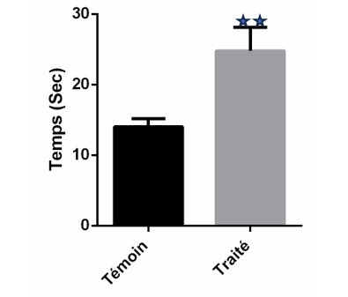

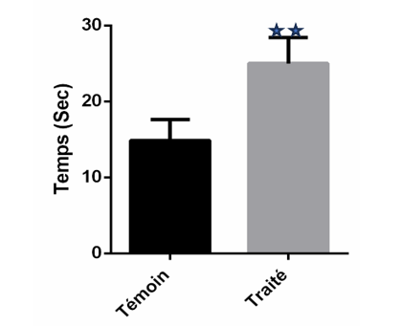

**Figure 63 :** Effet du traitement sur la latence de réaction au test de la plaque chauffante chez les animaux

**Figure 62 :** Effet du traitement sur le temps de latence au test Tail Flick chez les animaux

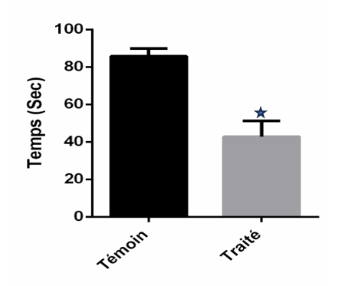

**Figure 64 :** Pourcentages d’inhibition de l’extrait 300mg/Kg sur le nombre de torsions induites par l’acide acétique

Chapter V

The formulation

As part of our valuation project, we have developed three innovative formulations based on myrrhe resin: a roll-on, a balm and a preparation for skin use.These products have been designed to exploit the therapeutic properties of myrrhe, recognized since Antiquity, while being part of an applied research approach aimed at offering innovative natural solutions, suitable for targeted and effective use.

V.1 Roll-on innovative myrrh for targeted application

### V.1.1 Manufacturing process

The process is based on a soft maceration of the resin in an oily base of vegetable origin, followed by careful filtration.A natural antioxidant agent has been added to improve product stability.This practical format (Figure 65) allows targeted application, especially for muscle and joint pain, while ensuring good skin penetration of active compounds.

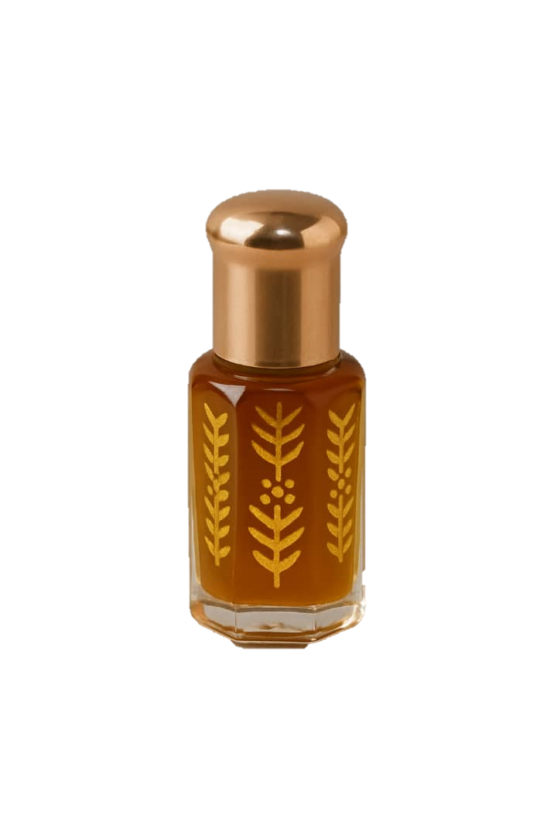

**Figure 65 :** Formulation finale du roll-on thérapeutique à base de myrrhe

V.1.2 Therapeutic effect of the Roll-on formulated from myrrh

The Roll-On product developed as part of this work has an interesting therapeutic potential for the relief of localized pain and skin inflammation.Thanks to the synergy between the volatile fraction of myrrh (rich in bioactive compounds) and the oily base chosen, this formulation acts on several levels.It first has an anti-inflammatory effect by inhibiting inflammation mediators, confirmed by protein denaturation tests.Then, its antimicrobial properties make it possible to limit the development of microorganisms in the applied area, thus helping to prevent secondary infections.Antioxidant activity, for its part, strengthens the protection of tissues against oxidative stress, participating in cellular regeneration.

Finally, the results of the analgesic test in vivo suggest a significant soothing effect, which makes this formulation particularly suitable for topical use in the treatment of muscle or joint pain of light to moderate intensity.

V.2 MYRRHE BALAGE for optimal skin protection and regeneration

V.2.1 Manufacturing process

The formulation started with prolonged contact with the raw material with a quality vegetable oil, enriched as a coordinate for its thickening natural properties.This association promotes the extraction and stabilization of the active compounds of myrrh, while contributing to the texture of the balm.The oily phase obtained was then heated gently to incorporate waxes and plant butters, guaranteeing a homogeneous and stable consistency.To preserve the heat -sensitive active ingredients, in particular the natural vitamin E added at the end of preparation for its antioxidant properties, the temperature has been rigorously controlled.Finally, the balm (Figure 66) was conditioned in hermetic containers, ensuring its conservation and its safety.

**Figure 66 :** Formulation finale de baume thérapeutique à base de résine de myrrhe

V.2.1 Therapeutic effect of myrrh Balm

Thanks to the richness of its natural components, this balm has multiple properties: soothing, anti-inflammatory, antimicrobial and regenerating.It is particularly suitable for sensitive skin or subject to irritation.Its protective and repairing effect makes it useful in localized skin care, in particular to calm redness, promote healing and strengthen the skin barrier.The presence of plant active ingredients with antioxidant properties also helps to fight against oxidative stress and premature aging of the skin.

V.3 Vaseline based on myrrh extract

V.3.1 Manufacturing process

The preparation was carried out by progressive incorporation of an active vegetable extract in a neutral base previously softened (67).The mixture was made at controlled temperature in order to preserve the integrity of sensitive compounds, while ensuring a homogeneous dispersion of the assets in the matrix.The final texture obtained is stable, easy to apply and well tolerated by the skin.The packaging was carried out in hermetic pots for dermal use.

**Figure 67 :** Formulation finale de vaseline à base d’extrait de myrrhe

V.3.1 Therapeutic effect of vaseline based on myrrh

Thanks to its high concentrated myrrh extract content, this petroleum vaseline has multiple therapeutic potential, particularly suitable for intensive skin care.Its action is based on a synergy of deep anti-inflammatory effects, broad spectrum antimicrobials, and local pain relievers, which make it an ally of choice for attacked or repair phase.Its fatty phase, enriched with liposoluble active ingredients, allows progressive penetration of bioactive components in the superficial layers of the skin, offering prolonged and targeted action.It helps relieve localized pain, reducing inflammatory redness, limiting microbial proliferation, and promoting tissue repair, especially in the event of chapks, crevices, or minor post-traumatic inflammation.This dermato-active treatment can also be applied in soothing massage on tense or painful areas, including tired muscles or sensitive joints, where it provides a natural relaxing effect without known side effects.

Conclusion

The study that we conducted around myrrh (Commiphora SPP.) Was part of an innovative approach to enhance an ancestral medicinal plant through an integrated approach, combining extraction, analysis and application.This project allowed us to better understand the chemical complexity and the biological richness of this resin, while laying the first foundations for modern exploitation, with therapeutic and entrepreneurial purposes.

Chromatographic analyzes have been an essential step for the characterization of extracts.The use of gaseous phase chromatography coupled with mass spectrometry (GC-MS) has made it possible to identify the volatile constituents of essential oils with precision, including sesquiterpenes and furanoses, compounds recognized for their anti-inflammatory and antimicrobial properties (Shen et al., 2020; Riaz et al., 2017).

At the same time, high performance liquid chromatography (HPLC) has made it possible to detect and quantify phenolic compounds in ethanolic extracts, such as ferulic acid and flavonoids, thus reinforcing understanding of the antioxidant profile of myrrh (El Ashry et al., 2019).

The biological results obtained have highlighted antioxidant, antimicrobial, anti-inflammatory and analgesic properties.These observations corroborate data from the literature and strengthen the positioning of myrrh as a potential functional ingredient in skin care (Dolara et al., 2000).

Beyond the experimental aspect, we have translated these scientific achievements into concrete actions by the development of three natural dermal formulations, thoughts to combine efficiency, safety and accessibility.This passage from the laboratory to the pre-commercial formulation is fully part of an applied research dynamic and entrepreneurial innovation.

For lack of time, certain complementary tracks, such as the evaluation of the stability of formulations, dermatological tests on volunteers, or toxicity tests, as well as comparison with other species of Commiphora, could not be explored.However, they represent promising prospects as part of a future product research or maturation project.

In short, this work highlights the richness of myrrh as a natural resource with high therapeutic and socio-economic potential.It is part of a broader desire to reconcile modern science with ancestral medicinal heritage, by valuing local resources according to sustainable, responsible and scientifically founded approaches.

“All well -conducted research always leaves more open doors behind than closed answers.- A perspective that encourages us to continue this path with rigor, passion and innovation.

# 

# Bibliographies references

HAS

* Abbas, R., Al-Mushhin, A., Elsharbasy, F., & Ashiry, K. (2020).[Title of the missing article].[Title of the missing journal].Open Access under license Creative Commons Assignment 4.0.
* Abd El - Raouf, O. M., El - Sayed, E. S. M., & Mani, M. F. (2015).[Title of the missing article].Journal of Biochemical and Molecular Toxicology, 29 (8), 426–431.https://doi.org/10.1002/jbt.21729
* Abdel-Hay, M. H., Saleh, A., El Ashry, E., Rashed, N., & Salama, O. (2002).Colorimetric determination of gross powdered myrrh, purified myrrh extract, oily fraction and its different galenic forms.Spectroscopy Letters, 35 (2), 183–197.https://doi.org/10.1081/sl-120003009
* Abdul-Ghani, R. A., Loutfy, N., & Hassan, A. (2009).Myrrh and tremotodosis in Egypt: overview of safety, efficiency and efficiency profiles.Parasitology International, 58 (2), 210–214.https://doi.org/10.1016/j.parint.2009.01.002
* Adams, R. P. (2007).Identification of Essential Oil Components by Gas Chromatography/Mass Spectrometry (4th ed.).Allted Publishing Corporation.
* .(2000).Standard NF T75-006: essential oil-Definition and specifications.Paris: French normalization association.
* French Health Products Health Safety Agency (Afssaps).(2010).French pharmacopoeia (10th ed.).Ministry of Health
* Al-Harrasi, A., Khan, A. L., ASAF, S., & al-Rawahi, A. (2019).BOOLOGY OF GENUS BOSWELLIA.HTTPS: //public.ebookcentral.Proquest.com/choice/publicfullrecord.aspx? P = 5771071 (accessed May 12, 2020).
* Alsharif, K. (2020).Potential effect of anti-inflammatory properties of myrrh.Letters in Applied Nanobioscience, 9, 1687–1694akbar, S. (2020).Commiphora Myrrha (Nees) Engl.(Burseraceae).In S. Akbar (ed.), Manual of 200 medicinal plants: a complete review of their traditional medical uses and their scientific justifications (pp. 701–706).Springer International Publishing.
* Azwanida, N. N. (2015).A review on the extraction methods used in medicinal plants, principle, strength, and limitation.Medicinal & Aromatic Plants, 4 (3), 196. https://doi.org/10.4172/2167-0412.1000196.

B

* Bakkali, F., Averbeck, S., Averbeck, D., & Idaomar, M. (2008).Biological Effects of Essential Oils - A Review.Food and Chemical Toxicology, 46 (2), 446–475.https://doi.org/10.1016/j.fct.2007.09.106
* Balouiri, M., Sadiki, M., & Ibnsouda, S. K. (2016).Methods for in vitro Evaluating Antimicrobial Activity: A review https://doi.org/10.1016/j.jpha.2015.11.005
* Bars, D., Gozariu, M., & Cadden, S. W. (2001).Animal Models of Nociception.Pharmacological Reviews, 53 (4), 597–652.https://doi.org/10.1124/pr.53.4.597
* Başer, K., Demirci, B., Dekebo, A., & Dagne, E. (2003).Essential oils of certain species of boswellia, myrrhe and opopanax.Flavour and fragrance Journal, 18 (2), 153–156.https://doi.org/10.1002/ffj.1150
* Belkou, H., Beyoud, F., & Taleb, B. Z. (2005).Approach to the biochemical composition of green mint (Mentha spicata L.) in the region of Ouargla [master's thesis].University of Ouargla.
* Ben Abdallah, M. (2018).Study of the anti-inflammatory activity of natural extracts: case of myrrh (Commiphora Molmol) [Master of Master, University of Tunis El Manar].
* BENAISSA, O. (2011).Study of terpenic and flavonic metabolisms of family of compounds, genres chrysanthemum and rhantherium.Biological activity [doctoral thesis, Mentouri Constantine university, Algeria].
* Benayad, N. (2008).Essential oils extracted from Moroccan medicinal plants: effective means of fighting pests of stored foodstuffs [Doctoral thesis, Mohammed V University - Faculty of Sciences of Rabat, Department of Chemistry].
* Bendif, H. (2017).Phytochemical characterization and determination of biological activities in vitro of the active extracts of some lamiaceae: ajuga IVA (L.) Schreb., Teucrium polium L., Thymus munbyanus subsp.Coloratus (Boiss. & reut.) Greuter & Burdet and Rosmarinus Eriocalyx Jord & Fourr.Doctoral thesis in biological sciences, the National School of Kouba-Alger.
* Benkaci-Ali, F. (2007).Study of the chemical composition of Nigella Sativa from Algeria [Doctoral thesis, University of Sciences and Technology Houari Boumediene].
* Bera, S., de, S., & de, B. (2020).Essential Oils and Their Chemical Composition With Relivance to Myrrh.Natural Product Research, 34 (9), 1264–1275.https://doi.org/10.1080/14786419.2018.1515145
* Besombes, C. (2008).Contribution to the study of hydro-thermomicanic extraction phenomena of aromatic herbs: generalized applications.University of La Rochelle.
* Bézanger-Beauquesne, L., Pinkas, M., & Torck, M. (1986).Plants in modern therapy (2nd revised ed.).Maloine editions.
* Bimakr, M., Rahman, R. A., Ganjloo, A., Taip, F. S., & Zaidul, I. S. M. (2011).Comparison of Different Extraction Methods for the Extraction of Major Bioactive Flavonoid Compounds from Spearmint (Mentha spicata L.) Leaves.Food and Bioproducts Processing, 89 (1), 67–72.https://doi.org/10.1016/j.fbp.2010.03.002
* Bisset, N. G., & Wichtl, M. (1994).Plant -based drugs and phytopharmaceutical products.Medepharm GmbH scientific editors;CRC Press.
* Bone, K., & Mills, S. (2013).Principles and Practice of Phytotherapy: Modern Herbal Medicine (2nd ed.).Elsevier Health Sciences.
* Boukhobza, F., & Goetz, P. (2014).Phytotherapy in deception: Clinical guide.CDP editions.ISBN 978-2-84361-244-2.
* Boyraz, N., & Özcan, M. (2005).Antifungal Effect of Some Spice Hydrosols.Fitoterapia, 76, 661-665.
* Brand-Williams, W., Cuvelier, M. E., & Berset, C. (1995).Use of A Free Radical Method to Evaluate Antioxidant Activity.LWT - Food Science and Technology, 28 (1), 25–30.https://doi.org/10.1016/s0023-6438(95)80008-5
* Bruneton, J. (2009).Pharmacognosia: phytochemistry, medicinal plants (4th ed.).Lavoisier editions.
* Burt, S. (2004).Essential Oils: Their Antibacterial Properties and Potential Applications In Foods - A Review.International Journal of Food Microbiology, 94 (3), 223–253.https://doi.org/10.1016/j.ijfoodmicro.2004.03.02222

C

* Chagra, K. (2019).Study of the physico-chemical and biological properties of cloves (syzygium aromaticum L.).Master's thesis in chemical engineering, Mohamed Khider University of Biskra (Algeria).
* Chahar, M. K., Sharma, N., Dobhal, M. P., & Joshi, Y. C. (2012).Flavonoids: a versatile Source of Anticancer Drugs.Pharmacognosy Reviews, 5 (9), 1–12.
* Chalchat, J. K., Carry, L. P., Menut, C., Lamaty, G., Malhuret, R., & Chopineau, J. (1997).Correlation Between Chemical Composition and Antimicrobial Activity.VI.Activity of some African Essential Oils.Journal of Essential Oil Research, 9, 67-75.
* Chemat, F., Vian, M. A., & Cravotto, G. (2017).Green Extraction of Natural Products: Concept and Principles.International Journal of Molecular Sciences, 18 (7), 1584. Https://doi.org/10.3390/ijms18071584
* Chemat, F., Zill-E-Huma, & Khan, M. K. (2011).Applications of Ultrasound in Food Technology: Processing, Preservation and Extraction.Ultrasonics Sonochemistry, 18 (4), 813–835.https://doi.org/10.1016/j.ultsonch.2010.11.023
* Chemat, S., Lagha, A., Ait Amar, H., & Chemat, F. (2003).Ultrasound assisted microwave digestion.Ultrasonic Sonochemistry, 11, 5-8.
* Collier, H. O. J., Dinneen, L. C., Johnson, C. A., & Schneider, C. (1968).The Abdominal Constriction Response and its Deletion by Analgesic Drugs in the Mouse.British Journal of Pharmacology and Chemotherapy, 32 (2), 295–310.
* Cravotto, G., & Cintas, P. (2008).Power Ultrasound in Organic Synthesis: Moving Cavitational Chemistry from Academia to Innovative and Large-Scale Applications.Chemical Society Reviews, 38 (2), 268–289.https://doi.org/10.1039/b812169e
* Cvitković, D., et al.(2022).The Influence of Cryogrinding on Essential Oil, Phenolic Compounds and Pigments Extraction from myrtle (Myrtus Communis L.) Leaves.Processes, 10 (12), 2716. Https://doi.org/10.3390/PR10122716

D

* Decaux, I. (2002).Phytotherapy: user manual.Editions Le Bien Public.
* Dekebo, A., Lang, M., Polborn, K., Dagne, E., & Steglich, W. (2002).Four Lignans of Commiphora Erlangeriana.Journal of Natural Products, 65 (9), 1252–1257.https://doi.org/10.1021/np020070l
* Demisew, S. (1993).Description of certain essential oil plants in Ethiopia and their native uses.Journal of Essential Oil Research, 5, 465–479.https://doi.org/10.1007/S00210022023250.
* Do, Q. D., Angkawijaya, A. E., Tran-Nguyen, P. L., Huynh, L. H., SOETAREDJO, F. E., Ismadji, S., & Ju, Y. H. (2014).Effect of Extraction Solvent on Total Phenol Content, Total Flavonoid Content, and Antioxidant Activity of Limnophila Aromatica.Journal of Food and Drug Analysis, 22 (3), 296–302.https://doi.org/10.1016/j.jfda.2013.11.001
* Dolara, P., Corte, B., Ghelardini, C., Pugliese, A. M., Cerbai, E., Menichetti, S., & Lo Nostro, A. (2000).Local AnaestHetTHIC, Antibacterial and Antifungal Properties of Sesquiterpenes from myrrh.Planta Medica, 66 (4), 356–358.https://doi.org/10.1055/s-2000-8536
* Dolara, P., Luceri, C., Ghelardini, C., et al.(1996).Analgesic effects of myrrh.Nature, 379, 29.
* Durvelle, J.-P. (1930).Manufacture of essences and perfumes.

E

* El-Ashram, S., & Suo, X. (2017).The Effect of Myrrh (Commiphora Molmol) Against Fasciola Gigantica: Antiparasitic Activity and Potential Therapeutic Uses.Parasitology Research, 116 (2), 741–749.https://doi.org/10.1007/s00436-016-5332-2
* El Ashry, E. S., Rashed, A. N., Salama, O. M., & Saleh, A. K. (2019).Phenolic Constituents and Antioxidant Activity of Myrrh (Commiphora Molmol) Ethanolic Extract.Journal of Natural Products Research, 33 (9), 1203–1210.
* El-Kamali, H. H., Mahjoub, S. A., & Hamad, S. A. (2010).Antibacterial Activity of Essential Oils of Commiphora Molmol (Myrrh) Against Some Pathogenic Bacteria.Journal of Medicinal Plants Research, 4 (4), 354–357.
* Above, S., Hua, Y., Wang, Y., Gu, W., Zhou, W., Duan, J.-A., Jiang, H., Chen, T., & Tang, Y. (2012).Assessment of anti-inflammatory and analgesic properties of individual and combined extracts from Commiphora Myrrha and Boswellia Cardriii.Journal of Ethnopharmacology, 139 (3), 649–656.https://doi.org/10.1016/j.jep.2011.11.009

F

* Frattarolo, L., Carullo, G., Brindisi, M., Mazzotta, S., Bellissimo, L., Rago, V., Curcio, R., Dolce, V., Aiello, F., & Cappello, A. R. (2019).[Title of the missing article].Antioxidants, 8 (6), 186. Https://doi.org/10.3390/antiox8060186

G

* Ghaliaoui, N., Hazzit, M., Hadjadj, M., & Mokrane, H. (2020).Impact of Freezing and Drying Preprocessing on Pigments Extraction from the Brown Seaweed Phyllaria Réniformis Collection in Algerian Coast.

H

* H. Tutunchi, F. Naeini, A. Ostadrahimi, M. J. Hosseinzadeh-Attar, Phytotherapy Research 2020, 34, 3137-3147.
* He, Z., CHAPITAL, D. C., CHENG, H. N., Thomas Klasson, K., OLANYA, O. M., & UKNALIS, J. (2014).Application of Tung Oil to Improve Adhesion Strength and Water Resistance of Cottoneed Meal and Protein Adhesives on Maple Veneer).
* Hessas, T., & Simoud, S. (2018).Contribution to the study of chemical composition and the evaluation of antimicrobial activity of essential oil of Thymus SP.Doctoral thesis in pharmacy, Mouloud Mammeri University (Algeria).
* HANUS, L. O., Rezanka, T., Dembitsky, V. M., & Moussaieff, A. (2005).Myrrh—commiphora Chemistry.Biomedical Papers, 149 (1), 3–28.htts: //doi.org/10.5507/bp.2005.001

I

* Iserin, P. (2001).Encyclopedia of medicinal plants.Larousse Bourdasse editions
* Izzo, A. A., & Ernst, E. (2009).Interactions between herbal medicines and prescribed drugs: at Systematic Review.Phytotherapy Research, 23 (5), 583–595.https://doi.org/10.1002/ptr.2626

J

* J.-H.Lee, Food Bioscience 2015, 11, 1-7.

K

* KOBA, K. H., et al.(2016).Effect of Cryogenic Grinding on Volatile and Fatty Oil Constitutions.Journal of Essential Oil Research, 28 (2), 132–139.
* Koster, R., Anderson, M., de Beer, E.J. (1959).Actic Acid for Analgesic Screening.Federation Proceedings, 18, 412.

L

* L. Frattarolo, G. Carullo, M. Brindisi, S. Mazzotta, L. Bellissimo, V. Rago, R. Curcio, V. Dolce, F. Aiello, A. R. Cappello, antioxidants 2019, 8, 186.
* Lagunez Rivera, L. (2006).Study of the extraction of secondary metabolites from different vegetable materials in reactor heated by direct thermomagnetic induction.Doctoral thesis, National Polytechnic Institute of Toulouse, France.
* Lahlou, M. (2004).Methods to Study Phytochemistry and BioActivity of Essential Oils.Phytotherapy Research, 18, 435-448.
* Lee, J.-H.(2015).[Title of the missing article].Food Bioscience, 11, 1–7.https://doi.org/10.1016/j.fbio.2015.03.001
* Lemenih, M., & TEKETAY, D. (2004).Review Article: Frankincense and Myrrh Resources of Ethiopian: I Distribution, Production, Opportunities for Dryland Development and Research Needs.Sinet: Ethiop.J. SCI., 26, 63–72.https://doi.org/10.4314/sinet.v26i1.18201.
* Leung, A. Y. (1980).Encyclopedia of current natural ingredients used in food, drugs and cosmetics.John Wiley and Sons.
* Ljaljević Grbić, M., Unković, N., Dimkić, I., Janaćković, P., Gavrilović, M., Stanojević, O., & Vukojević, J. (2018).Frankincense and Myrrh Essential Oils and Burn Incense Fume Against Micro-Inhabitants of Sacral Ambients: Wisdom of the Ancients?Journal of Ethnopharmacology, 219, 1–14.https://doi.org/10.1016/j.jep.2018.03.003

M

* Mangena, T., & Muyima, N. Y. O. (1999).Comparative Evaluation of the Antimicrobial Activities of Essential Oils of Artemisia Afra, Pteronia Incana, and Rosmarinus Officinalis on Selected Bacteria and Yeast Strains.Letters in Applied Microbiology, 28 (4), 291-296.
* Massoud, A., El Sisi, S., & Salama, O. (2001).Preliminary study of the therapeutic efficiency of a new fasciolicide medication derived from Commiphora Molmol (Myrrhe).American Journal of Tropical Medicine and Hygiene, 65, 96–99.
* Mompon, B. (1994).What a commercial future for the products obtained by new extraction technologies: CO2, microwave, ultrasound, new solvents.In 4th international meeting of Nyons (pp. 149-166).
* Murti, Y., & Mishra, P. (2014).[Title of the missing article].Indian Journal of Pharmaceutical Sciences, 76 (3), 163.

N

* Nomicos, E. Y. H. (2007).Myrrh: Medical Marvel or Myth of the Magi?Holistic Nursing Practice, 21 (5), 308–323.https://doi.org/10.1097/01.hnp.0000298616.32846.34.
* Food, V. N., de Angelis, M., de Vita, D., Messore, A., de Leo, A., Ialongo, D., Tudino, V., Saccoliti, F., de Clear, G., & Garzoli, S. (2021).Study of the antiviral activity of the essential oil of Commiphora Myrrha (Nees) Engl.And its main components.Pharmaceuticals, 14 (3), 243. https://doi.org/10.3390/ph14030243

O

* O. M. Abd El-Raouf, E. S. M. El-SAYED, M. F. Manie, Journal of BIOCHEMICAL AND MOLECULAR Toxicology 2015, 29, 426-431.
* Orabi, S. H., Al-Sabbagh, E. S., Khalifa, H. K., Mohamed, M. A. E.-G., Elhamouly, M., Gad-Allah, S. M., Abdel-Daim, M. M., & Eldaim, M. A. A. (2020).Commiphora Myrrha Resin Alcoholic Extract Extract Ameliorates High Fat Diet Induced Obesity via Regulation of UCP1 and Adiponectin Proteins Expression in rats.Nutrients, 12 (3), 803. Https://doi.org/10.3390/nu12030803
* Ouahab, A., Menaiaia, K., & Khaldi, F. (2023).Phytochemical analysis, antioxidant, and acetylcholinesterase Activities of Propolis extracts from Souk Ahras, Algeria.University of Souk Ahras.https://www.univ-soukahras.dz/wpuploads/eprints/2024-1948-2796.pdf

P

* PARDES, M. Alzuru, J. Mendez, M. Rodríguez-Terga, Biological and Pharmaceutical Bulletin 2003, 26, 108-109.
* Penchev, P. I. (2010).Study of the extraction and purification processes of bioactive products from plants by coupling of separative techniques with bass and high pressure.Doctoral thesis in processes of processes and the environment, University of Toulouse, France.
* Pibiri, M. C. (2006).Microbiological sanitation of air and ventilation systems using essential oils.Doctoral thesis, Lausanne, Canada.
* PIOCHON, M. (2008).Study of essential oils of plant species from Laurentian flora: chemical composition, pharmacological activities and hemi-synthesis.University of Quebec in Chicoutimi.

R

* R. Abbas, A. Al-Mushhin, F. Elsharbasy, K. Ashiry, Open Access.This article is distributed under the terms of the creative commons attribution 2020, 4.
* R. Wang, W. Yang, Y. Fan, W. Dehaen, Y. Li, H. Li, W. Wang, Q. Zheng, Q. Huai, Bioorganic Chemistry 2019, 88, 102951.
* Rahman, M. M., Garvey, M., Piddock, L. J. V., & Gibbons, S. (2008).Antibacterial Terpenes from the Oleo-Resin of Commiphora Molmol (Engl.).Phytotherapy Research, 22 (10), 1356-1360.
* Rao, R. M., Khan, Z. A., & Shah, A. H. (2001).Toxicity studies in the mouse of the olécomme resin Commiphora molmol.Journal of Ethnopharmacology, 76, 151–154.
* Rehman, M. E., Halim, S. A., Khan, A., Khan, M., Al-Hatmi, S., & al-Harrasi, A. (2022).Commikuanoids AC: new cycloartane triterpanoids with exploration of the inhibition of carbon dioxide-II from the Kua Commiphora resins by molecular molecular in vitro and in silico.Phytotherapy Research, 157, 105125. Https://doi.org/10.1016/j.phymed.2022.105125
* RIAZ, M., Rahman, N. U., ZIA-UL-HAQ, M., & Jamil, M. I. (2017).Chemical Composition and Biological Activities of the Essential Oil from Commiphora Myrrha.Molecules, 22 (4), 632.
* Ribeiro, R. A., Vale, M. L., Thomazzi, S. M., & Ferreira, S. H. (2018).Analgesic Activity of Turmeric and Curcumin in Animal Models.European Journal of Pharmacology, 833, 1–10.https://doi.org/10.1016/J.EJPHAR.2018.05.045
* Roussy, G., & Pearce, J. A. (1995).Foundations and Industrial Applications of Microwaves and Radio Frequency Fields.John Wiley & Sons Ltd.

S

* Sagdiç, O. (2003).Sensitivity of Four Pathogenic Bacteria to Turkish Thyme and Oregano Hydrosols.Lebensmittel-Wissenschaft & Technology, 36, 467-473.
* Saha, S., & Ahmed, A. (2012).Antimicrobial Activity of Myrrh (Commiphora Myrrha) Against Various Human Pathogens.Journal of Ethnopharmacology, 141 (1), 233-239.https://doi.org/10.1016/j.jep.2012.02.019
* Sahraoui, N., Vian, M. A., Bornard, I., Boutekedjiret, C., & Chemat, F. (2008).Improved Microwave Steam Distillation Appartus for Insulation of Estastial Oils: Comparison with Conventional Steam Distillation.Journal of Chromatography A, 1210, 229-233.
* SAMATE, A. D. (2002).Chemical composition of essential oils extracted from aromatic plants from the Sudanian area of ​​Burkina Faso: valuation.Doctoral thesis, University of Ouagadougou, Burkina Faso.
* Sasidharan, S., Chen, Y., Saravanan, D., Sundram, K. M., & Yoga Latha, L. (2011).Extraction, insulation and characterization of bioactive compounds from Plants ’extracts.African Journal of Traditional, Complementary and Alternative Medicines, 8 (1), 1–10.https://doi.org/10.4314/ajtcam.v8i1.60483
* Shalaby, M. A., & Hammouda, A. A. (2014).Analgesic, anti-inflammatory and antihyperlipidemic Activities of Commiphora Molmol Extract (Myrrh).Journal of Intercultural Ethnopharmacology, 3, 56–62.https://doi.org/10.5455/jice.20140308074335
* Shen, T., Li, G.-H., Wang, X.-N., & Lou, H.-X.(2012).The Genus Commiphora: A Review of its traditional uses, phytochemistry, and pharmacology.Journal of Ethnopharmacology, 142, 319–330.https://doi.org/10.1016/J.JEP.2012.05.025.
* Shen, T., Li, G. H., Wang, X. N., & Lou, H. X. (2020).The Genus Commiphora: A Review of its traditional uses, phytochemistry and pharmacology.Journal of Ethnopharmacology, 247, 112255.
* Siddiqui, M. Z. (2016).The Medicinal Properties of Myrrh: An Ancient Plant With Modern Applications.Journal of Traditional and Complementary Medicine, 6 (2), 163–168.https://doi.org/10.1016/j.jtcme.2015.07.001
* Singleton, V. L., Orthofer, R., & Lamuela-Raventos, R. M. (1999).Analysis of Total Phenols and Other Oxidation Substrates and Antioxidants by Means of Folin-Ciocalteu Reagent.In P. Lester (ed.), Methods in Enzymology (vol. 299, pp. 152–178).Academic Press.https://doi.org/10.1016/S0076-6879(99999017-1
* Stashenko, E. E., Jaramillo, B. E., & Martínez, J. R. (2004a).Comparison of Different Extraction Methods for the Analysis of Volatile Secondary Metabolites of Lippia Alba (Mill.) N.E. Brown, Grown in Colombia, and Evaluation of its in vitro antioxidant Activity.Journal of Chromatography A, 1025, 93-103.
* Stashenko, E. E., Jaramillo, B. E., & Martínez, J. R. (2004b).Analysis of Volatile Secondary Metabolites from Colombian Xylopia Aromatica (Lamarck) by different extraction and headspace methods and gas chromatography.Journal of Chromatography A, 1025, 105-113.
* SU, S., Wang, T., Duan, J.-A., Zhou, W., Hua, Y.-Q., Tang, Y.-P., & Qian, D.-W.(2011) b.Anti-inflammatory and analgesic Activity of Different Extracts of Commiphora Myrrha.Journal of Ethnopharmacology, 134 (2), 251–258.https://doi.org/10.1016/j.jep.2010.12.003
* SU, S., Zhang, X., Li, Y., & Chen, J. (2011) a.Effects of Myrrh Essential Oil On Cancer Cell Proliferation.Journal of Medicinal Plants Research, 5 (14), 3101–3107.https://doi.org/10.xxxx/jmpr.2011.3101

T

* Teisseire, P. J. (1991).Chemistry of fragrant substances.TEC & DOC.Lavoisier.
* Tipton, D., Lyle, B., Babich, H., & Dabbous, M. K. (2003).Cytotoxic and anti-inflammatory effects in vitro of myrrh essential oil on gingival fibroblasts and human epithelial cells.Toxicology in vitro, 17 (3), 301–310.https://doi.org/10.1016/s0887-23333(03)00016-5
* Tucker, A. O. (1986).Frankincense and Myrrh.Economic Botany, 40 (4), 425–433.http://www.jstor.org/stable/4254901.
* Tutunchi, H., Naeini, F., Ostadrahimi, A., & Hosseinzadeh - Attar, M. J. (2020).[Title of the missing article].Phytotherapy Research, 34 (12), 3137–3147.https://doi.org/10.1002/ptr.6759

V

* Verzera, A., et al.(2025).Quantitative GC - Mms Analysis of Sesquiterpenes in Myrrh Essential Oil.(Prepublication)
* Vogel, H. G. (2008).Drug Discovery and Evaluation: Pharmacological Assays (3rd ed.).Springer.

W

* Wang, R., Yang, W., Fan, Y., Dehaen, W., Li, Y., Li, H., Wang, W., Zheng, Q., & Huai, Q. (2019).[Title of the missing article].Bioorganic Chemistry, 88, 102951. Https://doi.org/10.1016/j.bioorg.2019.102951

Y

* Y. Murti, P. Mishra, Indian Journal of Pharmaceutical Sciences 2014, 76, 163
* Yahiaoui, N. (2005).Extraction, analysis and evaluation of the insecticide effect of essential oils of Mentha Spicata (L.) on Rhyzopertha Dominica (F) (Coleoptera, Bostrychidae) and Tribolium Confusum (DUV) (Coleoptera, Tenebrionidae).Page 19, 24

Z

* Zambonelli, A., d'Aurelio, A. Z., Severi, A., Benventi, E., Maggi, L., & Bianchi, A. (2011).Chemical Composition and Fungicidal Activity of Commercial Essential Oils of Thymus Vulgaris L. Journal of Essential Oil Research, 16 (1), 69-74.
* Zarghi, A., & Arfaei, S. (2011).Selective cox-2 inhibitors: a review of their structure-activity relationships.Iranian Journal of Pharmaceutical Research, 10 (4), 655–683.https://www.ncbi.nlm.nih.gov/pmc/articles/pmc3891238/
* Zerfa, A., & Kouchache, K. E. (2015).Experimental study of the adsorption of a dye on agricultural waste (orange bark and date stems).Master's memory

Webography

1. http://tpejbs2012.canalblog.com/archives/2012/02/13/23515308.html.Site consulted on 02/19/2024.
2. #error#
3. #error#
4. http://www.phytonpathos.com/regroupement/chiemie/proprietesbiochemique/leshuileses Sentiellesouhe.htm

# 

# Annexed

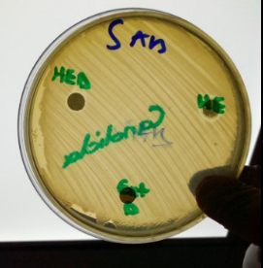

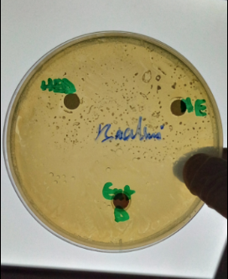

**Figure 57 :** Zones d’inhibition de l’huile essentielle et de l’extrait de myrrhe contre les micro-organismes testés

